Antenatal parenting support for vulnerable women: an exploratory randomised controlled trial of Mellow Bumps versus Chill-out in Pregnancy or Care as Usual
White, J., Thompson, L., Puckering, C., Waugh, H., Henderson, M., MacBeth, A., Wilson, P.

Dr. Jane White, Investigator Scientist, MRC/CSO Social and Public Health Sciences Unit, University of Glasgow. E-mail: jane.white@glasgow.ac.uk
Current appointment: Public Health Advisor, NHS Health Scotland, Glasgow

Dr. Lucy Thompson, Research Fellow, Institute of Health and Wellbeing, University of Glasgow. E-mail: lucy.thompson@glasgow.ac.uk
Current appointment: Senior Research Fellow, University of Aberdeen

Dr. Christine Puckering, Mellow Parenting, Glasgow. Email: christine@mellowparenting.org

Ms Harriet Waugh, Early Intervention Research Officer, Social Policy, West Lothian Council. E-mail: harriet.waugh@westlothian.gov.uk

Dr. Marion Henderson, Senior Investigator Scientist, MRC/CSO Social and Public Health Sciences Unit, University of Glasgow. E-mail: marion.henderson@glasgow.ac.uk

Dr. Angus MacBeth, Lecturer in Clinical Psychology, University of Edinburgh E-mail: angus.macbeth@ed.ac.uk

Professor Philip Wilson (CI), Professor of Primary Care and Rural Health, Centre for Rural Health, University Of Aberdeen. E-mail: p.wilson@abdn.ac.uk

Correspondence should be addressed to Dr. Jane White.

ABSTRACT
Background:
Social adversity and poor maternal mental health during pregnancy have long-term adverse effects on children’s health, social and educational outcomes. Stress in pregnancy may have direct physiological effects on the foetus as well as impairing development of maternal sensitivity to the child. Improved antenatal support and more effective engagement with ‘high-risk’ mothers-to-be is needed.
Method:
Pregnant women meeting high-risk criteria were invited to participate. Participants (n=35) were randomly allocated in clusters of six, to either Mellow Bumps (MB), Chill-out in Pregnancy (CHiP) or care-as-usual. MB is a six-week antenatal parenting programme which aims to decrease maternal stress levels and emphasises the importance of early interaction in enhancing brain development and attachment. CHiP is a six-week stress reduction programme.
Results:
The interventions are promising in terms of maternal mental health. Qualitative feedback suggested that interventions’ format was acceptable. A larger trial may be justified if effect sizes can be estimated with more precision.

Trial registration:
This trial is registered with ClinicalTrials.gov (ID NCT01590212).

KEYWORDS:
Maternal mental health; infant mental health; antenatal care; parenting intervention

KEY MESSAGES:
- Social adversity and poor maternal mental health during pregnancy have long-term adverse effects on children’s health, social and educational outcomes.
- There is limited evidence of the effectiveness of antenatal psychosocial parenting support programmes.
- We report a trial of antenatal group-based interventions designed to improve maternal mental health and sensitivity to the infant in women with additional health and social care needs.
- We found that providing group based parenting support in an acceptable format to pregnant women with additional health and social care needs may impact on their mental wellbeing.
- Further research is needed.

BACKGROUND:
Social adversity and poor maternal mental health during pregnancy have long-term adverse effects on children’s health, social, educational and economic outcomes
(O'Connor et al. 2002, Olivier et al, 2015). Women with social difficulties are more likely to suffer from stress, depression and/or anxiety during pregnancy, which may disrupt maternal sensitivity to the infant’s cues (Pearson et al. 2011). Poor mother-child interaction and poor maternal mental health strongly predict child maltreatment (Pawlby et al. 2011). Children who experience neglectful or abusive, rather than nurturing, care in their early years are more likely to be disadvantaged throughout their life (Mäntymaa et al. 2004). Language skills are more likely to be limited (Sylvestre & Mérette 2010) with a potential negative impact on long-term adult outcomes such as educational attainment, mental health and levels of employment (Law et al. 2009).
Improved antenatal support and more effective engagement with women facing social adversity has been recognised as a priority if inequalities in health are to be reduced (The Marmot Review, 2010). Maternal and contextual factors, such as substance misuse, domestic violence or mental health problems, can be detected early in pregnancy. Universal antenatal programmes nevertheless tend to be directed towards the physical aspects of pregnancy, giving birth and caring for the new baby (Birtwell et al, 2013). These classes are poorly attended by women/couples facing social adversity (Mabelis & Marryat, 2011). Antenatal interventions which target improving maternal well-being and the mother-infant relationship are crucial.
There is limited rigorous evidence about the effectiveness of psychosocial parenting interventions delivered during the antenatal and early postnatal period, especially for group-based interventions (Barlow et al. 2007). A recent systematic review by Fontein-Kuipers et al. (2014) looked at the effectiveness of antenatal interventions. Of ten trials identified, half of the intervention programmes were provided in group or class setting. The focus varied from preparation for natural childbirth to mindfulness sessions. The sample sizes tended to be small and participants were young (under 25 years), primiparous and/or married. The authors concluded that the evidence for the effectiveness of antenatal interventions on the reduction of maternal distress was inconclusive.
One exception is the Family Nurse Partnership (FNP) intervention. FNP specifically targets vulnerable/disadvantaged young women who are having their first baby. The long term impact of FNP in the UK is currently being evaluated, although short-term results suggest an improvement in maternal sensitivity (Barnes et al. 2011). However, FNP is an intensive and, therefore, expensive intervention, provided to a limited sub-group of pregnant women. It may not be transferable or feasible to offer it to other women.
This paper reports an exploratory trial of Mellow Bumps (MB). The impact on the mental health of pregnant women with substantial additional health and social care needs of participation in a MB group and that of a comparison intervention (Chill-out in Pregnancy) was compared with care-as-usual.
Mellow Bumps
MB is a group-based parenting intervention designed to support pregnant women with additional health and social care needs. MB was developed, by Scotland-based charity Mellow Parenting (www.mellowparenting.org), as one of a range of early intervention programmes which promote positive relationships in families (Breustedt & Puckering 2013). MB aims to encourage nurturing, engagement and attunement between mother and baby by decreasing maternal antenatal stress levels and increasing expectant mothers’ understanding of the neonates’ capacity for social interaction. It is underpinned by attachment and self-regulatory theories. Qualitative evaluations have described positive outcomes (Breustedt & Puckering 2013, Birtwell, et al 2013).
MB is offered between twenty to thirty weeks gestation, to capture the period when the risk of miscarriage is low and foetal movement felt, but before major preoccupation with giving birth. Six sessions are offered weekly pre-birth and there is a reunion session about three months post-birth. The programme is delivered non-didactically to maximise participant engagement and rapport. Each session, which last two hours, incorporates one subject related to maternal wellbeing and one with an infant focus. Maternal topics include healthy eating, exercise, having fun as well as exploring barriers to good parenting and beneficial sources of support. Infant subjects include information about competencies, infant brain development and the significance of very early interaction for shaping development. There is an emphasis on practical activities, viewing videos and discussion rather than written materials. At the end of each week there is a guided relaxation session (Figure 1).

Figure 1: Mellow Bumps (Breustedt & Puckering 2013)
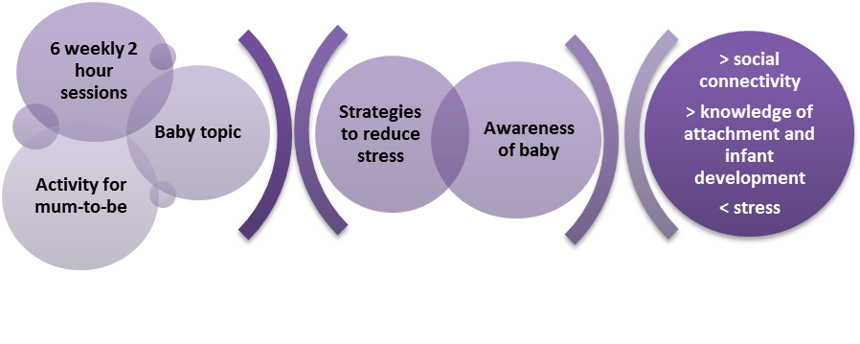

Chill-out in Pregnancy (CHiP)
CHiP is a group-based antenatal support programme underpinned by self-regulatory theory. Like MB, it is designed to be offered between twenty to thirty weeks gestation. The format of CHiP is similar to MB with the same number of sessions and delivery approach but there is no content related to infant mental development or parent-child interaction. Each session incorporates a subject related to maternal wellbeing like those in MB. Like MB, there is an emphasis on practical activities, viewing videos and discussion as well as a guided relaxation session at the end of each week (Figure 2).

Figure 2: Chill-out in Pregnancy

Care-as-usual (CAU)
All participants received care in line with local National Health Service (NHS) guidelines. The package of care depended on an individual woman’s needs. For example, as well as regular midwifery appointments, women might be seen by support workers from addiction services and social work.

METHODOLOGY
Ethics
Informed consent, which included permission to use the information collected, along with anonymous quotes, in research reports and publications, was obtained from participants prior to interview. Information about the study was sent to participants in advance. Personal details about each participant were kept confidentially. Any identifiable personal information in the audio-recordings was removed during transcription. The study was reviewed and approved by NHS West of Scotland Research Ethics Committee (12/WS/0024).

Study Settings
This study took place in NHS Ayrshire & Arran (NHS AA) and in one Community Health Care Partnership (CHCP) of NHS Greater Glasgow & Clyde (NHS GGC). Both NHS health authorities are in the west of Scotland. About 40% of the population of Inverclyde CHCP live in one of the 15% most deprived geographical areas of Scotland (Scottish Index of Multiple Deprivation 2013). In 2012, 766 live births were registered in the CHCP area (National Records Scotland). In NHS AA, approximately 19.8% of the population live in one of the 15% most deprived areas of Scotland (Hooke et al. 2013). In 2012, 3701 live births were registered (National Records Scotland).

Design
Pregnant women, aged 16 years or older, meeting NHS GGC Special Needs in Pregnancy (SNiP; Glasgow Child Protection Committee 2008) criteria and with at least basic understanding of written and spoken English, were approached by community midwives and invited to take part. SNiP protocols are largely based on maternal and family factors which can be detected early in pregnancy. It includes women who have previous or current mental health issues, substance misuse, have had previous children who are in local authority care or are involved in the criminal justice system.
We aimed to run two MB groups, two CHiP groups and two CAU ‘groups’; one of each in each area with eight women in each group (n=48). In order to ensure that there were sufficient women at the right stage of pregnancy to make running a group intervention viable, consenting participants were randomly allocated in blocks of six to either MB, CHiP or CAU. For the final group, randomisation was abandoned to ensure that equal numbers of each of the intervention groups would take place. Participants were offered a £20 shopping voucher at the last data collection point as recompense for time spent in the study.
Outcome Measures
Participants were asked to complete the Adult Wellbeing Scale (AWS; Snaith et al. 1978) and Edinburgh Postnatal Depression Scale (EPDS; Cox et al 1987) at three time points: pre-intervention (baseline), post-intervention and 8-12 weeks post-birth. The questionnaires were administered face-to-face in the participants’ home.
The AWS generates scores in four domains: depression, anxiety, outward-directed irritability and inward-directed irritability. The dimensions have different cut-off scores that indicates a possible problem in that area (Table 1). The EPDS generates a single score. The cut-off points that indicate that a woman may have depression are detailed in Table 1.
Table 1: Cut-off scores
Domain | Normal score | Borderline score | Probable problem score
EPDS | 0-9 | 10-12 | 13-30
AWS depression | 0-3 | 4-6 | 7-15
AWS anxiety | 0-5 | 6-8 | 9-15
AWS outward-directed irritability | 0-4 | 5-7 | 8-12
AWS inward-directed irritability | 0-3 | 4-6 | 7-12

Analyses were conducted using SPSS version 19 for Windows. Descriptive statistics were used to describe scores at baseline by study group, and Pearson’s Chi squared tests or independent samples t-tests to determine whether groups differed on these scores. Differences between post-intervention scores, accounting for the effect of pre-intervention scores, were measured using analysis of covariance (ANCOVA).
At each data collection point, participants were also asked to provide saliva samples, by drooling or spitting into provided receptacles, for cortisol assays. Samples were to be collected on three occasions (on waking, 45 minutes later and last thing at night) each day repeated on two days.
At 8-12 weeks post-birth, participants were invited to take part in a semi-structured interview to talk about their experiences as well as be filmed while they cared for their baby. Interviews were audio-recorded and transcribed verbatim. The videos were examined using the Mellow Parenting Observation System (Puckering et al. 2014)

RESULTS
Sample
Thirty-five women were recruited to the project. Of 31 participants who completed the questionnaires at baseline, 21 (68%) completed the information at all three time points. Of the remainder two participants completed baseline and post-intervention questionnaires and two completed baseline and 8-12 weeks post-birth measures (see Figure 3).

Figure 3: Participant flow diagram.

Demographics
Table 2 summarises the demographic characteristics of the sample. The majority of participants had mental health issues (48%, n=17) or there were child protection concerns (23%, n=8). Six (24%) had children who were in local authority care. Many, however, had complex issues. For example, one had previous child protection concerns as well as a history of substance misuse and involvement with the criminal justice system. There were no statistically significant differences between the groups at baseline (p≤0.05).

Table 2: Characteristics of sample
 | MB | CHiP | CAU
 | %(n) | %(n) | %(n) | p-value for chi-square (X²)
Age groups
19 years or less | 10 (1) | 11.1 (1) | 8.3 (1) | p=0.74
20-24 years | 40 (4) | 33.3 (3) | 33.3 (4)
25-29 years | 30 (3) | 11.1 (1) | 16.7 (2)
30-34 years | 20 (2) | 11.1 (1) | 8.3 (1)
35-39 years | 0 | 11.1 (1) | 25 (3)
40+ years | 0 | 22.2 (2) | 8.3 (1)
First time parent
 | 40 (4) | 22.2 (2) | 16.7 (2) | p=0.44
Previous child in local authority or kinship care
 | 33.3 (2) | 42.9 (3) | 0 | p=0.08
SIMD Quintile
1 (most deprived) | 80 (8) | 55.6 (5) | 58.3 (7) | p=0.73
2 | 10 (1) | 33.3 (3) | 33.3 (4)
3 | - | - | -
4 | 10 (1) | 11.1 (1) | 8.3 (1)
5 (least deprived) | - | - | -
Primary SNiP criteria
Mental health issue | 50 (5) | 44.4 (4) | 58.3 (7) | p=0.55
Child protection concerns | 20 (2) | 33.3 (3) | 16.7 (2)
Criminal justice involvement (self or partner) | 10 (1) | 11.1 (1) | 8.3 (1)
Substance misuse | 20 (2) | - | -
Care leaver | - | 11.1 (1) | -
Domestic abuse | - | - | 8.3 (1)
Young person with complex needs | - | - | 8.3 (1)
TOTAL number | 10 | 9 | 12

Questionnaires
Figure 4 illustrates the proportion of women who had scores in the ‘probable problem’ range of each outcome measure. At baseline, 14 participants (45.2%) had a score on the EPDS that indicated there was likely depression. A similar number (n=13, 41.9%) had depression scores which were in the borderline category. Two women (6.5%) had high scores for outwardly-directed irritability of AWS. No participants had high scores in the inward-directed irritability dimension of AWS. An independent samples t-test revealed no statistically significant differences in the baseline measures between the allocation groups (p≤0.05).
Figure 4: Baseline measure likely problems
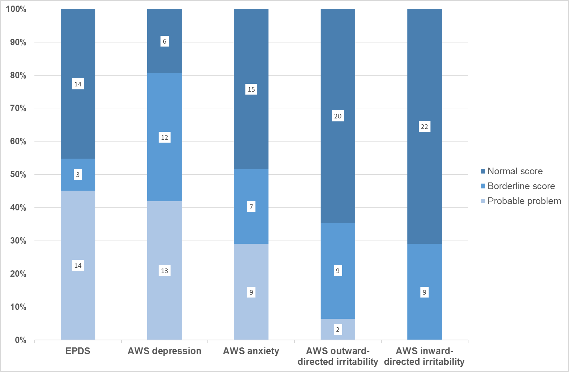
Change over time:
The changes in EPDS and AWS scores by group allocation between baseline and the two follow-up data collection points are illustrated in Figure 5. In these charts the thick line across the box is the median of the scores, for the different groups, at each data collection point. Each box represents the limits within which 50% of the scores fall. The lines above and below each box show the 25% highest and lowest scores respectively. The dots represent individual scores that were outside these parameters.
There seemed to be a trend towards improvement in all outcome measures in all groups over time. Participants in the intervention groups appeared to show improvements in the EPDS and some of the AWS subscale scores that were not replicated in the CAU group. Nevertheless, no statistically significant differences (p≤0.05) between the groups were found.
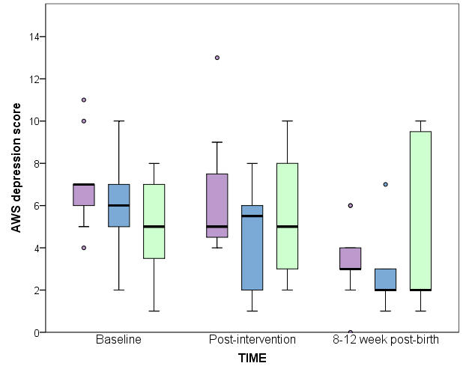
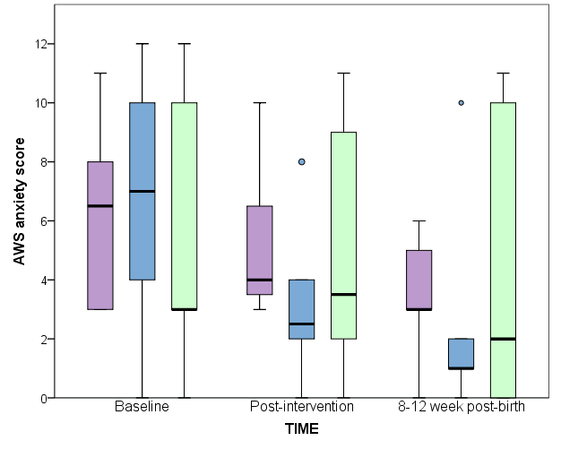
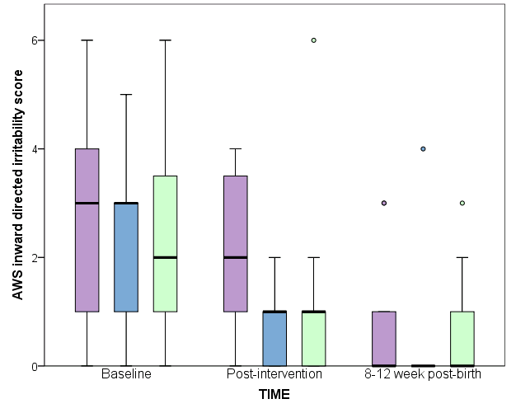
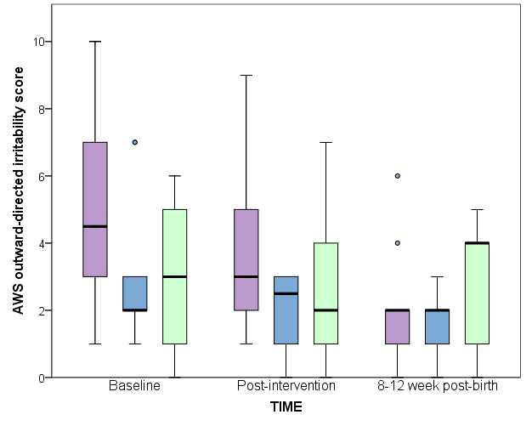
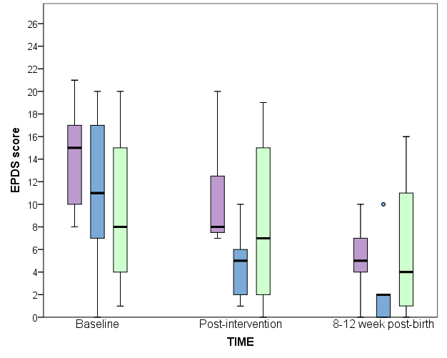
Figure 5: EPDS and AWS scores by group allocation at baseline, post-intervention and 8-12 weeks post-birth
CHiP
CAU
MB

Cortisol Assays
The saliva samples were unpopular with participants:
“spittin’ in the bottles, oh, that was horrible…it was disgusting” (PID 106, CAU).
As a consequence, small sample numbers were received; it was not possible to analyse any potential differences between the groups.
Mother-baby video
Eighteen participants (58%) agreed to the researcher filming them whilst they cared for their baby. No statistically significant differences were found between the groups.
Qualitative Feedback
Twenty-two participants (71%) agreed to talk about their experiences in a semi-structured interview. The following provides examples of the feedback from those who took part in an intervention group; some have been anglicised (original text, where appropriate, is at end of paper).
Both MB and CHiP were popular with those that attended. It seemed to be a place that participants felt very comfortable and relaxed. Being able to meet other pregnant women in a non-judgemental environment was valued,
“(I was worried that) all those were going to judge me because I’m tagged and I’m pregnant and when I got there (Mellow Bumps), it was like we’re all pretty much in the same boat”(PID 113, MB)

“the CHiPs (sic) group was fantastic…(I felt) that I wasn’t the only person that was going through this…it makes you feel normal, instead of the outcast” (PID 123, CHiP).
Even though some of the participants were experienced parents, they seemed to develop coping strategies as well as understandings of early infant development from the activities,
“I do it differently from what I what I did with the rest of them…we were watching the DVD and it was about…talking to your child…about the brain cells…I spend more time talking to him (this baby)…I always imagine, when I’m talking to him, these small extra brain cells”(PID 107, MB).

The relaxation sessions were particularly popular. Several participants spoke about using the techniques that they had learned after the group had finished,
“I panic a lot…(I noticed that) when he’s being sick, pooing and peeing and scratching his face all at the same time, I was just singing away to him, changing his bum…I was like ‘why am I not panicking?’ and I realised half way through, I was breathing (the way I was taught)!” (PID 123, CHiP).
Perhaps as a reflection of their enjoyment of the groups, several participants said that they thought the programmes were not long enough,
“I didn’t think it (Mellow Bumps) was long enough…’cause I remember saying’ to (another group member), ‘that was just like pure crap, I was actually enjoying that’ and (she) was like, ‘I was just getting into it and it finished’” (PID 107, MB).

DISCUSSION
This study is the first attempt, to our knowledge, to assess the efficacy of a primarily antenatal intervention with this traditionally hard-to-reach population. Even though the size of the sample means that the results should be interpreted with caution, this study suggests that these group programmes may have helped women facing social adversity and their infants. Feedback from those that took part in the groups was positive suggesting that the format of the programmes was acceptable to this population.
Further research with a larger sample size is needed to confirm or refute the preliminary findings and to examine the impact of the interventions in the longer term. The small sample numbers and relative short-term follow-up in our study meant it was not possible to detect any differences between the two interventions. The potential additional benefit of MB’s focus on the mother-infant relationship over and above the focus on maternal well-being common to both interventions warrants further exploration.
Limitations
The findings of this project should be considered in the light of the following limitations. Firstly, the study was limited to participants living in two areas in west Scotland. It is possible that the working practices of community midwives may have differed from other settings. Secondly, all the participants were actively engaged with health services when they were recruited to the study. It was not possible to identify individuals who were reluctant to engage with midwives. Also, we cannot exclude the possibility that those participants approached were those thought by midwives to be most likely to take part in the group programmes. Lastly, it is possible that participants answered the questionnaires in a way that they felt would be received positively by either the researchers or health and social service professionals.

CONCLUSION
Intervening in the antenatal period may improve outcomes for pregnant women with additional health and social care needs and their infants and be more cost-effective than intervening later (Dennis & Hodnett 2007). The results suggest that psycho-educational antenatal interventions may benefit pregnant women with significant psychosocial needs. Further research is needed.
REFERENCES
Barlow, J., Jarrett, P., Mockford, C., Mcintosh, E., Davis, H. And Stewart-Brown, S., 2007. Role of health visiting in improving parenting and health in families at risk of abuse and neglect: results of a multicentre randomised controlled trial and economic evaluation. Archives of Disease in Childhood, vol. 92, no. 3, pp. 229-233.
Barnes, J., Ball, M., Meadows, P., Howden, B., Jackson, A., Henderson, J. and Niven, L., 2011. The family-nurse partnership programme in England: Wave 1 implementation in toddlerhood and a comparison between waves 1 and 2a implementation in pregnancy and infancy. London: Department of Health.
Birtwell, B., Hammond, L. and Puckering, C., 2013. 'Me and my Bump': an interpretative phenomenological analysis of the experiences of pregnancy for vulnerable women. Clinical Child Psychology and Psychiatry, vol. Printed online before print; October 23 2013.
Breustedt, S. and Puckering, C., 2013. A qualitative evaluation of women's experiences of the Mellow Bumps antenatal intervention. British Journal of Midwifery, vol. 21, pp. 187-194; 187.
Cox, J.L., Holden, J.M. and Sagovsky, R., 1987. Detection of postnatal depression: development of the 10-item Edinburgh Postnatal Depression Scale. British Journal of Psychiatry, vol. 150, pp. 782-786; 782.
Dennis, C.L. and Hodnett, E., 2007. Psychosocial and psychological interventions for treating postpartum depression. . Cochrane Database of Systematic Reviews, vol. 4.
Doyle, O., Harmon, C.P., Heckman, J.J. and Tremblay, R.E., 2009. Investing in early human development: timing and economic efficiency. Economics & Human Biology, Mar, vol. 7, no. 1, pp. 1-6
Fontein-Kuipers, Y.J., Nieuwenhuijze, M.J., Ausems, M., Bude, L. and De Vries, R., 2014. Antenatal interventions to reduce maternal distress: a systematic review and meta-analysis of randomised trials. BJOG, vol. 121, pp. 389-397.
Hooke, A., Inglise, J., Shannon, S., Forsyth, R. and Campbell, R., 2013. Ayrshire Healthy Weight Strategy. Volume II: Fact file.
Law, J., Rush, R., Schoon, I. and Parson, S., 2009. Modelling developmental language difficulties from school entry into adulthood: literacy, mental health, and employment outcomes. Journal of Speech, Language, and Hearing Research, vol. 52, pp. 1401-1416.
Mabelis, J., Marryat, L., 2011 Growing up in Scotland: Parental service use and informal networks in the early years. Edinburgh: The Scottish Government.
Mäntymaa, M., Puura, K., Luoma, I., Salmelin, R.K. and Tamminen, T., 2004. Early mother–infant interaction, parental mental health and symptoms of behavioral and emotional problems in toddlers. Infant Behavior and Development, vol. 27, no. 2, pp. 134-149.
National Records of Scotland. Vital Events Reference Tables 2012: Estimated population, births, stillbirths, deaths, marriages and civil partnerships, numbers and rates, by administrative area, Scotland, 2012. Online: http://www.nrscotland.gov.uk/files/statistics/ve-ref-tables-2012/ve-12-t1.3.pdf Accessed 17 April 2015
O'Connor, T.G., Heron, J., Golding, J., Beveridge, M. and Glover, V., 2002. Maternal antenatal anxiety and children's behavioural/emotional problems at 4 years. Report from the Avon Longitudinal Study of Parents and Children. British Journal of Psychiatry, vol. 180, pp. 502-508.
Olivier, J.D.A., Åkerud, H. And Sundström P.I., 2015. Antenatal depression and antidepressants during pregnancy: Unravelling the complex interactions for the offspring. European Journal of Pharmacology, vol. 753, pp. 257-262
Pawlby, S., Hay, D., Sharp, D., Waters, C.S. and Pariante, C.M., 2011. Antenatal depression and offspring psychopathology: the influence of childhood maltreatment. British Journal of Psychiatry, vol. 199; 112, pp. 106-106.
Pearson, R.M., Heron, J., Melotti, R., Joinson, C., Ramchandani, P., Stein, A. and et al, 2011. The association between observed non-verbal maternal responses at 12 months and later infant development at 18 months and IQ at 4 years : A longitudinal study. Infant Behavior and Development, vol. 34, no. 4, pp. 252-533.
Puckering, C., Alley, C.S., Doolin, O., Purves, D., McConnachie, A., Johnson, P.C.D., Marwick, H., Heron, J., Golding, G., Gillberg, C. and Wilson, P., 2014. Association between parent-infant interactions in infancy and disrupted behaviour disorders at age seven: a nested, case-control ALSPAC study. BMC Pediatrics, vol. 14, pp. 223-230.
Scottish Index of Multiple Deprivation, 2013. Local Authority Summary - SIMD 2012. Inverclyde.
Snaith, R.P., Constantopoulos, A.A., Jardine, M.Y. and McGuffin, P., 1978. A clinical scale for the self-assessment of irritability. British Journal of Psychiatry, vol. 132, pp. 167-171; 164.
Sylvestre, A. and Mérette, C., 2010. Language delay in severely neglected children: A cumulative or specific effect of risk factors? Child Abuse & Neglect, vol. 34, no. 6, pp. 414-428.
The Marmot Review 2010: Fair Society, Healthy Lives. The Strategic Review of Health Inequalities in England post 2010. London: The Marmot Review.

LIST OF ABBREVIATIONS
AWS - Adult Wellbeing Scale
CAU – Care-as-Usual
CHCP - Community Health Care Partnership
CHiP– Chill-out In Pregnancy
EPDS – Edinburgh Postnatal Depression Score
FNP – Family Nurse Partnership
MB – Mellow Bumps
NHS – National Health Service
NHS AA – NHS Ayrshire & Arran
NHS GGC – NHS Greater Glasgow & Clyde
SNiP - Special Needs in Pregnancy

COMPETING INTERESTS
We have the following relationships with the Mellow Parenting (MP) organisation:
- CP is co-author of MB and CHiP programmes. She is co-founder of the MP organisation. She is programme director and consultant trainer for MP programmes.
- AMacB was supervised by CP during clinical psychology doctoral training. This incorporated a placement with the MP organisation. This was not funded by MP. He has been trained in the MP intervention and has co-facilitated a MP group.
- PW and LT have worked as employees in the University of Glasgow Department of Child and Adolescent Psychiatry alongside CP.
- PW, AMacB and LT have received research grants from the Scottish Collaboration for Public Health Research and Policy and from the Yorkhill Infant Mental Health Endowment Fund to conduct research on the MB and Mellow Babies programme respectively.
- PW and MH presented at a MP conference and had overnight accommodation and catering provided.
- HW was employed by MP at the time of the project.
- MP provided, without charge to the project, the training for the group facilitators and some of the group resources.

AUTHORS' CONTRIBUTIONS
All the authors have contributed to and approved the final draft of this paper.
Dr Jane White was the research assistant employed by the University of Glasgow on this project (funded by the Scottish Collaboration forPublic Health Research and Policygrant SCPH/13). She was responsible for all aspects of the fieldwork – from recruitment, obtaining consent and administering the outcome measures at the different time points. She led on the analysis of the collected information, final report writing and the writing of this paper.
Dr Lucy Thompson contributed to the design and management of this study. She provided supervision and support to Jane on a day-to-day basis. She contributed to the research steering group which met regularly throughout the project. She contributed to early drafts of this paper.
Dr Christine Puckering is co-author of the Mellow Bumps and Chill-out in Pregnancy programme. She provided supervision to the Mellow Bumps facilitators. She contributed to the design and strategic management of this study as well as the regular steering group meetings. She coded the videos blinded to group membership.
Ms Harriet Waugh is co-author of theChill-out in Pregnancy programme which she developed while employed by Mellow Parenting. She contributed to the research steering group.
Dr. Marion Hendersoncontributed to the design and strategic management of this study.She contributed to the research steering group and fed into the drafting of this paper. As Jane’s line manager after the funding of the project ended, she supported the study by facilitating the completion of data collection and report writing.
Dr. Angus MacBeth contributed to the design and strategic management of this study. He contributed to the research steering group.
Prof. Phil. Wilson was the principal investigator for this project. He contributed to the design and management of this study.

FUNDING
This study was funded by the Scottish Collaboration for Public Health Research and Policy (grant SCPH/13; 1 Jan. 2012-31 March 2013; £ 74 775) and the MRC/CSO Social and Public Health Sciences Unit, University of Glasgow (£5000, one-off contribution towards costs of cortisol assays).

ACKNOWLEDGEMENTS
This project would not have been possible without the help and support of numerous people. We would like to thank:
• The women who have agreed to take part.
• Elaine Moore, Anne Clarke, Karen Bell, Mary Garven, Marion Dodd, Beth Donnelly, Alison Barr, Jean Reid, and the community midwives who have helped to recruit participants, NHS Ayrshire & Arran.
• Anne Jamieson, Catriona McLean, Morag McPhail, Rose Sloan, Joanne McGarry, Karen Smith, Halina McIntyre, NHS Greater Glasgow & Clyde.
• Rosemary Mackenzie, Harriet Waugh and the Mellow Parenting team who trained the group facilitators, developed the Chill-out in Pregnancy programme for this study and have provided on-going support.
- Dr. ManjuHaridas who provided supervision to the Chill-out in Pregnancy group facilitators
• Leona Cunningham, Mellow Parenting, who helped with the analysis of the qualitative feedback
• Elsa Ekevall and Kim Jones, University of Glasgow.
• Caoimhe Clarke, Catherine Nixon, Shona Shinwell, MRC/CSO SPHSU, University of Glasgow
- Dr. Clare Allely who helped draft this manuscript
• The Scottish Collaboration for Public Health Research and Policy who provided the majority of the funding.
- The MRC/CSO Social and Public Health Sciences Unit, University of Glasgow who provided funding for the cortisol assays
- The Scottish Mental Health Research Network who provided research assistant support to help transcribe the qualitative interview

Released from prison into the community on licence wearing an electronic tag (Home Detention Curfew)
“(I was worried that) aw those were gonna judge me because I’m tagged and I’m pregnant an’ when I got there (Mellow Bumps), it was like we’re all pretty much in the same boat”
“I dae it differently frae what I what I did wi’ the rest of thaim…we were watching the DVD and it was aboot… talking to your child and all that, aboot the brain cells and all that… I spend mair time talking to him (this baby)…I always imagine, when I’m talking to him, these wee extra brain cells”
A slang word for something considered to be of poor standard

