Drug Transporter Gene Expression in Human Colorectal Tissue and Cell Lines: Modulation with Antiretrovirals for Microbicide Optimization

Authors: Indrani Mukhopadhya¹, Graeme I Murray², Susan Berry¹, John Thomson³, Bruce Frank⁴, Garry Gwozdz⁴, Julia Ekeruche-Makinde⁵, Robin Shattock⁵, Charles Kelly⁶, Francesco Iannelli⁷, Gianni Pozzi⁷, Emad M El-Omar¹, Georgina L Hold¹ and Karolin Hijazi¹*

Address: ¹School of Medicine & Dentistry, University of Aberdeen, Aberdeen, UK, ²Pathology, Division of Applied Medicine, University of Aberdeen, Aberdeen, UK, ³Department of Gastroenterology, Aberdeen Royal Infirmary, Aberdeen, UK, ⁴Particle Sciences Inc., Bethlehem, PA, USA, ⁵Mucosal Infection & Immunity Group, Section of Infectious Diseases, Imperial College, London, United Kingdom, ⁶Dental Institute, King’s College London, London, UK, ⁷Laboratory of Molecular Microbiology and Biotechnology, Department of Medical Biotechnologies, University of Siena, Siena, Italy.

* Corresponding author. Tel: +44 (0) 1224-555153, e-mail address k.hijazi@abdn.ac.uk

Running Title: Drug transporters for antiretroviral drugs in human colorectal tissue.

Key Words: Drug transport, gene expression, colon, Caco-2 cells, antiretroviral

SYNOPSIS
Objectives To comprehensively assess mRNA expression of 84 drug transporters in human colorectal biopsies and 6 representative cell lines. To investigate the alteration of drug transporter gene expression after exposure to three candidate microbicidal ARV drugs, (tenofovir, darunavir and dapivirine) in Caco-2 cells. The outcome of the objectives informs development of optimal antiretroviral (ARV)-based microbicidal formulations for prevention of HIV-1 infection.
Methods Drug transporter mRNA expression was quantified from colorectal biopsies and cell-lines by quantitative real-time PCR. Relative mRNA expression was quantified in Caco-2 cells after induction with ARVs. Data was analysed using Pearson’s correlation coefficients (r), hierarchical clustering and principal component analysis (PCA).
Results Expression of 58 of the 84 transporters was documented in colorectal biopsies, with CNT2, P-gp and MRP3 being the highest expressed. No difference was noted between individual subjects, when analysed by age, gender or biopsy site (rectum or recto-sigmoid) (r=0.95-0.99). High expression of P-gp and CNT2 proteins was confirmed by immunohistochemical staining. Similarity between colorectal tissue and cell-line drug transporter gene expression was variable (r = 0.64-0.84). PCA showed distinct clustering of human colorectal biopsy samples with the Caco-2 cells defined as the best surrogate system. Induction of Caco-2 cell-lines with ARV drugs suggests that darunavir-based microbicides incorporating tenofovir may result in drug-drug interactions likely to affect distribution of individual drugs to sub-epithelial target cells.
Conclusions These findings will help optimise complex formulations of rectal microbicides to realise their full potential as an effective approach for pre-exposure prophylaxis against HIV-1 infection.

INTRODUCTION
The Human immunodeficiency virus-1 (HIV-1) pandemic is in its third decade and current strategies to prevent acquisition and dissemination of this infection are focused on oral antiretroviral (ARV) drugs as pre-exposure prophylaxis.¹ ARV based vaginal microbicides on the other hand have shown variable efficacy levels in randomized controlled trials, with adherence being the critical factor for determining their efficacy.²⁻⁵ There is also a definite clinical need in modulating microbicides to prevent HIV-1 infection via the anorectal route, which has around 20 times higher transmission risk per exposure compared to the vaginal route.^{6, 7} In addition to exploiting breaches within the epithelial barrier and potential interaction with intraepithelial migrating cells – the main mechanisms implicated in HIV-1 transmission across the vaginal mucosal barrier – HIV-1 can cross the rectal epithelium by transcytosis through epithelial cells⁸ and M cells⁹, and opening of tight junctions.¹⁰⁻¹² The efficacy of rectal microbicides has been assessed in non-human primate models and in ex-vivo colonic explant culture systems.^{8, 9, 13, 14} This preclinical evaluation of potential microbicides in these models is essential as the pharmacokinetics of ARV drugs, more specifically Dapivirine, has been shown to be dissimilar in colonic and vaginal tissues of human volunteers, which was postulated to be due to differences in the local expression of the cytochrome P450 enzymes.¹⁵

The pharmacokinetics of topically administered ARV drugs in the colon is likely dependant not only on their metabolism by the cytochrome P450 enzyme system but by the expression of drug transporters in the colorectal epithelium.^{16, 17} The expression of drug transporters may play a central role in not only determining the mucosal concentration of ARV microbicidal drugs being used as a combination but also contributing to the complex drug-drug interactions between the constitutive drugs.¹⁸ The major efflux transporters are the ATP Binding Cassette (ABC) transporters whilst the Solute Carrier (SLC) and Solute Carrier Anion (SLCO) transporters are largely responsible for uptake of drugs. Understanding of the interplay between different ARV drugs and drug transporters expressed in the colorectal epithelium will help design effective microbicide combinations. This in turn will finally determine the extent of mucosal disposition and active concentration of the ARV drugs in the CD4+ T cells which are the primary targets and reservoirs of HIV-1 infection.¹⁹ The analyses of selective subsets of drug transporters in the colon have documented high expression of MRP3, P-glycoprotein (P-gp), MCT1 and BCRP.²⁰⁻²² The interaction of various classes of ARV drugs with these and other important drug transporters have been well documented in the small intestine, liver and kidney but not in the colorectal epithelium.¹⁸ Three ARV drugs which are currently being tested as potential microbicides include tenofovir, darunavir, and dapivirine.²³ However, most of the studies utilise these drugs in formulations for vaginal application and it is critical that their safety and efficacy as rectal microbicides is assessed separately.

The physiological expression of colorectal drug transporters has been largely interpreted from surgical resection specimens as well as diagnostic endoscopic biopsies.^{20, 24} Understanding of the xenobiotic pathways undertaken by ARV drugs and their interaction with drug transporters requires a robust in vitro experimental model. Colorectal primary cell cultures have been used for this purpose but are affected by rapid loss of differentiation of the cells which does not permit longer induction studies with ARV drugs.^{25, 26} As a result, most of our knowledge is based on information from colorectal cell lines.^{27, 28} However, mRNA expression of drug transporters in these organotypic cell lines does not correlate with that observed in human colonic tissue.^{20, 22} Human colorectal explant-based models currently used to pre-clinically evaluate the antiviral activity of candidate microbicides may be a suitable model for evaluating ARV interactions with drug transporters, although this may be limited by short-term viability.^{9, 13, 14}

The pharmacokinetics of ARVs as topical microbicidal agents in the colorectal epithelium has not been fully elucidated. There have been several studies which have looked at a subset of both ABC and SLC transporters in the colon compared with other organs and organotypic cell lines, but the changes of gene expression on exposure to ARV’s have not been documented.²⁰⁻²² The aim of the current study was to provide a comprehensive characterisation of the physiological expression of 84 drug transporter genes in the colorectal epithelium. This was coupled with induction studies of a surrogate colorectal cell line to outline the functional consequences of ARV exposure on drug transporter gene expression.

MATERIALS AND METHODS
Tissue samples
Human colorectal biopsies were obtained from healthy subjects undergoing colonoscopy at Aberdeen Royal Infirmary (UK) as part of the Scottish Colorectal Cancer Screening Program. Ethical approval for this study was obtained by the North of Scotland Research Ethics Service, UK (reference numbers 09/SO802/106 and 12/NS/0061). Subjects were recruited to the study after obtaining written informed consent according to the World Health Organisation guidelines for good clinical practice (GCP) and the local Research Ethics Committee policies. Biopsy samples were collected from subjects whose colonoscopy was found to be normal. The drug list of the participants was scrutinised prior to their inclusion into the study. Subjects were excluded if they had received systemic antibiotics or steroids in the three months prior to their colonoscopy or had been on any immunosuppressive drugs at any time. Subjects were also excluded if they had any major co-morbidity. The subjects recruited were all healthy and the majority (62%) were on no concomitant medications for the last three months. The rest 38% were on routine anti-hypertensives, statins, paracetamol or aspirin, which is expected in the study cohort chosen. Paired samples from two standard anatomical sites, rectum and recto-sigmoid, were collected and four mucosal punch biopsies were obtained from each site. Biopsies were removed from forceps and placed in sterile 1.5mL tubes, immediately snap-frozen in liquid nitrogen and were subsequently stored at -80°C until RNA extraction. Colorectal biopsies for drug stimulation studies were collected from healthy subjects and specimens were immediately placed in DMEM (Sigma, Dorset, UK) containing 10% heat-inactivated FCS (HyClone Laboratories, Utah, USA), 2% L-glutamine (Sigma) and antibiotics (100U penicillin, 100 µg of streptomycin, and 50 µg of gentamicin/mL, Sigma). For immunohistochemical studies normal colorectal biopsies were obtained from the NHS Grampian Biorepository (ethics reference number 11/NS/0015; tissue bank request number TR000005).

Cell lines and culture methods
Human colorectal (Caco-2 and HT-29) and rectal (SW1463) adenocarcinoma cell lines were purchased from Health Protection Agency culture collections (HPA, Salisbury, UK). Caco-2 cells were maintained in Eagle's Minimum Essential Medium (EMEM) (Sigma) containing 10% FCS, 1% nonessential amino acids (Sigma), and 2% L-glutamine. Cells were seeded at a density of 1 × 10⁶ cells/ well on 12 mm Transwell® Permeable Supports with 0.4µm pore polycarbonate membrane insert and 1.12 cm² growth areas (Corning Costar, Cambridge, MA, USA). Membrane filters were placed in a 12 mm well with 1.5 and 0.5 mL of culture medium in the baso-lateral and apical compartments, respectively. The medium for the Transwell® plates was supplemented with 0.1% gentamicin. Cells were cultivated over 21 days at 37°C in an atmosphere of 5% CO₂. Medium was changed from both the compartments every second day. Transepithelial Electric Resistance (TEER) was measured using EVOM² epithelial voltohmmeter and STX2 electrodes (World Precision Instruments, Hertfordshire, UK) and TEER values of approximately 2000 ohms/cm² after 21 days were accepted as an indication of an intact monolayer. HT-29 cells were cultured in McCoys 5A modified medium (Sigma), supplemented with 10% FCS and 2% L-glutamine and incubated at 37°C with 5% CO₂. HT-29 cells were routinely sub-cultured by trypsinization using trypsin (0.05%)-EDTA (0.02%) solution (Sigma), and were seeded at a density of 2 × 10⁶ cells per 75-cm² flask. SW1463 cells were grown in L15 medium (Sigma) with 10% FCS and 2% L-glutamine and incubated at 37°C atmospheric air with no CO₂.

Anti-retroviral compounds
Tenofovir was provided by Gilead Science (Foster City, CA, USA). Darunavir was provided by Janssen R&D Ireland (Cork, Ireland). Dapivirine was purchased from Selleckchem (Suffolk, UK). Stock solutions of dapivirine and darunavir were dissolved in DMSO (Sigma) and tenofovir was dissolved in sterile PBS. The maximum DMSO concentration in the induction assays never exceeded 1% (v/v).

For preparation of darunavir-based dissolving films micronized darunavir (0.57 %) was added to a mixture of tween 80 (0.55%, Spectrum Chemical) and water (91.499 %, Ricca) and homogenized for 10 minutes using a probe homogenizer. PEO-10 (1.10 %, Dow) and PEO WSR301 (0.055 %, Dow) were added and mixed for 30 minutes. PEG 1000 (0.916 %, EMS) was then added and mixed for another 30 minutes using a mechanical stirrer. Once homogeneous, HPMC E50 (5.310 %, Ashland Chemical) was added to the above dispersion and stirred by mechanical mixer for an additional 120 minutes, followed by bath sonication of the dispersion for 30 minutes to remove any entrained air. The dispersion was coated onto release paper at slow speed using a Coatema Easycoater, set for 1400 µm wet thickness, and then dried at 37°C. For preparation of tenofovir-based dissolving films, tenofovir (1.89 %) was added to a mixture of glycerin (3.33 %, Fisher) and water (53.37%, Ricca) and homogenized for 2 minutes using a probe homogenizer. NaOH at 1 M (6.50 %, Fisher) was added until tenofovir was completely dissolved. A premixed solution of propyl paraben (0.01 %, Spectrum)/PECOL (0.83 %, Gattefosse) and alcohol (28.07 %, Spectrum) was added to the tenofovir solution; this solution was covered to minimize evaporation. PEO 205 (1.00 %, Dow) was added to the above final solution and mixed using a mechanical stirrer for 10 minutes. Once dissolved, Benecel E50 (5.00 %, Ashland) was added and mixed for another 60 minutes, followed by bath sonication of the dispersion for 30 minutes to remove any entrained air. The dispersion was coated onto release paper at slow speed using a Coatema Easycoater set for 1400 µm wet thickness, and then dried at 37°C.

Cytotoxicity assays
Alamar Blue® cell viability assay (Life Technologies, Paisley, UK) was used to determine the tolerability of Caco-2 cells to the three drugs and DMSO vehicle. Caco-2 cells were seeded in 96-well plates and allowed to adhere for 48 hours. Medium was replaced with serial dilutions of fresh medium containing dapivirine (0-100µM), darunavir (0-750µM),tenofovir (0-5mM) or DMSO (0-1%). After 24, 72 and 168 hours at 37˚C, 10% alamar Blue® was added to each well. Following 4 hour incubation, fluorescence was monitored at 530 nm excitation wave lengths and 590 nm emission wave lengths on a Synergy™ HT Multi-Detection Microplate Reader (BioTek).

Stimulation of Caco-2 cells with ARV drugs
The uppermost tolerable concentrations of the three drugs which could be solubilised in an appropriate vehicle (10µM dapivirine, 250µM darunavir and 5mM tenofovir) were added to the apical surface of the Caco-2 cell layers separately in different wells. For each experiment an appropriate control well was included (cells with 1% DMSO as control for darunavir and dapivirine stimulation and cells with media alone for tenofovir stimulation). The cells induced with drugs were then incubated in a 37°C incubator with 5% CO₂ for 24-168 hours. Additionally, darunavir, tenofovir and respective placebo dissolving films (1.5 cm²) were subdivided into 6 equal sections using a ruler for accurate measurement and were cut using a sterile scalpel precisely. Individual film sections were then added to the apical surface of the confluent 21 day Caco-2 cell layers in Transwells and incubated at 37°C with 5% CO₂ for 72 hours. After the incubation period cells were harvested from the Transwell® inserts for RNA extraction. All stimulation experiments were done as three biological repeats.

Explant culture
After collection, biopsies were maintained at 4⁰C for transportation to the laboratory and were processed within 1 hour of collection in complete media as described earlier. In the laboratory, biopsies were washed and explant culture was done following methods published previously.¹³ Biopsies were cultured and supported on pre-soaked gel foam rafts (1 cm², 7mm thick; Wellbeck Pharmaceuticals, USA) at the air–media interface in 24-well plates containing 300 µL of media. They were incubated in blank media for 24 hours in a humidified atmosphere with 5% CO₂ and then either snap-frozen in liquid nitrogen for RNA extraction or formalin-fixed for histological examination. For the latter, eight biopsies collected from a single subject were incubated at four different experimental conditions in pairs. One pair of biopsies were immediately formalin fixed on arrival in the lab to act as controls, two biopsy samples were incubated in media alone, two with media containing 1% DMSO vehicle and two pieces with one of the ARVs (10µM DPV) for 24 hr on gel foam rafts. Formalin-fixed tissues were embedded in paraffin, sectioned and stained with haematoxylin and eosin (H&E).

Stimulation of colorectal explants with ARV drugs
From each individual subjects, 2 biopsies were stimulated with 10uM Dapivirine, 2 with 250uM Darunavir, 2 with 5mM Tenofovir and 2 with appropriate controls (media or 1% DMSO). Stimulated explants were cultured in pairs on pre-soaked gel foam rafts and incubated for 24 hr in a humified atmosphere with 5% CO2 and then snap frozen in liquid nitrogen for RNA extraction.

Isolation of RNA and cDNA synthesis
Total RNA was extracted from colorectal biopsies using a combination of the TRIzol reagent (Invitrogen, UK) and the Qiagen Rneasy Micro kit (Qiagen, Manchester, UK) following the manufacturer’s recommendations. RNA was extracted from HT-29 and Caco-2 cell cultures using the Qiagen Rneasy Mini kit (Qiagen) following the manufacturer’s recommendations. DNase treatment was performed on all RNA samples to remove genomic DNA contamination. RNA preparation was quantified using a Nanodrop ND-1000 UV spectrophotometer (Thermo Fisher Scientific, MA, USA). The integrity of the RNA was confirmed for all samples using Agilent 2200 TapeStation system. Complementary DNA (cDNA) was prepared from total RNA by using SuperscriptTM First-Strand Synthesis System for real-time PCR (Life Technologies, Paisley, UK). For rectal adenocarcinoma cell lines SW837, HRA-16 and HRT-18, total RNA was directly purchased from HPA.

Relative mRNA expression analysis
Real Time quantitative PCR was performed on an ABI PRISM 7900HT sequence detection system (Applied Biosystems, Foster City, CA) for the analysis of 84 drug transporter genes and 12 housekeeper genes using TaqMan® Array 96-well Fast plates for Human Drug Transporters (Life Technologies). Quantitative PCR was performed in a final reaction volume of 10µL per gene containing 20ng of RNA converted to cDNA and TaqMan® Gene Expression Master Mix (Life technologies) according to the manufacturer’s instructions. The cycling conditions were: stage 1 (50°C, 2 min); stage 2 (95°C, 10 min); stage 3, 40 times (95°C, 15 s, followed by 60°C, 1 min). For quantifying the effect of formulated ARV films on drug transporter gene expression in Caco-2 cells, Single tube Taqman® gene expression assays were used for a selected subset of drug transporter genes known to be relevant for ARV transport (Pg-p, BCRP, MRP1-5, MRP10, CNT2, ENT2, LAT2, OATPE and OATPD)¹⁸ using the same cDNA concentration and PCR cycling conditions as the arrays. The relative gene expression levels were determined using the comparative CT method (∆∆ CT method). ²⁹ The cut-off CT was set at 35 cycles for all analysis. From the initial panel of twelve housekeeper genes, HPRT1, PGK1 and PPIA were selected as endogenous controls, as determined by SD scores which is an indicator of consistent expression across all samples and is calculated using geometric averaging.³⁰ Human universal reference total RNA (Clontech Laboratories, CA, USA), comprising of a standardized mixture of total RNA from a collection of adult human tissues, was used as calibrator as previously described.²⁷ The mRNA levels of each transporter in this RNA reference was arbitrarily set at the value of 1 unit and data for colorectal tissue and cell lines were expressed in arbitrary units comparatively to the standardised RNA reference. DataAssist® software (Applied Biosystem) was used for analysis of the quantitative PCR data. The relative quantification (RQ) values were expressed as mean and standard deviation. An arbitrary classification system was assigned to the data, designating relative expression levels >2 as high mRNA expression, levels between 2 and 1 as moderate mRNA expression, levels between 1 and 0.1 as low mRNA expression and levels below 0.1 as unexpressed. The variable expression group included genes which were expressed in a proportion of subjects (33% -92% subjects) but not expressed in others with the mean RQ in the group ranging from 0.15 to 1.96. Ranking of the genes were then done according to their mean expression and fold variation.

Immunohistochemistry
Colorectal biopsies taken from the initial cohort of subjects were utilized for gene expression analysis and showed no inter-subject differences. To confirm localization of the predominant drug transporters, biopsies for immunohistochemistry were obtained from new recruits from the same screening list. Formalin-fixed and paraffin-embedded biopsy samples were cut into 4 µm sections and mounted on glass slides. The slides were deparaffinised in xylene and hydrated in graded ethanol series. Heat induced antigen retrieval of epitopes was done by microwaving the slides for 20 minutes fully immersed in citrate buffer (pH 6.0). Slides were then stained with primary antibodies for ABCB1/P-gp, clone JSB-1 (Abcam, Cambridge, UK; 1:40 dilution), SLC29A2/ENT2, clone EPR11674 (Abcam,; 1:200 dilution), SLC289A2/CNT2 (Abcam; 1:40 dilution) and chromogranin A, clone DAK-A3 (Dako; 1:200 dilution) followed by peroxidase conjugated goat anti-rabbit/mouse secondary antibody (Dako EnVision™ FLEX Detection system, Dako, Ely, UK). DAB (3, 3’-diaminobenzidine) was used as the substrate chromogen. Staining was performed using the DAKO AutoStainer (Dako) as previously published.³¹ Slides were washed in water and counter stained with haematoxylin. Normal human liver sample was used as a positive control for P-gp, ENT2 and CNT2 whereas normal human pancreas sample was used as positive control for chromogranin A. For negative control, the primary monoclonal antibody was omitted from the immunohistochemical procedure and replaced with antibody diluent.

Statistical analysis
Pearson’s product moment correlation (r) was used to look for differences of gene expression using ∆CT values amongst groups and correlation was observed at the significance level p = 0.05. Hierarchical clustering was done for all genes using Pearson’s correlation. Principal component analysis (PCA) was performed to elucidate differences between colorectal biopsy samples and various cell lines using using normalized expression levels (∆CT).²¹ Scatter plot was generated using principal component 1 and 2. All mRNA expression data are presented as means ± standard deviation and Independent (unpaired) samples t test was used to demonstrate differences of mRNA expression. The unpaired samples t-test was used as the mRNA expression data were collected from two independent and identically distributed sets of samples, one from each of the two populations being compared. Statistical analysis was performed using SPSS 21 (IBM Corp; Armonk, NY) software.

RESULTS
Demographic characteristics of subjects
A total of twenty-six healthy subjects were recruited for this study. Biopsy samples from twelve healthy subjects (EU3 to EU10, EU12, EU13, EU14 and EU16), of whom six were male and six female, were used to study the drug transport gene mRNA expression in normal colorectal tissue. The mean age was 58.6 ± 7.4 years (range 50-70 years). Biopsies from seven more subjects were obtained from the NHS Grampian biorepository to study protein expression of highly expressed colorectal drug transporters (EU42 to EU47 and EU49, mean age 57.9 ± 8.4 years, six male and one female). Seven further subjects (EU24, EU25, EU48, EU54, EU55, EU56 and EU60, mean age 64.6± 3.5 years, 3 male and 4 female) were recruited for tissue explant culture. One pair of biopsies from EU24, EU25, EU48 and EU54 were used for baseline drug transporter gene expression assessment after 24 hours explant culture in medium alone, biopsies from EU54, EU55 and EU60 were used for ARV stimulation studies of explants and EU56 was used for H&E staining.

Drug transporter gene expression in colorectal biopsies
Out of the 84 drug transporter genes analysed 52 were expressed, 26 were not expressed and 6 had variable mRNA expression in colorectal tissue. SLC28A2/CNT2 was the most expressed uptake transporter in this study (RQ 25.8 ± 21.6) followed by efflux transporters ABCB1/P-gp (RQ 4.8± 2.7) and ABCC3/MRP3 (RQ 3.9 ± 1.6). The rank order of the highest expressed efflux and uptake drug transporters in colorectal tissue were ABCB1/P-gp > ABCC3/MRP3 > ABCG2/BCRP > ABCD3 (RQ 4.8± 2.7, 3.9±1.6, 2.5± 1.3 and 2.3 ± 0.6 respectively) and SLC28A2/CNT2 > SLC16A1/MCT1 > SLC29A2/ENT2 > SLC28A3/CNT3 (RQ 25.8 ± 21.6, 2.8± 2.5, 2.4± 0.8 and 2.3± 1.5 respectively) (Tables 1 and 2, Supplementary Table 1). There was no mRNA expression documented for the important efflux transporter ABCC2/MRP2, uptake transporters SLC22A1-3 (OCT1-3) and kidney specific SLC22A6-8 (OAT1-3) drug transporters. The mean and standard deviation of RQ values of all the 84 drug transporters are enumerated in Supplementary Table 1. The differences between gene expressions of these 84 genes were compared between the individual subjects and assessed with respect to gender and site of biopsy. No significant difference was noted in mRNA expression of the drug transporter genes between individual subjects (r = 0.98-0.83, p<0.0001), when stratified according to sex (r = 0.98-0.95, p<0.0001) or by colorectal biopsy sites (rectum and recto-sigmoid; r = 0.99-0.96, p<0.0001).

Drug transporter protein expression in colorectal biopsies
Immunohistochemical staining was performed on colorectal biopsy samples from seven subjects for the ABCB1/P-gp, SLC28A2/CNT2 and SLC29A2/ENT2 proteins as they were found to be highly expressed on the mRNA analysis. Immunohistochemistry analysis for other highly expressed drug transporters was limited by the unavailability of specific and well characterised antibodies. Immunohistochemistry of colorectal biopsies for the ABCB1/P-gp protein showed uniform, strong staining of the surface microvillus border (Figure 1a) correlating with mRNA expression of P-gp in the colorectal tissues (Table 1). The staining pattern suggests that ABCB1/P-gp protein expression is predominantly in the luminal plasma membrane of epithelial cells as previously documented ³². SLC29A2/ENT2 staining was prominent in the epithelium and sub-epithelial cells (Figure 1b). The localization of this protein appeared to be primarily in the nucleus which is consistent with this transporter being involved in transporting purine and pyrimidine analogues.³³ Staining for SLC28A2/CNT2 showed sparse staining of cells in the epithelium, which appeared separate and distinct from epithelial cells (Figure 1c). Separate sections showed strong staining of these cells with chromogranin A, suggesting that they were primarily enterochromaffin cells which lie interspersed within the colorectal epithelia (Figure 1d).

Drug transporter gene expression in colorectal and rectal cell lines
In the two colorectal cell lines, Caco-2 and HT-29, mRNA expression could be detected in 53 and 36 of the 84 drug transporters studied, respectively. SLC10A1/NTCP (RQ 66.5± 29.2) was the most highly expressed uptake transporter followed by efflux transporter ABCC2/MRP2 (RQ 12.7± 0.1) in Caco-2 cells whereas, SLC7A11 (RQ 8.4± 2.9) was the most highly expressed uptake transporter and ABCC3/MRP3 (RQ 5.0±0.1) the highest expressed efflux transporter in HT-29 cells. There was no mRNA expression of ABCB1/P-gp noted in HT-29 cells. The drug transporter expression profile of all cell lines tested is detailed in Tables 1 and 2 and Supplementary Table 1. In SW1463 rectal cell line the highest expressed drug transporters were ABCB1/P-gp, SLC29A2/ENT2, SLC28A3/CNT3, SLCO4A1/OATPE, SLC38A5, SLC2A1/GLUT1, SLC7A5/LAT1 and ABCC3/MRP3 (RQ 32.4± 16.9, 19.4± 6.7, 11.8± 1.5, 11.7±1.6, 9.8± 3.0, 8.1± 4.3, 4.1± 2.2 and 4.1± 2.2 respectively). In SW837, HRA-16 and HRT-18 rectal cell lines the highest expressed drug transporters were SLCO4A1/OATPE (RQ 12.8±7.4, 6.2± 2.3 and 3.1±0.1) SLC38A5 (RQ 3.2 ±1.9, 12.7± 1.5 and 0.01± 0.0) and SLCO1B3/OATP8 (RQ 3.2± 0.9, 3.1± 0.4 and 12.6± 0.1) respectively (Tables 1 and 2 and Supplementary Table 1 ).

Comparison of relative mRNA expression between colorectal biopsies and cell lines
Relative gene expression of ABC and SLC transporters in colorectal tissue, colonic cell lines and rectal cell lines are summarised in Tables 1 and 2. Variable correlation between colorectal tissues and cell lines was observed as determined by Pearson’s correlation (r = 0.64-0.84) with r values of 0.67-0.77 for Caco-2 and 0.71-0.75 for HT-29. To give an overview of the mRNA expression profile of all the 84 target genes in the samples tested, hierarchical cluster analysis was performed. Analysis indicated that samples fell into 3 distinct clusters. Based on gene expression levels three major clusters were observed. The colorectal biopsies and the Caco-2 cell line clustered separately whereas the third cluster incorporated all the other cell lines (Figure2). The distinct patterns of gene expression between the colorectal biopsy samples and the colorectal cell line were elucidated by PCA (Figure 3). The relative contribution of the ∆Ct variance was shown by two major principal components PC1 and PC2, plotted in two dimensions of the scatterplot. The PC1 explained 38% of the variation and was mainly dependent on the expression of ABCG2/BCRP, ABCC3/MRP3, ABCD3, SLC29A2/ENT2, SLC22A1/GLUT1 and SLC25A13/ CITRIN drug transporter genes. The PC2 explained 18.7% of the variation and was mainly dependent on the expression of SLC2A3, SLC7A5, TAP1 and ABCA4. The recto-sigmoid and rectum biopsies were in the same cluster confirming no differences between these two anatomical sites. The human colorectal biopsies, CaCo-2 cells, HT-29 cells and the rectal cell lines were distinguishable. The colorectal biopsy samples clustered closest with the Caco-2 cell line with the least degree of variance. The HT-29 cell line clustered separately from the biopsy samples. All the rectal cell lines were clustered together but separate from the colorectal biopsies.

ARV drug concentrations for stimulation assays
The viability of cell lines was assessed using Alamar Blue cell viability assays to determine the optimum drug concentrations to be used for stimulation studies. The drug concentrations which showed inhibition of cell proliferation not greater than 20% were used to stimulate the cell lines. Tenofovir showed no reduction in viability at concentrations up to 5mM, whereas darunavir and dapivirine showed cell vitality within acceptable limits (90±10%), at concentrations of 10 µM and 250 µM respectively.

Stimulation of Caco-2 cells with ARV drugs
Since Caco-2 cells had the closest match with the drug transporter profile in colorectal tissues based on PCA and also due to the presence of P-gp expression, which was absent in HT-29 cells, we tested the effect of ARV drugs on this cell line. Stimulation of Caco-2 cells with tenofovir for 72 hours resulted in up-regulation of several drug transporters. Around two-fold inductions were noted for LAT2, GLUT1, MVP, MRP5, OATPE and SLC38A5. However this difference did not reach statistical significance for OATPE and SLC38A5. Conversely, around two-fold down-regulation was seen with OCT3, VDAC2, OAT4, PEPT2, IBAT, BAT1, ABCA1, NTCP, MRP4 and AQP1 respectively. The change was statistically significant for PEPT2, BAT1, ABCA1 and AQP1 (Figure 4a). Darunavir stimulation for 72 hours led to a two-fold increase in mRNA expression of GLUT1, PEPT1 and ABCA1 and a two-fold down-regulation of SLC38A2, MRP1 and PEPT2 with the latter two differences being statistically significant (Figure 4b). Dapivirine led to the positive stimulation of several transporters after 72 hours incubation (Figure 4c) but the only significant difference was noted with SLC3A2. Similarly ABCA1 was the only drug transporter that showed statistically significant down-regulation of mRNA (Figure 4c). No expression changes were observed in cells stimulated for 24 hours. Stimulation periods of 168 hours (7 days) resulted in expression changes comparable to those seen after 72 hours. Stimulation with the higher dose of tenofovir film (~2 mg) led to around two fold significant up-regulation of MRP5, OATPE and LAT2 mRNA expression and down-regulation of ENT2 and MRP3 (1.5 fold) mRNA and a similar trend was seen for the lower dose of tenofovir film (~1 mg) (Figure 5a). Stimulation of Caco-2 cells with darunavir film (~0.28 mg) induced significant up-regulation of BCRP (1.8 fold) and OATPE (1.6 fold) genes (Figure 5b).

Explant culture
To investigate the suitability of the colorectal explant model for assessment of the effect of ARV drugs on drug transporter gene expression in human tissue, the histology of biopsy samples was assessed with H&E staining after 24 hr incubation at different experimental conditions. Out of the eight pieces of biopsies collected from an individual subject (EU56), a pair of biopsies were immediately formalin fixed on arrival in the lab to act as controls (Figure 6a), two biopsy samples were incubated in media (Figure 6b), two with media containing 1% DMSO vehicle (Figure 6c) and two pieces with one of the ARVs (10µM DPV) (Figure 6d) for 24 hr on gel foam rafts. There was a uniform loss of crypt architecture with loss of epithelial cells observed after 24 hr but no obvious changes in the lamina propria of the explant (Figure 6b-d). Baseline drug transporter gene expression profile of colorectal explants was studied (4 healthy subjects) in explants incubated for 24hr incubation in medium alone. The quality of the RNA extracted (RNA Integrity Number (RIN) = 7.28 ± 0.2) was comparable to RIN values obtained for RNA extracted from colorectal biopsies immediately snap frozen after collection (RIN = 7.24 ± 0.6). Expression of most drug transporters was comparable to the expression seen in fresh biopsy samples with high expression of CNT2, P-gp and MRP3 (Tables 1 and 2, supplementary Table 1). However, after 24 hr incubation there was a selective loss or downregulation of expression of BCRP, ENT2 and ABCD3 which were found to be highly expressed in colorectal samples processed immediately on collection (Tables 1 & 2).
Explant stimulation with ARVs
Biopsy samples from three subjects (EU54, EU55 and EU60) were used to study the drug transporter expression profile after incubation with the three ARV drugs. Out of the eight pieces of biopsies from each individual, a pair was used for incubation with each of the three drugs and the last pair of biopsies was incubated with control media. Induction of colorectal explants with TFV resulted in more than 2 fold up-regulations of MRP-1 and MRP-2 genes and a concomitant more than two-fold downregulation of MRP-4, LAT-2 and OATPD genes (Figure 7a). On the other hand, stimulation of explants with DPV led to >2 fold down-regulation of MRP-1 and OATPE (Figure 7b). Darunavir led to down-regulation by more than two fold of MRP3, CNT2 and OATPE (Figure 7c). The significant results are summarized in Figure 7.

DISCUSSION
This study describes mRNA expression profiles of 84 drug transporter genes in normal colorectal biopsies and representative cell lines and the effect on expression of exposure to ARV drugs. To our knowledge, this is the first study to evaluate such an extensive set of drug transporters in the colorectal epithelium and the effect by ARV drugs and will inform future studies defining the role of drug transporters in the pharmacokinetics of topically applied ARV drugs. We found that 52 out of 84 drug transporters were consistently expressed in the colorectal biopsy samples confirming organ-specific drug transporter expression profiles in the colon.^{20, 21} The data from colorectal biopsies showed that gene expression of drug transporters was not affected by age or gender and showed very little intra and inter-individual differences. In a previous study, age-related changes of drug transporter gene expression was noted when comparing intestinal biopsy samples from paediatric and adult subjects.³⁴ We did not find any demonstrable differences of gene expression of drug transporters among the adult subjects screened in this study. Gender related differences in drug transporters have not been specifically studied in the colon. In the analyses presented here we show no difference of gene expression of drug transporters between males and females. Previous reports have suggested that P-gp expression is lower in peripheral mononuclear cells of female subjects while BCRP expression was equal in the two sexes.^{35, 36} There was no distinction between the gene expression in biopsy samples taken from the rectum or the contiguous distal sigmoid colon. Studies on delivery of rectal microbicides indicates the extent of reach of these formulations is about 60 cm from the anal verge.³⁷ The lack of difference of drug transporter gene expression between the rectum and the recto-sigmoid would suggest a more predictable, uniform uptake of putative microbicidal drugs from the distal recto-sigmoid segment. We show high expression of the ABC transporters, P-gp, BCRP and MRP3 in colorectal biopsies which is consistent with findings from previous studies.^{20-22, 24, 38, 39} The mRNA expression of P-gp was confirmed by immunohistochemistry which showed uniform staining of the microvilli. High expression of P-gp in the colon will have a significant impact on ARV drugs being considered as preventive rectal microbicides. P-gp acts as a gatekeeper for several xenobiotics and directly determines their bioavailability.⁴⁰ It has been implicated in efflux of NRTIs like tenofovir and abacavir but was shown to be inhibited by PIs and NNRTIs.⁴¹⁻⁴⁴ This suggests that a drug combination of NRTIs and PIs or NNRTIs may impact P-gp in opposing fashions and be mutually beneficial in maintaining tissue concentrations. This theoretical benefit was not demonstrable in a volunteer study which showed increased P-gp expression in ARV-treated patients compared to ARV-naïve HIV subjects.⁴⁵ The interpretation of these findings is difficult as the 16 patients recruited were on 9 different drug combinations. The study also demonstrated that HIV-1 infection in itself down-regulated P-gp expression when biopsies from ARV-naïve HIV-1 patients were compared to uninfected individuals. In our study BCRP was also found to be highly expressed in the colorectal biopsies. Similar to P-gp, BCRP also mediates efflux of NRTIs and is inhibited by PIs and NNRTIs and as a result shares similar clinical implications.^{46, 47}

MRP3 showed high expression in colorectal tissue in our study in agreement with other reports.^{20, 24, 38, 39} MRP3 is highly expressed in the liver and intestine and is involved in the physiological regulation of bile salt enterohepatic circulation.⁴⁸ The basolateral localization of MRP3 in the enterocyte may facilitate transfer of drugs to the portal circulation.⁴⁹ A study based on transfected cell lines suggested that NRTIs and NNRTIs can inhibit MRP3.⁵⁰ Our findings of low expression of MRP1, MRP4, MRP5 and MRP6 and no expression of MRP2 are consistent with previous reports.^{21, 22, 39} One of these studies showed protein but not mRNA expression of MRP2 in cadaveric colonic samples.²⁴ Clinical and in vivo data have demonstrated that tenofovir is a substrate for MRP4 while the role for MRP2 is less clear. ^{51, 52} The lack of expression of MRP2 and MRP4 in the colon may have important implications for tenofovir-based microbicidal formulations, namely greater retention of tenofovir in colorectal tissue as demonstrated in a healthy volunteer study measuring drug penetration after an oral dose of the drug.⁵³ In this study rectal concentrations of tenofovir were found to be 100-fold higher than that in the vagina and could be partially explained by expression of MRP2 in the vagina.^{54, 55} We have also documented increased expression of ABCD3, which is a peroxisomal transporter that is involved in the transport of long and branched chain acyl-CoA and bile acid intermediates and has not been reported to have any interaction with ARV drugs.⁵⁶

Uptake transporters CNT2, CNT3, ENT2 and MCT1 were found highly expressed in colorectal biopsy samples, consistent with a study which specifically assessed these transporters.²⁰ CNT2, CNT3 and MCT1 are nucleoside transporters involved in the transport of hydrophilic nucleosides and nucleoside analogs within cells.⁵⁷ In this study we provide detailed information on localisation of ENT2 and CNT2 protein utilising immunohistochemistry. The staining for ENT2 showed uniform nuclear staining of all epithelial cells, but CNT2 staining was concentrated on few cells interspersed within the epithelium. CNT2 positive cells stained with chromogranin suggesting they were enterochromaffin cells. A further study also found significant expression of these two transporters but did not find any detectable expression of CNT3 expression.⁵⁸ Nucleoside transporters, more specifically CNT2 and CNT3 are involved in the uptake of NRTI’s and PI’s and their increased expression will enhance the bioavailability of these drugs.^{59, 60} The other uptake transporter which showed a high expression was MCT1 which is a ubiquitous transporter detected in the intestine and colon.^{61, 62} Importantly, our study did not show significant expression of any of the OAT or OCT group of drug transporters as previously shown.^{21, 22, 63} However, other studies have recorded low mRNA expression of OAT1, OCT3 in colorectal biopsies with one study demonstrating immunohistochemical staining of OAT1 in scattered epithelial cells.^{38, 63} We have also found low expression of OATP2B1 in agreement with other studies²⁴, which is likely to impact distribution of rectally-applied PIs as it is a substrate for PIs and is potently inhibited by some of them.¹⁸

Gene expression profiles of colorectal biopsies were compared to six colonic and rectal cell lines to confirm the suitability of these organotypic cell lines as surrogates for human colorectal tissue. Caco-2 cells, which originate from a colonic adenocarcinoma cell line has been the most widely reported model to study carrier-mediated uptake and efflux mechanisms with full differentiation reported after approximately 21 days. The data reported in the present study are comparable to the collated results of the drug transporter gene expression of Caco-2 cells from 10 different laboratories.²⁸ In another study, gene expression of the HT29 cell line was reported to be the closest match with human colorectal samples when considering 377 genes encompassing not only drug transporters but also xenobiotic metabolizing enzymes, nuclear receptors and transcription factors but data described here do not support this finding.²⁰ We have noted differences in the mRNA profile in HT-29 and Caco-2, with enhanced expression of MRP2 in Caco-2 cells and lack of expression of P-gp in the HT29 cells in comparison to the colorectal tissue samples (Table 1 and 2). Specific focus on the 84 drug transporter gene expression with hierarchical clustering and PCA analysis in this study showed that Caco-2 clustered separately but had the closest relation with colorectal biopsies compared to the other cell lines (Figure 1 and 3). To our knowledge this is the first report of drug transporter expression in rectal cell lines SW1463, SW837, HRA-16 and HRT-18. P-gp and MRP3 were expressed similarly but BCRP was much lower than the colorectal biopsy samples with wide variations in the expression of SLC transporters. This was further confirmed by the principal component analysis which demonstrated a high degree of variance of the rectal cell lines with colorectal biopsies. This study shows that the Caco-2 cell line was more a suitable surrogate model compared to rectal cell lines to study drug transporter gene expression in human colorectal tissue, although we acknowledge reports indicating that expression of transporters in Caco-2 cells was closest to that seen in the small intestine.²¹

In light of these findings Caco-2 cells were chosen for induction studies with ARV drugs currently in the pipeline of microbicides development, namely tenofovir, dapivirine and darunavir. The drug concentrations for stimulation studies were determined keeping in mind the potential cytotoxic effects on the cell lines and data from pre-clinical and clinical studies. A recent phase 1 study has confirmed safety of 1% tenofovir gel as rectal microbicide.⁶⁴ Rectally-applied tenofovir gel showed protection in NHP studies at a concentration of 1% and the concentration of tenofovir retrieved in rectal fluid of macaques was in the range of 9 mM, which was higher than drug concentrations used to stimulate the Caco-2 cell lines in our study.⁶⁵ The NNRTI dapivirine has been incorporated in a vaginal ring and is currently being tested in phase 3 clinical trials but this has not been utilised for rectal delivery.⁶⁶ A dapivirine/darunavir combination vaginal ring has also undergone pre-clinical trial in a macaque model and this combination is being tested as a vaginal microbicide in the DAPIDAR trial.⁶⁷⁻⁶⁹ No pre-clinical or clinical studies are available for rectal formulations of this combination. Nonetheless, the concentrations of dapivirine and darunavir used for stimulation of cell lines in this study were determined by results of the cytotoxicity assays and concentrations that maintained solubility in culture medium.

Stimulation of Caco-2 cell lines with ARV drugs showed altered mRNA expression of key genes for ARV drug transporters. Darunavir significantly down-regulated MRP1 implicated in transport of both PIs and NRTIs, some of which are also known to inhibit this transporter.¹⁸ This is likely to affect net drug transport across the epithelial barrier depending on the cell membrane distribution of MRP1. On the other hand, concurrent up-regulation of BCRP which we detected in Caco-2 cells stimulated with formulated darunavir could counteract the effect of MRP1 down-regulation. A previous report showed that darunavir increased the mRNA expression of P-gp after one week of incubation of LS180 colorectal cells.⁷⁰ In our study, a very modest level of darunavir-induced up-regulation of P-gp was observed in Caco-2 cells stimulated with formulated drug only and did not reach statistical significance. Formulated darunavir decreased gene expression of MRP4, albeit at non-statistically significant levels. MRP4 is mostly expressed on the apical cell membrane and is responsible for rapid efflux and reduced bioavailability of tenofovir.⁵¹ Tenofovir in both forms as well as formulated darunavir also up-regulated expression of the mostly baso-lateral MRP5 transporter. MRP4 down-regulation and MRP5 up-regulation may facilitate distribution of tenofovir to sub-epithelial target cells. On the other hand, MRP5 has been considered to be a factor for unexplained drug resistance in HIV-1 patients.⁷¹ Tenofovir in the formulated form was also found to increase expression of OATPE, a member of the SLCO transporter family. SLCO transporters have been implicated in transport of PIs¹⁸ and as such tenofovir may increase intracellular accumulation of darunavir if combined with this drug, thus decreasing distribution to sub-epithelial CD4+ T cells. Dapivirine showed no effect on expression of key transporters involved in efflux and influx of nucleotide analogues. Up-regulation of OATPE and down-regulation of OATP2B1 by dapivirine may affect net transport of darunavir but expression changes of these transporters did not reach statistical significance. There were divergent effects of tenofovir, darunavir and dapivirine on the expression of the ABCA1 transporter which is a cholesterol efflux regulatory protein known to be down regulated during HIV-1 replication.⁷² Our findings suggest that darunavir may have the potential to reverse this change by up-regulation of ABCA1, the implication of which is yet to be determined. Keeping in mind the primary objective of utilising these drugs as constituents of a rectal microbicide, the induction studies with tenofovir, darunavir and dapivirine have not shown expression changes of key efflux or uptake transporters that negatively impact their individual distribution to sub-epithelial target cells. In light of the effect of darunavir against MRP transporters known to be substrates for tenofovir, distribution of tenofovir to target cells in the colorectal region could be enhanced by combination with darunavir. On the other hand the effect of tenofovir on SLCO transporters may negatively impact on darunavir distribution to sub-epithelial target cells. These findings will inform detailed pharmacokinetic modelling studies and pre-clinical studies of these microbicide combinations in non-human primates.⁷³ The induction and expression of drug transporters in the colorectal epithelium will determine pharmacokinetics of microbicides from the luminal compartment to the submucosal compartment as they may influence drug absorption and distribution.

Colorectal explant culture systems have been used as a surrogate model to evaluate safety and efficacy of topical microbicides for the prevention of HIV infection.^{9, 14} We performed a preliminary study to look at the effectiveness of this model to assess changes in drug transporter expression after induction with different ARV drugs. Histologically there was shedding of the crypt epithelium even after 24 hours in the explant samples cultured with medium alone. We observed a selective loss of expression of key drug transporters like BCRP and ENT2 after this period. Nonetheless, good quality mRNA could be extracted from the explants after 24 hours and showed expression of a majority of drug transporters including CNT2, P-gp and MRP3 similar to that seen in fresh biopsy samples. The tissue explant model is a valuable tool for pre-clinical assessment of inhibition of HIV-1 infection by topical microbicides acting on mucosal CD4+ T cells but may be less than ideal for studying the effect of ARV stimulation on drug transporter expression in the explant epithelium.¹⁴ There was a selective loss or downregulation of expression of certain important genes like BCRP, ENT2 and ABCD3 after 24 hours in the explant model with a parallel histological loss of the colorectal epithelium. In this background, stimulation data after incubation with ARV drugs may be unreliable. This is exemplified to a certain extent by comparison of the ARV induced gene expression data in Caco-2 cells and the explant culture system. For instance, stimulation of Caco-2 cells with Tenofovir and Dapivirine upregulated OATPE gene expression whereas the exact converse was seen in the explant culture model. Time-course studies with a larger number of samples will be needed to optimise this model to study ARV stimulation.

This is the first study to provide an extensive assessment of the expression of all drug transporters in the rectum and distal colon that are likely to be involved in the pharmacokinetics of rectally-delivered ARV-based microbicides. High expression of ABC transporters P-gp, BCRP and MRP3 and the SLC transporters CNT2, CNT3, ENT2 and MCT1 in normal colorectal biopsies observed in this study needs to be considered in design of microbicide formulations. This study shows that Caco-2 is the most appropriate surrogate cell line to pursue in vitro transport kinetics studies of candidate microbicides. Induction of Caco-2 cell lines with darunavir and tenofovir suggests that darunavir-based microbicides incorporating tenofovir may result in drug-drug interactions likely to affect distribution of individual drugs. The findings from this study will inform development of microbicidal combinations that will be both effective and safe for pre-exposure prophylaxis against HIV-1 infection. Our study aimed to elucidate drug transporter gene expression in the colorectal epithelium which is a factor determining drug delivery to the target cells, namely the CD4+ T cells in the lamina propria. The findings of the effect of ARVs on tissue explants provides an indication of the overall effect on drug transporter expression in all cell types of the colorectal mucosa. However, data may be confounded by the loss of histological integrity observed after 24h culture.

Pharmacokinetics studies in non-human primate models and ultimately within clinical trials will elucidate the linkage of drug transporter expression in the epithelium and mucosal concentrations of ARV. The number of CD4+ T cells that we could retrieve in the endoscopic biopsy samples was too small to study the concomitant expression changes in CD4+ T cells. Future studies will establish drug transporter expression in submucosal CD4+ T cells and the pharmacokinetics of ARV microbicides within the target CD4+ T cells.

Acknowledgements
We thank members of the MOTIF consortium for useful discussions and exchange of ideas during the course of this study. We would like to extend our thanks to the study participants and the clinical teams for their invaluable contribution. We thank NHS Grampian Biorepository for support in performing the immunohistochemical studies, Janssen R&D Ireland for provision of darunavir and Gilead Sciences for provision of tenofovir.

Funding
This work was supported by the European Union's Seventh Programme for research, technological development and demonstration under grant agreement No 305316 as part of the MOTIF (Microbicides Formulation Through Innovative Formulation for Vaginal and Rectal Delivery) project.

Transparency declarations: Particle Sciences is a commercial company and one of the direct beneficiaries of the MOTIF project funded by European Commission under grant agreement No 305316. Authors affiliated with Particle Sciences (FB and GG) have led the part of the work relating to formulation of darunavir and tenofovir and drafted relevant sections of the manuscript. FB and GG own options in Particle Sciences. All other authors: none to declare

References

1. Mutevedzi PC, Newell ML. The changing face of the HIV epidemic in sub-Saharan Africa. Trop Med Int Health 2014; 19: 1015-28.
2. Abdool Karim Q, Abdool Karim SS, Frohlich JA et al. Effectiveness and safety of tenofovir gel, an antiretroviral microbicide, for the prevention of HIV infection in women. Science 2010; 329: 1168-74.
3. van der Straten A, Van Damme L, Haberer JE et al. Unraveling the divergent results of pre-exposure prophylaxis trials for HIV prevention. AIDS 2012; 26: F13-9.
4. Marrazzo JM, Ramjee G, Richardson BA et al. Tenofovir-based preexposure prophylaxis for HIV infection among African women. The New England journal of medicine 2015; 372: 509-18.
5. Rees H D-MS, Baron D, Lombard C, Gray G, Myer L, Panchia R, Schwartz J, Donce G. FACTS 001 Phase III Trial of Pericoital Tenofovir 1% Gel for HIV Prevention in Women http://wwwcroiconferenceorg/sessions/facts-001-phase-iii-trial-pericoital-tenofovir-1-gel-hiv-prevention-women CROI, Seattle 2015.
6. Baggaley RF, White RG, Boily MC. HIV transmission risk through anal intercourse: systematic review, meta-analysis and implications for HIV prevention. International journal of epidemiology 2010; 39: 1048-63.
7. Boily MC, Baggaley RF, Wang L et al. Heterosexual risk of HIV-1 infection per sexual act: systematic review and meta-analysis of observational studies. The Lancet Infectious diseases 2009; 9: 118-29.
8. Rohan LC, Yang H, Wang L. Rectal pre-exposure prophylaxis (PrEP). Antiviral research 2013; 100 Suppl: S17-24.
9. Abner SR, Guenthner PC, Guarner J et al. A human colorectal explant culture to evaluate topical microbicides for the prevention of HIV infection. J Infect Dis 2005; 192: 1545-56.
10. DeGruttola V, Seage GR, 3rd, Mayer KH et al. Infectiousness of HIV between male homosexual partners. J Clin Epidemiol 1989; 42: 849-56.
11. Wiley JA, Herschkorn SJ, Padian NS. Heterogeneity in the probability of HIV transmission per sexual contact: the case of male-to-female transmission in penile-vaginal intercourse. Stat Med 1989; 8: 93-102.
12. Poles MA, Elliott J, Taing P et al. A preponderance of CCR5(+) CXCR4(+) mononuclear cells enhances gastrointestinal mucosal susceptibility to human immunodeficiency virus type 1 infection. J Virol 2001; 75: 8390-9.
13. Fletcher PS, Elliott J, Grivel JC et al. Ex vivo culture of human colorectal tissue for the evaluation of candidate microbicides. AIDS 2006; 20: 1237-45.
14. Herrera C, Cranage M, McGowan I et al. Colorectal microbicide design: triple combinations of reverse transcriptase inhibitors are optimal against HIV-1 in tissue explants. AIDS 2011; 25: 1971-9.
15. To EE, Hendrix CW, Bumpus NN. Dissimilarities in the metabolism of antiretroviral drugs used in HIV pre-exposure prophylaxis in colon and vagina tissues. Biochem Pharmacol 2013; 86: 979-90.
16. Walubo A. The role of cytochrome P450 in antiretroviral drug interactions. Expert Opin Drug Metab Toxicol 2007; 3: 583-98.
17. Kim RB. Drug transporters in HIV Therapy. Top HIV Med 2003; 11: 136-9.
18. Kis O, Robillard K, Chan GN et al. The complexities of antiretroviral drug-drug interactions: role of ABC and SLC transporters. Trends Pharmacol Sci 2010; 31: 22-35.
19. Haase AT. Targeting early infection to prevent HIV-1 mucosal transmission. Nature 2010; 464: 217-23.
20. Bourgine J, Billaut-Laden I, Happillon M et al. Gene expression profiling of systems involved in the metabolism and the disposition of xenobiotics: comparison between human intestinal biopsy samples and colon cell lines. Drug metabolism and disposition: the biological fate of chemicals 2012; 40: 694-705.
21. Englund G, Rorsman F, Ronnblom A et al. Regional levels of drug transporters along the human intestinal tract: co-expression of ABC and SLC transporters and comparison with Caco-2 cells. European journal of pharmaceutical sciences : official journal of the European Federation for Pharmaceutical Sciences 2006; 29: 269-77.
22. Hilgendorf C, Ahlin G, Seithel A et al. Expression of thirty-six drug transporter genes in human intestine, liver, kidney, and organotypic cell lines. Drug metabolism and disposition: the biological fate of chemicals 2007; 35: 1333-40.
23. Krakower DS, Mayer KH. Pre-Exposure Prophylaxis to Prevent HIV Infection: Current Status, Future Opportunities and Challenges. Drugs 2015; 75: 243-51.
24. Drozdzik M, Groer C, Penski J et al. Protein abundance of clinically relevant multidrug transporters along the entire length of the human intestine. Molecular pharmaceutics 2014; 11: 3547-55.
25. Baten A, Sakamoto K, Shamsuddin AM. Long-term culture of normal human colonic epithelial cells in vitro. FASEB J 1992; 6: 2726-34.
26. Fonti R, Latella G, Bises G et al. Human colonocytes in primary culture: a model to study epithelial growth, metabolism and differentiation. Int J Colorectal Dis 1994; 9: 13-22.
27. Maubon N, Le Vee M, Fossati L et al. Analysis of drug transporter expression in human intestinal Caco-2 cells by real-time PCR. Fundam Clin Pharmacol 2007; 21: 659-63.
28. Hayeshi R, Hilgendorf C, Artursson P et al. Comparison of drug transporter gene expression and functionality in Caco-2 cells from 10 different laboratories. European journal of pharmaceutical sciences : official journal of the European Federation for Pharmaceutical Sciences 2008; 35: 383-96.
29. Schmittgen TD, Livak KJ. Analyzing real-time PCR data by the comparative C(T) method. Nature protocols 2008; 3: 1101-8.
30. Vandesompele J, De Preter K, Pattyn F et al. Accurate normalization of real-time quantitative RT-PCR data by geometric averaging of multiple internal control genes. Genome biology 2002; 3: RESEARCH0034.
31. Brown GT, Cash BG, Blihoghe D et al. The expression and prognostic significance of retinoic acid metabolising enzymes in colorectal cancer. PloS one 2014; 9: e90776.
32. Bittl A, Nap M, Jager W et al. Immunohistochemical detection of P-glycoprotein on frozen and paraffin-embedded tissue sections of normal and malignant tissues. Anticancer research 1995; 15: 1007-14.
33. Nagai K, Nagasawa K, Kyotani Y et al. Mouse equilibrative nucleoside transporter 2 (mENT2) transports nucleosides and purine nucleobases differing from human and rat ENT2. Biol Pharm Bull 2007; 30: 979-81.
34. Mooij MG, Schwarz UI, de Koning BA et al. Ontogeny of human hepatic and intestinal transporter gene expression during childhood: age matters. Drug metabolism and disposition: the biological fate of chemicals 2014; 42: 1268-74.
35. Tornatore KM, Brazeau D, Dole K et al. Sex differences in cyclosporine pharmacokinetics and ABCB1 gene expression in mononuclear blood cells in African American and Caucasian renal transplant recipients. Journal of clinical pharmacology 2013; 53: 1039-47.
36. Prasad B, Lai Y, Lin Y et al. Interindividual variability in the hepatic expression of the human breast cancer resistance protein (BCRP/ABCG2): effect of age, sex, and genotype. Journal of pharmaceutical sciences 2013; 102: 787-93.
37. Hendrix CW, Fuchs EJ, Macura KJ et al. Quantitative imaging and sigmoidoscopy to assess distribution of rectal microbicide surrogates. Clinical pharmacology and therapeutics 2008; 83: 97-105.
38. Seithel A, Karlsson J, Hilgendorf C et al. Variability in mRNA expression of ABC- and SLC-transporters in human intestinal cells: comparison between human segments and Caco-2 cells. European journal of pharmaceutical sciences : official journal of the European Federation for Pharmaceutical Sciences 2006; 28: 291-9.
39. Zimmermann C, Gutmann H, Hruz P et al. Mapping of multidrug resistance gene 1 and multidrug resistance-associated protein isoform 1 to 5 mRNA expression along the human intestinal tract. Drug metabolism and disposition: the biological fate of chemicals 2005; 33: 219-24.
40. Sharom FJ. The P-glycoprotein multidrug transporter. Essays in biochemistry 2011; 50: 161-78.
41. van Gelder J, Deferme S, Naesens L et al. Intestinal absorption enhancement of the ester prodrug tenofovir disoproxil fumarate through modulation of the biochemical barrier by defined ester mixtures. Drug metabolism and disposition: the biological fate of chemicals 2002; 30: 924-30.
42. Shaik N, Giri N, Pan G et al. P-glycoprotein-mediated active efflux of the anti-HIV1 nucleoside abacavir limits cellular accumulation and brain distribution. Drug metabolism and disposition: the biological fate of chemicals 2007; 35: 2076-85.
43. Zastre JA, Chan GN, Ronaldson PT et al. Up-regulation of P-glycoprotein by HIV protease inhibitors in a human brain microvessel endothelial cell line. Journal of neuroscience research 2009; 87: 1023-36.
44. Weiss J, Weis N, Ketabi-Kiyanvash N et al. Comparison of the induction of P-glycoprotein activity by nucleotide, nucleoside, and non-nucleoside reverse transcriptase inhibitors. European journal of pharmacology 2008; 579: 104-9.
45. De Rosa MF, Robillard KR, Kim CJ et al. Expression of membrane drug efflux transporters in the sigmoid colon of HIV-infected and uninfected men. Journal of clinical pharmacology 2013; 53: 934-45.
46. Wang X, Furukawa T, Nitanda T et al. Breast cancer resistance protein (BCRP/ABCG2) induces cellular resistance to HIV-1 nucleoside reverse transcriptase inhibitors. Molecular pharmacology 2003; 63: 65-72.
47. Weiss J, Rose J, Storch CH et al. Modulation of human BCRP (ABCG2) activity by anti-HIV drugs. The Journal of antimicrobial chemotherapy 2007; 59: 238-45.
48. Dawson PA. Role of the intestinal bile acid transporters in bile acid and drug disposition. Handbook of experimental pharmacology 2011: 169-203.
49. Zhou SF, Wang LL, Di YM et al. Substrates and inhibitors of human multidrug resistance associated proteins and the implications in drug development. Current medicinal chemistry 2008; 15: 1981-2039.
50. Weiss J, Theile D, Ketabi-Kiyanvash N et al. Inhibition of MRP1/ABCC1, MRP2/ABCC2, and MRP3/ABCC3 by nucleoside, nucleotide, and non-nucleoside reverse transcriptase inhibitors. Drug metabolism and disposition: the biological fate of chemicals 2007; 35: 340-4.
51. Ray AS, Cihlar T, Robinson KL et al. Mechanism of active renal tubular efflux of tenofovir. Antimicrobial agents and chemotherapy 2006; 50: 3297-304.
52. Mallants R, Van Oosterwyck K, Van Vaeck L et al. Multidrug resistance-associated protein 2 (MRP2) affects hepatobiliary elimination but not the intestinal disposition of tenofovir disoproxil fumarate and its metabolites. Xenobiotica; the fate of foreign compounds in biological systems 2005; 35: 1055-66.
53. Patterson KB, Prince HA, Kraft E et al. Penetration of tenofovir and emtricitabine in mucosal tissues: implications for prevention of HIV-1 transmission. Science translational medicine 2011; 3: 112re4.
54. Zhou T, Hu M, Cost M et al. Short communication: expression of transporters and metabolizing enzymes in the female lower genital tract: implications for microbicide research. AIDS research and human retroviruses 2013; 29: 1496-503.
55. Hijazi K, Cuppone AM, Smith K et al. Expression of Genes for Drug Transporters in the Human Female Genital Tract and Modulatory Effect of Antiretroviral Drugs. PloS one 2015; 10: e0131405.
56. Morita M, Imanaka T. Peroxisomal ABC transporters: structure, function and role in disease. Biochimica et biophysica acta 2012; 1822: 1387-96.
57. Gray JH, Owen RP, Giacomini KM. The concentrative nucleoside transporter family, SLC28. Pflugers Archiv : European journal of physiology 2004; 447: 728-34.
58. Meier Y, Eloranta JJ, Darimont J et al. Regional distribution of solute carrier mRNA expression along the human intestinal tract. Drug metabolism and disposition: the biological fate of chemicals 2007; 35: 590-4.
59. Ritzel MW, Ng AM, Yao SY et al. Molecular identification and characterization of novel human and mouse concentrative Na+-nucleoside cotransporter proteins (hCNT3 and mCNT3) broadly selective for purine and pyrimidine nucleosides (system cib). The Journal of biological chemistry 2001; 276: 2914-27.
60. Sato K, Sai Y, Nishimura T et al. Influx mechanism of 2',3'-dideoxyinosine and uridine at the blood-placenta barrier. Placenta 2009; 30: 263-9.
61. Enerson BE, Drewes LR. Molecular features, regulation, and function of monocarboxylate transporters: implications for drug delivery. Journal of pharmaceutical sciences 2003; 92: 1531-44.
62. Adibi SA. Regulation of expression of the intestinal oligopeptide transporter (Pept-1) in health and disease. American journal of physiology Gastrointestinal and liver physiology 2003; 285: G779-88.
63. Nicol MR, Fedoriw Y, Mathews M et al. Expression of six drug transporters in vaginal, cervical, and colorectal tissues: Implications for drug disposition in HIV prevention. Journal of clinical pharmacology 2013.
64. McGowan I, Hoesley C, Cranston RD et al. A phase 1 randomized, double blind, placebo controlled rectal safety and acceptability study of tenofovir 1% gel (MTN-007). PloS one 2013; 8: e60147.
65. Dobard CW, Taylor A, Sharma S et al. Protection Against Rectal Chimeric Simian/Human Immunodeficiency Virus Transmission in Macaques by Rectal-Specific Gel Formulations of Maraviroc and Tenofovir. J Infect Dis 2015.
66. MacQueen KM, Tolley EE, Owen DH et al. An interdisciplinary framework for measuring and supporting adherence in HIV prevention trials of ARV-based vaginal rings. Journal of the International AIDS Society 2014; 17: 19158.
67. Murphy DJ, Desjardins D, Dereuddre-Bosquet N et al. Pre-clinical development of a combination microbicide vaginal ring containing dapivirine and darunavir. The Journal of antimicrobial chemotherapy 2014; 69: 2477-88.
68. Nel A, Haazen W, Nuttall J et al. A safety and pharmacokinetic trial assessing delivery of dapivirine from a vaginal ring in healthy women. AIDS 2014; 28: 1479-87.
69. Angenent S. York trials new HIV prevention method. 2015. https://www.york.ac.uk/news-and-events/news/2015/research/hiv-prevention-trial/.
70. Konig SK, Herzog M, Theile D et al. Impact of drug transporters on cellular resistance towards saquinavir and darunavir. The Journal of antimicrobial chemotherapy 2010; 65: 2319-28.
71. Wijnholds J, Mol CA, van Deemter L et al. Multidrug-resistance protein 5 is a multispecific organic anion transporter able to transport nucleotide analogs. Proceedings of the National Academy of Sciences of the United States of America 2000; 97: 7476-81.
72. Mujawar Z, Rose H, Morrow MP et al. Human immunodeficiency virus impairs reverse cholesterol transport from macrophages. PLoS biology 2006; 4: e365.
73. Baeten JM, Donnell D, Ndase P et al. Antiretroviral prophylaxis for HIV prevention in heterosexual men and women. The New England journal of medicine 2012; 367: 399-410.

Table 1: Expression of ABC transporters in colorectal tissues and representative cell lines
Gene | Common Name | Colorectal Tissue, n=12* | Colorectal cell line |  | Rectal cell line |  |  |  | Colorectal Explant 24 hr, n=4
 |  |  | Caco-2 | HT-29 | SW1463 | SW837 | HRA16 | HRT18
ABCA1 | ABCA1 | + | + | - | - | - | - | - | ++
ABCA12 | ABCA12 | +/- | - | - | - | + | + | ++ | +++
ABCA13 | ABCA13 | +/- | - | - | - | - | - | - | -
ABCA2 | ABCA2 | + | + | + | + | + | + | + | -
ABCA3 | ABCA3 | - | - | - | - | + | - | - | -
ABCA4 | ABCA4 | - | - | - | - | - | - | - | -
ABCA9 | ABCA9 | + | - | - | - | - | - | - | -
ABCB1 | Pgp | +++ | +++ | - | +++ | + | +++ | ++ | +++
ABCB11 | BSEP | + | - | - | - | - | - | - | +
ABCB4 | MDR3 | + | - | - | - | - | - | - | +
ABCB5 | ABCB5 | - | - | - | - | - | - | - | -
ABCB6 | ABCB6 | + | ++ | + | + | + | + | + | +
ABCC1 | MRP1 | + | ++ | + | ++ | ++ | + | + | +
ABCC10 | MRP10 | + | + | + | ++ | + | + | + | +
ABCC11 | MRP8 | - | - | - | - | - | - | - | -
ABCC12 | MRP9 | - | - | - | - | - | - | - | -
ABCC2 | MRP2 | - | +++ | - | +++ | - | +++ | - | -
ABCC3 | MRP3 | +++ | +++ | +++ | +++ | +++ | ++ | + | ++
ABCC4 | MRP4 | + | ++ | ++ | ++ | + | + | + | ++
ABCC5 | MRP5 | + | + | - | ++ | + | + | + | +
ABCC6 | MRP6 | + | + | - | + | - | + | - | -
ABCD1 | ABCD1 | + | - | + | + | ++ | - | + | +
ABCD3 | ABCD3 | +++ | + | + | ++ | + | + | + | +
ABCD4 | ABCD4 | + | + | + | + | + | + | + | +
ABCF1 | ABCF1 | + | + | + | ++ | ++ | + | ++ | ++
ABCG2 | BCRP | +++ | ++ | + | + | + | - | - | -
ABCG8 | ABCG8 | +/- | - | - | - | - | - | - | -
AQP1 | AQP1 | - | - | - | - | - | - | - | -
AQP7 | AQP7 | - | - | - | - | - | - | - | -
AQP9 | AQP9 | - | - | - | - | - | - | - | ++
ATP6V0C | ATP6V0C | + | + | + | ++ | + | + | + | +
ATP7A | ATP7A | + | + | + | + | + | + | + | +
ATP7B | ATP7B | + | + | - | ++ | - | + | - | +
MVP | MVP | ++ | + | - | ++ | + | + | + | +++
TAP1 | TAP1 | + | - | - | + | + | + | + | +++
TAP2 | TAP2 | + | + | + | + | + | + | + | ++
VDAC1 | VDAC1 | ++ | + | + | ++ | + | + | + | +
VDAC2 | VDAC2 | ++ | + | + | + | + | - | - | +
- Rectal and recto-sigmoid biopsies, Genes in bold are implicated in ARV drug transport, RQ=Relative quantification.
+ | High expression, Mean RQ >2 | ++ | Moderate expression, Mean RQ 1-2 | + | Low expression, Mean RQ <1 | - | Unexpressed, Mean RQ < 0.1 | +/- | Variable expression  (Observed in 33% -92% subjects)
Table 2: Expression of SLC transporters in colorectal tissues and representative cell lines
Gene | Common Name | Colorectal Tissue, n=12* | Colorectal cell line |  | Rectal cell line |  |  |  | Colorectal Explant, 24 hr, n=4
 |  |  | Caco-2 | HT-29 | SW1463 | SW837 | HRA16 | HRT18
SLC10A1 | NTCP | +/- | +++ | - | - | - | - | - | -
SLC10A2 | IBAT | +/- | + | - | - | - | - | - | -
SLC15A1 | PEPT1 | + | ++ | - | +++ | - | ++ | - | ++
SLC15A2 | PEPT2 | + | + | - | - | - | - | - | -
SLC16A1 | MCT1 | +++ | + | + | +++ | + | + | + | +
SLC16A2 | MCT8 | +/- | - | - | - | - | - | - | -
SLC16A3 | MCT3 | ++ | + | ++ | ++ | +++ | + | ++ | +++
SLC19A1 | SLC19A1 | + | + | + | +++ | +++ | ++ | +++ | +
SLC19A2 | THTR1 | + | ++ | + | + | + | + | + | +
SLC19A3 | THTR2 | + | +++ | - | + | - | + | - | -
SLC22A1 | OCT1 | - | + | - | + | - | + | - | +/-
SLC22A2 | OCT2 | - | - | - | - | - | - | - | -
SLC22A3 | OCT3 | - | - | + | +++ | + | + | - | +
SLC22A6 | OAT1 | - | - | - | - | - | - | - | -
SLC22A7 | OAT2 | - | - | - | - | - | - | - | -
SLC22A8 | OAT3 | - | - | - | - | - | - | - | -
SLC22A9 | OAT4 | - | - | - | - | - | - | - | -
SLC25A13 | CITRIN | ++ | ++ | ++ | +++ | ++ | ++ | ++ | +
SLC28A1 | CNT1 | - | - | - | - | - | - | - | -
SLC28A2 | CNT2 | +++ | - | - | - | - | - | - | +++
SLC28A3 | CNT3 | +++ | + | +++ | +++ | - | +++ | + | +++
SLC29A1 | ENT1 | + | ++ | + | +++ | + | + | + | +
SLC29A2 | ENT2 | +++ | +++ | +++ | +++ | +++ | +++ | +++ | -
SLC2A1 | GLUT1 | + | +++ | +++ | +++ | +++ | +++ | - | +++
SLC2A2 | GLUT2 | - | + | - | - | - | - | - | -
SLC2A3 | GLUT3 | - | +++ | - | - | + | - | + | +
SLC31A1 | SLC31A1 | + | + | ++ | ++ | + | + | + | +
SLC38A2 | SLC38A2 | ++ | + | ++ | +++ | + | + | + | +
SLC38A5 | SLC38A5 | + | - | ++ | +++ | +++ | +++ | - | ++
SLC3A1 | NBAT | + | + | - | + | - | - | - | -
SLC3A2 | SLC3A2 | + | + | ++ | +++ | + | + | + | +
SLC5A1 | SGLT1 | ++ | + | + | +++ | + | + | - | +++
SLC5A4 | SGLT3 | - | - | - | - | - | - | - | -
SLC7A11 | SLC7A11 | + | + | +++ | +++ | + | + | + | +++
SLC7A5 | LAT1 | - | + | +++ | +++ | +++ | + | +++ | +
SLC7A6 | LAT3 | + | +++ | + | +++ | +++ | ++ | ++ | +
SLC7A7 | YLAT-1 | - | ++ | - | + | + | + | - | -
SLC7A8 | LAT2 | + | + | - | + | - | + | + | -
SLC7A9 | BAT1 | - | + | - | + | - | - | - | -
SLCO1A2 | OATP | - | + | - | - | - | - | - | -
SLCO1B1 | OATPC | - | - | - | + | - | - | + | -
SLCO1B3 | OATP8 | - | - | +++ | + | +++ | +++ | +++ | -
SLCO2A1 | OATP2A1 | + | - | - | - | + | - | - | +
SLCO2B1 | OATP2B1 | + | +++ | - | + | - | + | - | -
SLCO3A1 | OATPD | + | - | - | - | + | + | - | +
SLCO4A1 | OATPE | + | + | ++ | +++ | +++ | +++ | +++ | +++
- Rectal and recto-sigmoid biopsies, Genes in bold are implicated in ARV drug transport, RQ=Relative quantification.
+ | High expression, Mean RQ >2 | ++ | Moderate expression, Mean RQ 1-2 | + | Low expression, Mean RQ <1 | - | Unexpressed, Mean RQ < 0.1 | +/- | Variable expression  ( Observed in 33% -92% subjects)
Figure 1: Immunochemical detection of drug transporters in colorectal tissue. Representative photomicrographs of (A) Colorectal tissue stained with monoclonal antibody JSB-1 against P-gp; (B) Colorectal tissue stained with monoclonal antibody EPR1164 against ENT2; (C) Colorectal tissue stained with polyclonal antibody ab79993 against CNT2; (D) Colorectal tissue stained with monoclonal antibody M0869 against chromogranin A. This figure appears in colour in the online version of JAC and in black and white in the print version of JAC.

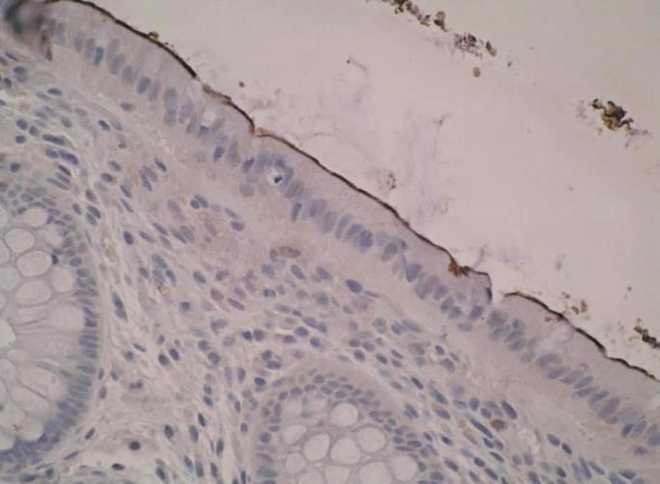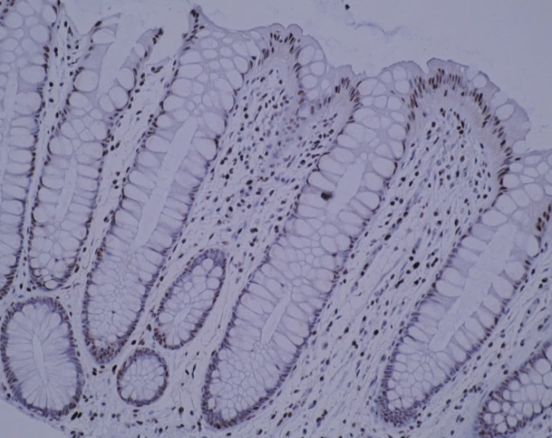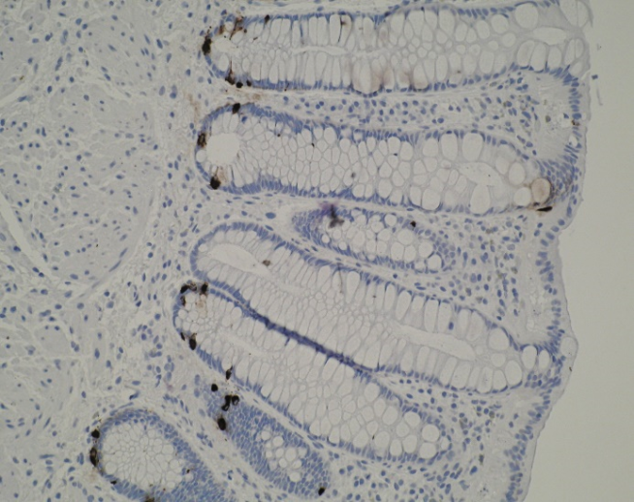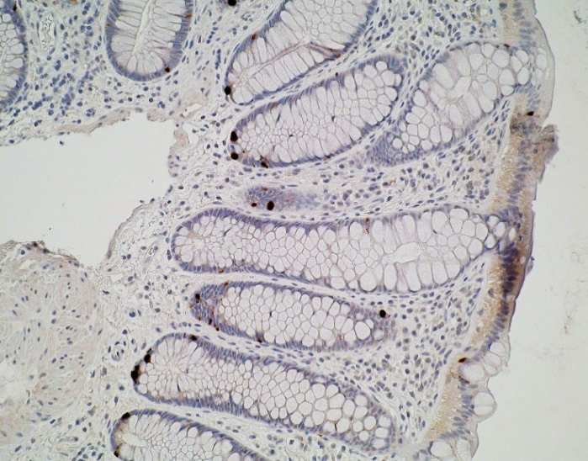
(d) Chromogranin A
(c) SLC28A2/CNT2
(a) ABCB1/P-gp
(b) SLC29A2/ENT2

Figure 2: Hierarchical clustering of mRNA expression of drug transporters in colorectal biopsies and six cell-lines. Distances between samples and assays are calculated for hierarchical clustering based on the ΔCT values using Pearson’s correlation. Normalization was done using three endogenous control genes (HPRT1, PGK1 and PPIA) and the ΔCT values were calculated by subtracting the mean of the CT values of the endogenous controls from the CT value of the gene for each sample. The rows of the heat map represent 84 drug transporter genes and the columns represent samples. The ΔCT value of the neutral/middle expression level (mean) is set such that red indicates an increase with a ΔCT value below the middle level, and green indicates a decrease, with a ΔCT value above the middle level. The relationship between colours and normalized values of gene expression is illustrated in the key at the bottom of the figure. Three major clusters were identified in the dendrogram based on gene expression levels. The colorectal biopsies from two sites (EU3 to EU10, EU12, EU13, EU14 and EU16) and the Caco-2 cell line clustered separately whereas the third cluster incorporated all the other cell lines (HT-29, SW1463, SW837, HRT-18 and HRA-16) suggesting closer linkage of Caco-2 cells to colorectal tissue drug transporter gene expression. This figure appears in colour in the online version of JAC and in black and white in the print version of JAC.

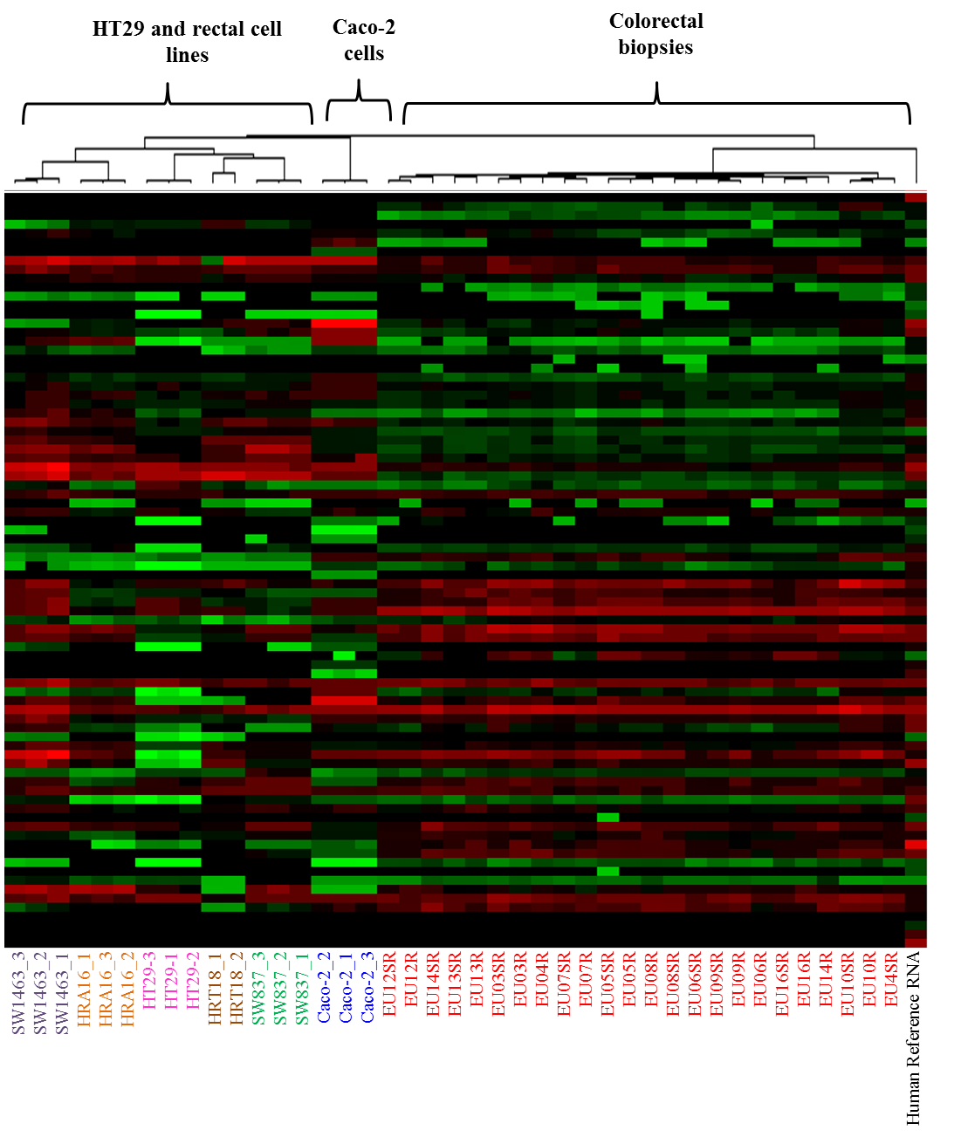

Figure 3: Principal component analysis of gene expression profiles generated from colorectal biopsy samples and six cell lines. Relative contribution of the ∆Ct variance is shown by two major principal components (PC1 and PC2) plotted in two dimensions. This figure appears in colour in the online version of JAC and in black and white in the print version of JAC.

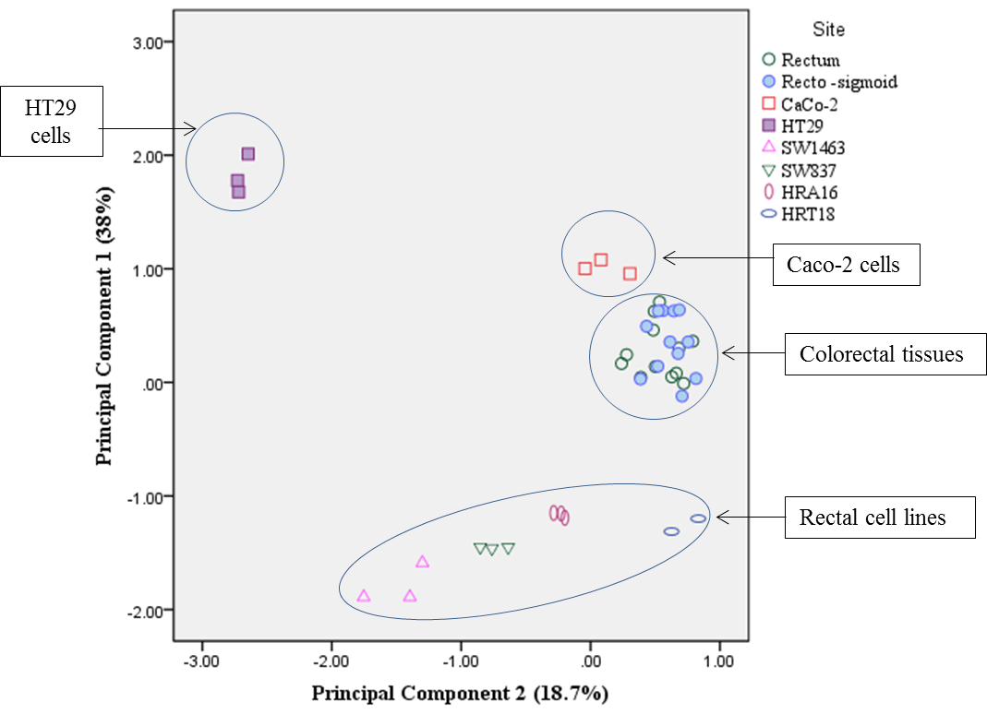

Figure 4: Effect of antiretroviral drugs on mRNA expression of drug transporters in Caco-2 cells. Mean RQ of genes up and down regulated in Caco-2 cells induced with (a) 5mM tenofovir (b) 250µM darunavir and (c) 10µM dapivirine for 3 days compared with appropriate medium controls. *P<0.05; **P<0.01 and ***P<0.001. The drug concentrations used were found to be non-toxic to the Cao-2 cells. The genes which were up and down regulated more than 1.5 times have been included in this figure.
(a)Tenofovir (b) Darunavir (c) Dapivirine

Figure 5: Effect of tenofovir and darunavir dissolving films on mRNA expression of drug transporters in Caco-2 cells. Mean RQ of genes up and down regulated in Caco-2 cells induced with (a) tenofovir films and (b) darunavir films for 3 days compared with appropriate respective placebo films as controls. *P<0.05; **P<0.01 and ***P<0.001.

(a) Tenofovir (b) Darunavir

Figure 6: Explant histology. Haematoxylin and eosin staining of formalin fixed paraffin embedded colorectal explant. Panel (a) shows staining of colorectal biopsy samples immediately formalin fixed on arrival in the lab, panel (b) shows biopsy samples incubated in media for 24 hr on gel foam rafts, panel (c) shows staining of colorectal biopsy samples incubated in media with 1% DMSO for 24 hr on gel foam rafts and panel (d) shows staining of colorectal biopsy samples incubated in media with ARV (10µM DPV) for 24 hr on gel foam rafts. This figure appears in colour in the online version of JAC and in black and white in the print version of JAC.
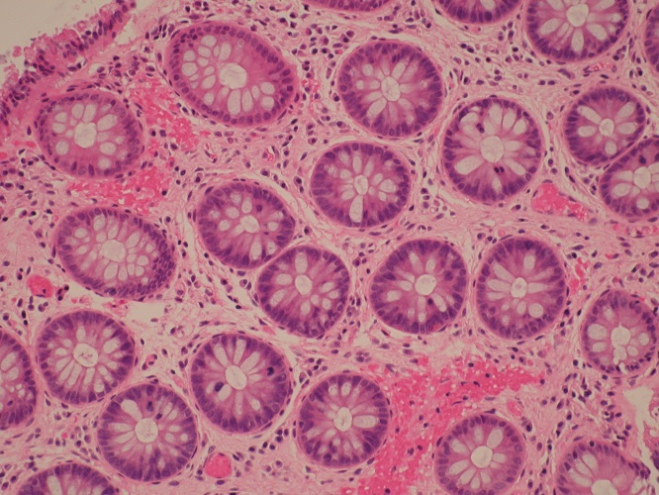
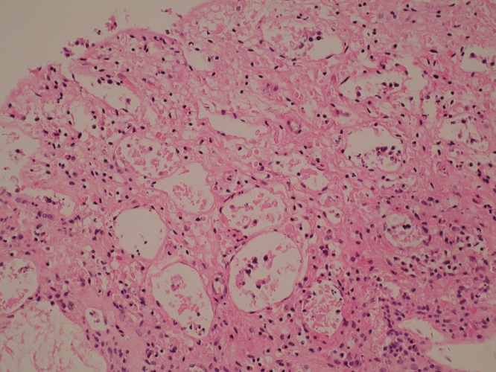
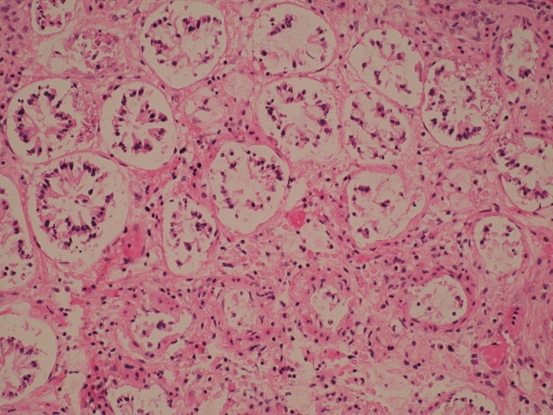
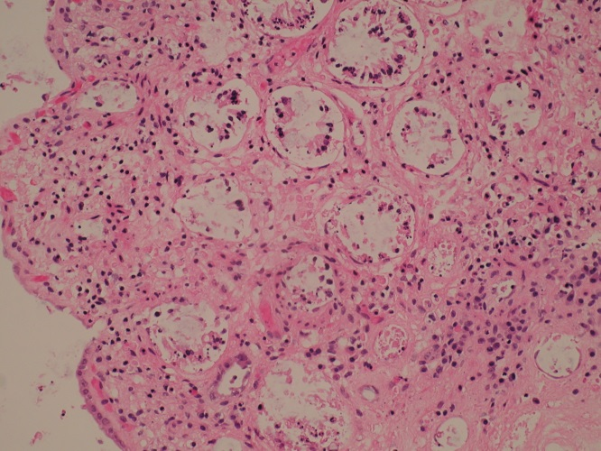
(a) Normal colorectal biopsy, 1 hr after collection
(b) 24 hr explant culture in media
(c) 24 hr explant culture in media with 1% DMSO
(d) 24 hr explant culture in media with ARV (10µM DPV)
Figure 7: Effect of antiretroviral drugs on mRNA expression of drug transporters in colorectal explants. Mean RQ of genes up and down regulated in colorectal explants induced with (a) 5mM tenofovir (b) 250µM darunavir and (c) 10µM dapivirine for 24hr compared with appropriate medium controls. *P<0.05; **P<0.01 and ***P<0.001.
(a) Tenofovir (b) Dapivirine
***
(c) Darunavir

