Social Crises Religious Revival Tables and Figures

Table 1 Methodism in England, membership and as proportion of the adult population, 1801-2001 (crisis decades shaded)

 | Total (1,000s) | Population 15 and Over (1,000s) | Density | % change from previous decade
1901 | 734 | 20,750 | 3.54 | --
1911 | 786 | 23,218 | 3.39 | -0.15
1921 | 752 | 25,366 | 2.96 | -0.43
1931 | 788 | 28,393 | 2.78 | -0.18
1941 | 715 | 30,124 | 2.37 | -0.41
1951 | 681 | 32,104 | 2.12 | -0.25
1961 | 668 | 33,465 | 2.00 | -0.12
1971 | 572 | 35,435 | 1.61 | -0.39
1981 | 454 | 37,090 | 1.22 | -0.39

Source: 1861-1971 Currie et al 1977: 140-142. 1981 Brierley 2003: Table 9.8; date actually 1980. The Methodist data before the reunion in 1932 includes figures for the various precursor Methodist bodies.

Table 2 Scottish Presbyterian Church Membership and as proportion of adult population, 1901-1971 (crisis decades shaded)

 | Members (1,000s) | Population 15 and over (1,000s) | % of adult Scots in membership | % change from previous decade
1901 | 1,164 | 2,996 | 38.85
1911 | 1,220 | 3,237 | 37.69 | -1.16
1921 | 1,278 | 3,466 | 36.87 | -0.82
1931 | 1,299 | 3,535 | 36.75 | -0.12
1941 | 1,292 | 3,818 | 33.84 | -2.91
1951 | 1,298 | 3,822 | 33.96 | +0.12
1961 | 1,313 | 3,832 | 34.26 | +0.30
1971 | 1,171 | 3,869 | 30.27 | -3.99

Source: Currie et al 1977: 132-4.

Table 3 Sunday school enrolments, England and Wales 1901-1961 (crisis decades shaded)

 | % of under 15s enrolled | % change over previous decade
1901 | 52.6
1911 | 51.4 | -1.2
1921 | 46.7 | -4.7
1931 | 45.8 | -0.9
1941 | 37.7 | -7.7
1951 | 30.0 | -7.7
1961 | 20.4 | -9.6

Source: Brierley 2011: table 14.4.2

Figure 1 Shetland Methodist Membership, 1900-1986

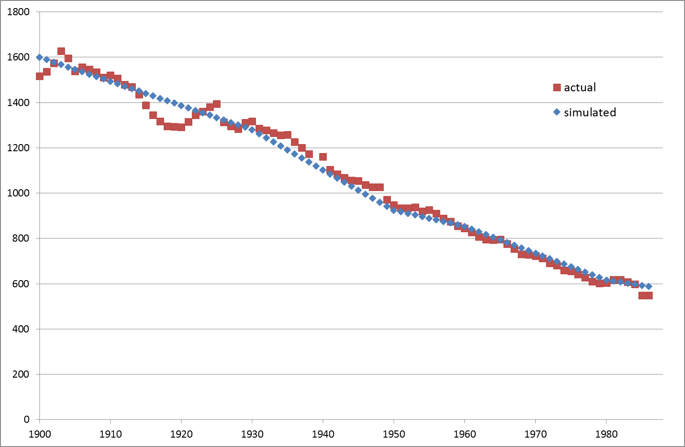

Source: Bowes 1988 Appendix H. Simulation described in the text.

Figure 2 UK Church Membership 1900-2010

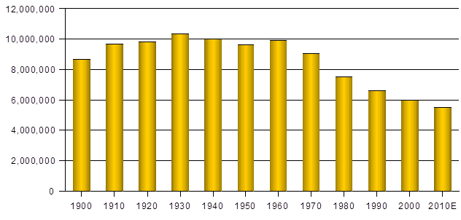Source: Peter Brierley, personal communication.
Figure 3 UK Church Membership, 1900-2010 as percentage of population

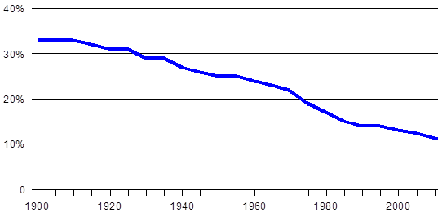
Source: Peter Brierley, personal communication.

Figure 4 Easter communicants, Church of England (% of population), 1901-2010

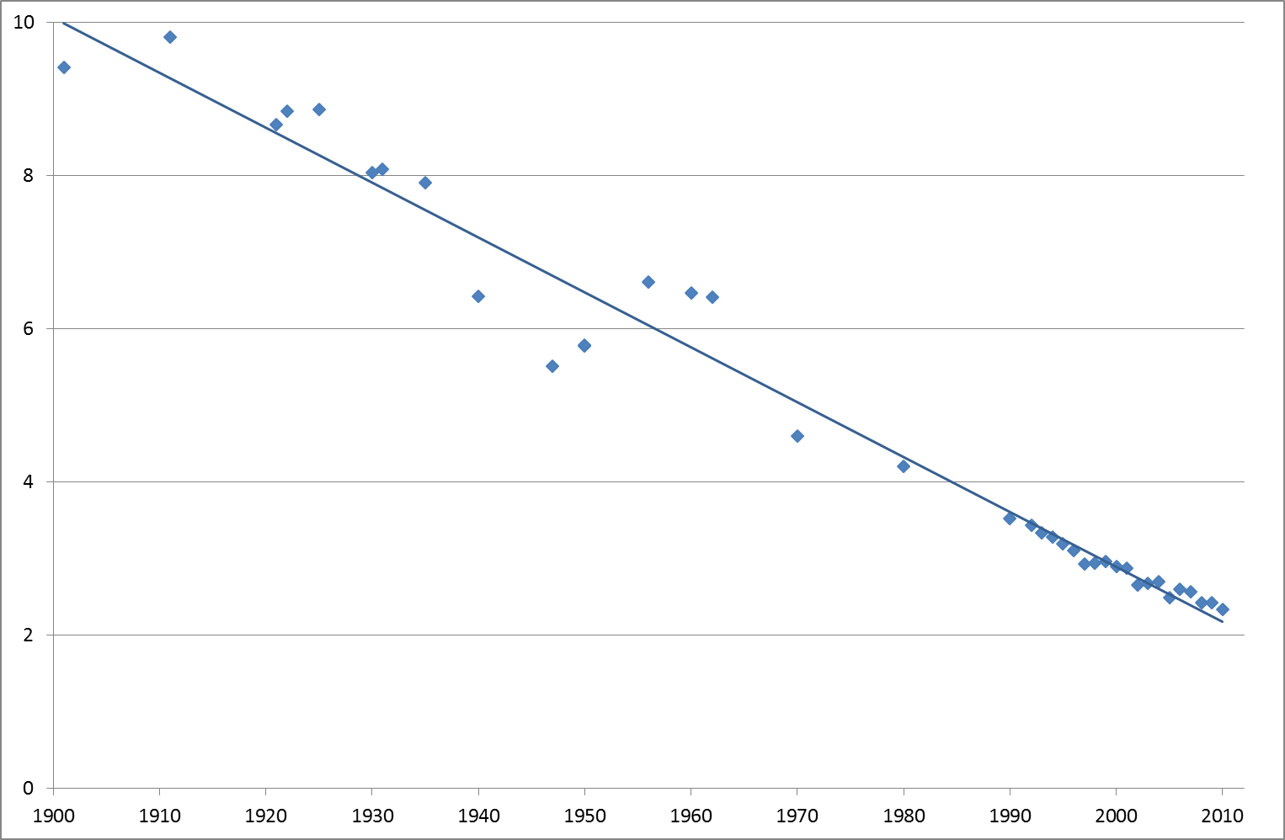

Source: Currie, Gilbert and Horsley 1977: 128-9, Church of England Yearbooks.

Figure 5: Attendance at religious services monthly or more often (%), 1990-2013 (ethnic minorities excluded)

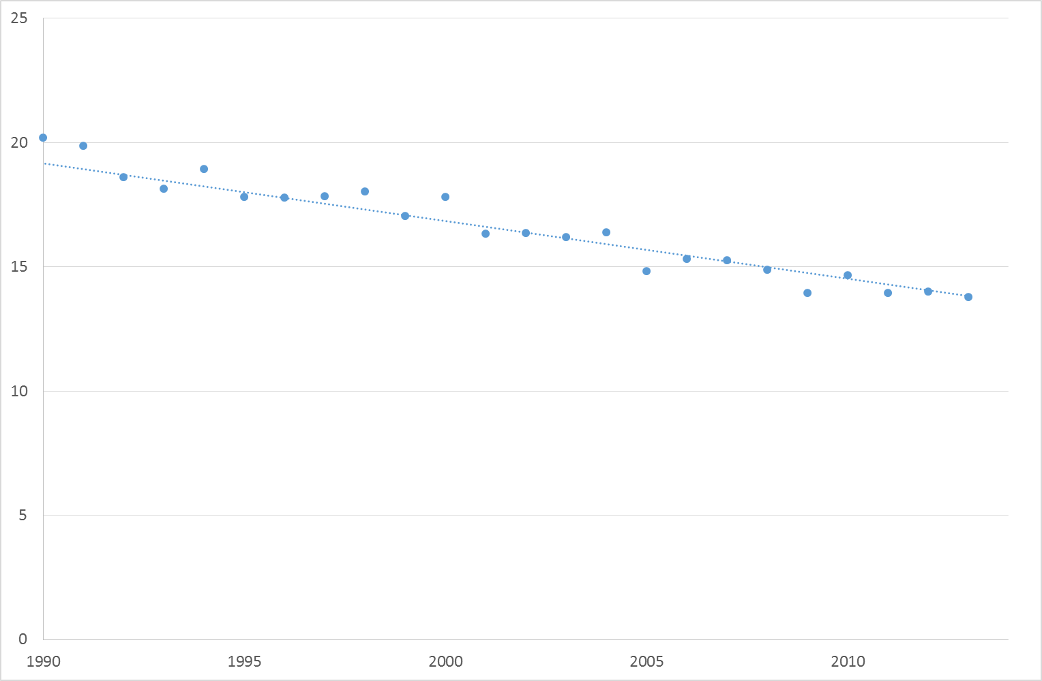

Source: British Social Attitudes surveys, 1990-2013

