Can new doctors be prepared for practice? A review

Anonymised for review

Abstract
Background
The transition from medical student to junior doctor is an important period of change. Research shows junior doctors often experience high levels of stress, and consequently burnout. Understanding how to prepare for the transition may allow individuals likely to struggle to be identified and assisted. The aim of this paper is to systematically review the literature on preparedness for practice in newly qualified junior doctors.
Methods
This was a systematic review of literature concerning the transition from student to junior doctor, published in the last 10 years, and which measured or explored one or more factors affecting preparedness.
Results
Nine papers were included in this review. These varied in design and methodological quality. Most used survey methodology (n=7). Six found knowledge and skills, particularly deficiencies in prescribing and practical procedures, relevant in terms of preparedness. Five looked at personal traits; high neuroticism and low confidence deemed to be important. Medical school and workplace factors including early clinical experience and shadowing positively affected preparedness. A lack of senior support proved detrimental. The influence of demographics was inconclusive.
Discussion
The studies reviewed indicate that both personal and organisational factors are pertinent to managing the transition from student to junior doctor. Further, prospective studies, both qualitative and quantitative, drawing on theories of change, are required to identify what precise factors would make a difference to this transition.
Background
“It is not the strongest of the species that survives, nor is it the most intelligent that survives. It is the one that is most adaptable to change.”
Charles Darwin, the Origin of Species
Transitions are periods of development during which individuals must adapt to new environments or situations [1]. Several important transitions have been identified in medical careers: from non-clinical to clinical teaching, from student to doctor and, thereafter, in relation to the progression between grades of practice [2-4].
While the process of learning to be a doctor continues far beyond graduation, there is an expectation that new doctors will perform adequately clinically, integrate into a clinical team and take full responsibility for their actions [5]. However, the move from observation to practice is often plagued with difficulty and new doctors report high levels of stress and burnout [1]. Graduates also feel under-prepared and exposed on entering the workplace [4, 6].
Preparedness for practice traditionally focuses on basic knowledge and skills, but it is clear that other factors are also influential including those associated with the medical school (e.g., curricula) and workplace (e.g., organisational support). Adapting to any transition also depends on individual variables such as how one manages responsibility and change. It is not clear how difficulties in these areas found in final year medical students affects their future as junior doctors [7]
A greater understanding of how to prepare students for life as a new junior doctor may enable interventions to be designed to provide individual and organisational support for the transition. At the individual level, it may be possible to identify those who are likely to struggle so they can be assisted proactively rather than supported after lack of preparedness impacts on their working and personal lives. At an organizational level, mandatory induction programs may be of benefit. Formalised support should continue beyond the initial transition. To gain insight into the nature of this difficult transition and explore where support may be helpful , we systematically reviewed the literature on preparedness for practice in newly-qualified doctors.
Methods
We searched MEDLINE and Scopus for relevant literature concerning the transition from student to junior doctor, published in the last 10 years (given medical education has undergone significant change in recent years [e.g., 8]), and which measured one or more factors affecting preparedness. Search strategy and terms are detailed in table 1. We also hand searched the reference lists of identified articles. Articles which looked at the implementation of preparatory courses or intervention programs were excluded as our question focused on identifying general messages not evaluating interventions to address identified difficulties in local contexts. See Figure 1 for an overview of the search strategy.
It is difficult to appraise, in a uniform manner, the quality and results of studies using different methodologies and different outcome measures. Thus, to provide a framework for review, we adapted the TREND (Transparent Reporting of Evaluations with Nonrandomised Designs) and CASP (Critical Appraisal Skills Program) checklists to produce a data collection tool (available on request from the authors) [9, 10].
Each paper was critically appraised independently by two authors then discussed by the group. We were aware that our conclusions could have been influenced by our individual experiences of being medical students. This change is particularly pertinent to us and we critically reflected on this via interact discussion.
As this was a secondary analysis of previously published data, ethical permission was not required for this study.
Note that we use the generic terms junior or new doctor to describe the population under study.

 | Medline Hits | Scopus Hits*
- teaching.mp | 65, 678 | 148, 894
- education.mp | 267, 952 | 554, 685
- medical education | 12, 135 | 168, 026
- medical undergraduate students | 25 | 8, 088
- medical teaching | 443 | 32, 521
- transition.tw | 19, 923 | 527, 470
- transition.mp | 94, 329 | 527, 470
- clinical clerkship.mp | 2, 253 | 1, 989
- patient safety.mp | 9, 590 | 188, 452
- 1or 2 | 305, 897 | 625, 164
- 3 or 5 | 12, 517 | 178, 776
- 10 and 11 | 12, 517 | 178, 776
- 4 or 12 | 12, 536 | 179, 314
- limit 7 to “English language”, “humans only”, yr “2002 – Current” | 30, 501 | N/A**
- limit 13 to “English language”, “humans only”, yr “2002 – Current” | 7, 217 | N/A**
- 14 and 15 | 85 | 1, 438
- limit 6 to “English language”, “humans only”, yr “2002 – Current” | 5, 862 | N/A**
- 14 or 17 | 108, 317 | 190, 405
- 15 and 18 | 95 | 123

*Scopus does not allow terms to be mapped or use term words
**Scopus does not offer a limit function when combining searches together
Table 1 Search strategy
Results
Twenty-six articles were identified by the search, of which nine related directly to the research question (see Table 2). All of the studies focused on new doctors’ views and perceptions [a-i]. Six of these studies reviewed were UK-based: one was German [f], one from Sweden [e] and one from the Netherlands [i]. The most common tool was a retrospective questionnaire [Table 2: b, c, e-h, i], followed by interviews [a, d, i] and audio diaries [a]. Sample sizes varied from a national survey of 11,610 junior doctors to a qualitative study of 31 [c, a].
A number of the survey-based studies reported relatively poor response rates [a, b, g, i] which may have introduced bias. Anonymised responses in two other questionnaire studies may have minimised this potential problem [f, h]. None of the qualitative papers reported data saturation or contradictory data, suggesting themes were potentially left undiscovered [a, d].
Only two studies provided information on participant selection [f, h]. In those which did not, there was no means of determining if those who took part were representative of the intended population.
All studies were retrospective. Asking participants to comment retrospectively may introduce recall bias and questions the accuracy of the results. No studies asked medical students how prepared they felt for work prior to the transition itself.
The majority of the papers found that aspects of knowledge and skills were relevant to junior doctor’s preparedness for practice [a, c, e-h]. The following were highlighted to be lacking in newly qualified doctors: prescribing; decision making, treatment planning and prioritisation; taking responsibility for one’s own learning; managing stress in the workplace; team working; interpersonal skills and competence in carrying out clinical procedures.
Workplace factors can influence the transition into work. Perceived lack of support from fellow and senior staff, lack of continuity (changing work rotas, understaffing and incomplete ward teams) and poor feedback contribute to feelings of exposure and underpreparedness [a, b, d, f].
Also relevant to the transition from student to junior doctor are factors related to medical school programmes. Having experience of shadowing and attachments increases preparedness [a, b, h]. Vertically integrated courses (i.e. early introduction of clinical skills) seem to prepare students better for life as junior doctors [i]. Feelings of preparedness vary extensively between medical schools [c], for reasons that have not, to date, been explored in any detail.
A number of individual factors seem to lead to feeling less prepared for life as a new doctor: scoring high in neuroticism, low in leadership skills, ability to deal with uncertainty and prioritise aspects of patient care [a, e]. Conversely, having high levels of agreeableness, conscientiousness, empathy and extraversion contribute to feeling well prepared [b, e], as does awareness of one’s limitations [h] and self-confidence [g].
A few studies looked at the relationship between demographic factors (gender, ethnicity and domestic situation) [b, c, f] and preparedness but it was difficult to extract anything conclusive from these papers due to conflicting results. For example, Cave and colleagues [b] found that gender and graduate status had no impact on students’ preparedness for practice while Goldacre et al. found the correlations between these variables and preparedness differed between year groups [c].
Discussion
This review identified that there are remarkably few empirical studies of the important and challenging transition from student to junior doctor. Those studies which have been carried out are mostly set in the UK context so may not be generalisable to other countries with different training programmes and healthcare organisation.
The studies indicate that new doctors feel inadequately prepared for practice, particularly in terms of knowledge and skills, and perceive a lack of organisational support. The evidence reviewed suggests that organisational factors, namely the level of clinical experience, gained through shadowing and/or curricula design which facilitates early exposure, are important but further work is needed to examine its precise benefits. Personal qualities such as personality type and factors also seem to impact on the transition. These may be at least as important as organisational factors. However, most studies to date that explore the relationship between personal variables and preparedness have been qualitative and single-site so it is difficult to extrapolate generalisable messages. The studies reviewed also hint at the need for any interventions that support the transition to be situated in “real-life” rather in a simulated environments, which may pose challenges in busy clinical practice. The ideal outcome measure in this area would be preparedness regarding the transition from student to junior doctor. However this entity is difficult to quantify and it is important to consider preparedness from various perspectives (eg. student, mentor, patient) and time points, given the perceptions of preparedness may differ between junior doctors and their supervisors.
To the best of our knowledge, no study has followed up senior medical students from prior to the transition to junior doctor, and through the first years of training. Only by doing well-planned, prospective longitudinal studies, both qualitative and quantitative, can we identify what precise factors make a difference to the transition. Existing approaches to supporting medical students in the transition to junior doctor must be evaluated and new methods developed. Any new approaches should be appraised using intervention methodology which leads itself to robust evaluation but yet acknowledges the role of context. This will allow us to progress our knowledge of what does and does not work in certain settings. Such interventions may usefully draw from recognised theories of managing change at an individual and organisational level.

References
- Fisher, CD. Organisational socialisation: an integrative review. Research in Personnel and Human Resources Management. 1986; 4: 101–45.
- Teunissen, P W. Westerman, M. Junior doctors caught in the clash: the transition from learning to working explored. Medical Education. 2011; 45 (1): 966-972.
- Teunissen, P W. Westerman, M. Opportunity or threat: The ambiguity of the consequences of transitions in medical education. Medical Education. 2011; 45 (1): 51-59.
- Kilminster, S. Zukas, M. Quintin, N. Roberst, T. Preparedness is not enough: understanding transitions as critically intensive learning periods. Medical Education. 2011; 45 (1):1006-1015.
- Prince, K J A. Van de Weil, M. van der Vleuten, C. Boshuizen, H. Scherpbier, A. Junior doctors opinions about the transition from medical school to clinical practice: A change of environment. Education for Health. 2004; 17 (3), 323-331.
- Tallentire, VR, Smith, SE. Skinner, J. Cameron, HS. Understanding the behaviour of newly qualified doctors in acute care contexts. Journal of medical education. 2011; 45 (1): 995-1005.
- Wilkinson, T. J Harris P. The transition out of medical school – a qualitative study of descriptions of borderline trainee interns. Medical Education. 2002; 36: 466-471.
- General Medical Council. Tomorrow’s Doctors. London: GMC 2009.
- Des Jarlais, D. C., Lyles, C., Crepaz, N., & the Trend Group. Improving the reporting quality of nonrandomized evaluations of behavioral and public health interventions: The TREND statement. American Journal of Public Health. 2004; 94: 361-366.
- National Collaborating Centre for Methods and Tools 2011. Critical appraisal tools to make sense of evidence. Hamilton, ON: McMaster University. (Updated 16 December, 2011). Retrieved from http://www.nccmt.ca/registry/view/eng/87.html. Accessed 15/05/2012

Table 2: Studies included in the review

- Brennan, N. Corrigan, O. Allard, J. Archer, J. Barnes, R. Bleakley, A. Collett, T. Regan de Bere, S. The transition from medical student to junior doctor: Todays experiences of tomorrows doctors. Medical Education. 2010; 44: 449-458.
- Cave, J. Woolf, K. Jones, A. Dacre, J. Easing the transition from student to doctor: How can medical schools help prepare their students for starting work? Medical Teacher. 2009; 31: 403-408.
- Goldacre, M. J. Taylor, K. Lambert, T. W. Views of junior doctors about whether their medical school prepared them well for work: questionnaire surveys. BMC medical education. 2010; 10: 78.
- Lempp, H. Cochrane, M. Rees, J. A qualitative study of the perceptions and experiences of Pre-Registration House Officers on teamwork and support. BMC Medical Education. 2005; 5 (10)
- Lindberg, O. The next step – alumni students’ views on their preparation for their first position as a physician. Medical Education Online 2010; 15: 4884.
- Oschmann, E B. Zier, U. Drexler, H. Schmid, K. Well prepared for work? Junior doctors self-assessment after medical education. BMC Medical Education. 2011; 11 (99).
- Tallentire, V R. Smith, E S. Wylde, K. Cameron, H S. Are medical graduates ready to face the challenges of foundation training? Postgraduate Medical Journal. 2011; 87: 590-595.
- Wall, D. Balshaw, A. Carloan, J. From undergraduate medical education to pre-registration house officer year: how prepared are students? Medical Teacher. 2006; 28 (5): 435-439.
- Wijnen-Meijer, M. ten Cate, OTJ. van der Schaaf, M. Borleffs, J C C. Vertical integration in medical school: effect on the transition to postgraduate training. Medical Education. 2010; 44: 272-279.

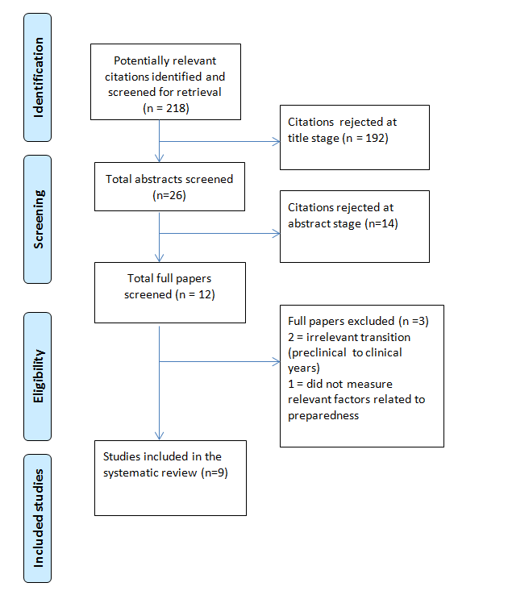
Figure 1

