Global form and motion processing in healthy ageing

Hannah C. Agnew¹, Louise H. Phillips¹ and Karin S. Pilz¹

¹School of Psychology, University of Aberdeen, Scotland, UK

Corresponding author

Hannah C. Agnew
School of Psychology
University of Aberdeen
William Guild Building
Aberdeen
AB243FX

Tel.: +44 (0)1224 272234
Email: hannah.agnew@abdn.ac.uk

Abstract

The ability to perceive biological motion has been shown to deteriorate with age, and it is assumed that older adults rely more on the global form than local motion information when processing point-light walkers. Further, it has been suggested that biological motion processing in ageing is related to a form-based global processing bias. Here, we investigated the relationship between older adults’ preference for form information when processing point-light actions and an age-related form-based global processing bias. In a first task, we asked older (> 60 years) and younger adults (19 - 23 years) to sequentially match three different point-light actions; normal actions that contained local motion and global form information, scrambled actions that contained primarily local motion information, and random-position actions that contained primarily global form information. Both age groups overall performed above chance in all three conditions, and were more accurate for actions that contained global form information. For random-position actions, older adults were less accurate than younger adults but there was no age-difference for normal or scrambled actions. These results indicate that both age groups rely more on global form than local motion to match point-light actions, but can use local motion on its own to match point-light actions. In a second task, we investigated form-based global processing biases using the Navon task. In general, participants were better at discriminating the local letters but faster at discriminating global letters. Correlations showed that there was no significant linear relationship between performance in the Navon task and biological motion processing, which suggests that processing biases in form- and motion-based tasks are unrelated.

Keywords: Biological motion
Ageing
Navon task
Global/local processing

Introduction

Biological motion can be defined as any movement pattern, produced by the body of a human or animal, and is an important visual cue that helps us to perceive the facial and body movements of others so that we can understand and predict their behaviour (e.g., Blake & Shiffrar, 2007). Successful decoding of biological motion information provides us with information about movement direction and intention but also about mental states, personality traits, and emotions (Bonda, Petrides, Ostry & Evans, 1996; Dittrich, Troscianko, Lea & Morgan, 1996; Heberlein & Saxe, 2004; Insch, Bull, Phillips, Allen & Slessor, 2012). The ability to perceive biological motion is commonly tested using point-light animations, which were first introduced by Johansson (1970, 1973). Point-light animations consist of dots or light points that mimic or represent the joint movements of a moving person. By integrating the motion of those dots, it is possible to recognise a human figure. The perception of biological motion is very robust and from point-light animations it is possible to extract information about gender (Kozlowski & Cutting, 1997; Pollick, Kay, Heim & Stringer, 2005), identity (Kozlowski & Cutting, 1997; Troje, Westhoff & Lavrov, 2005; Loula, Prasad, Harber & Shiffrar, 2005), or emotions (Dittrich et al. 1996; Roether, Omlor, & Giese, 2008, Spencer, Sekuler, Bennett, Gises & Pilz, 2016), and to identify a wide range of different actions (Figure 1; Vanrie & Verfaille, 2004).

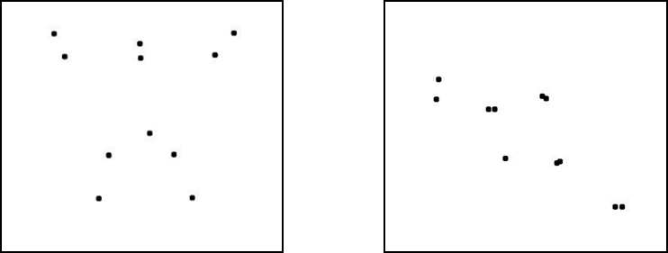

Figure 1. Still frames of jumping (left) and driving (right) point-light actions (Vanrie & Verfaille, 2004). (1.5 column)

Interestingly, recent studies have shown that biological motion perception changes with age (Norman, Clayton, Shular & Thompson, 2004, Billino, Bremmer & Gegenfutner, 2008; Pilz, Bennett & Sekuler, 2010, Insch et al., 2012, Legault, Troje & Faubert, 2012). It has been found that older adults have difficulties detecting point-light walkers in noise (Billino et al., 2008; Pilz et al., 2010), need more time to process biological motion than younger adults (Norman et al. 2004; Pilz et al., 2010) and have difficulties discriminating walkers from short distances (Legault et al., 2012). In a recent study, Pilz et al. (2010) suggested that older and younger adults use different kinds of information present in point-light animations. Point-light animations contain local motion information, the local motion trajectories of the single dots, and global form information, which is revealed when integrating the single dots into a global percept at each point in time. The global motion of the animated figure can be derived from the integration of the local motion trajectories of the single dots or by integrating the global form information over time (e.g., Giese and Poggio, 2003).

Pilz et al. (2010) investigated the contribution of form and motion information to age-related changes in biological motion processing by presenting three different kinds of upright and inverted point-light walkers: normal walkers that contained local motion, and global form information, random-position walkers that contained primarily global form information (adapted from Beintema and Lappe, 2002), and scrambled walkers that contained preserved local motion information, but disrupted global information (e.g., Bertenthal & Pinto, 1994; Troje & Westhoff, 2006; Thornton, Pinto & Shiffrar, 1998). Participants had to discriminate the walking direction of the stimuli. Pilz et al. (2010) found that at longer stimulus durations older adults were as good as younger adults at discriminating the walking direction for upright normal and random-position walkers. Interestingly, older adults had difficulties discriminating the walking direction for inverted normal walkers, but at longer stimulus durations performed as well as younger adults for inverted random-position walkers. These results indicate that older adults are better at discriminating the motion direction for less familiar stimuli when local motion information is absent. Pilz et al. (2010) therefore suggested that older adults have difficulties integrating global form and local motion information as efficiently as younger adults. More recently, Insch et al. (2012) investigated the relationship between global form and biological motion processing by relating performance on a point-light action discrimination task with performance in a Navon type task (Navon, 1977). The Navon task is often used to investigate a visual preference for processing the global information contained within a stimulus, otherwise known as global precedence. Global precedence occurs when the global and local levels of a stimulus are incongruent, and the global stimulus interferes with processing the local stimulus to a greater degree, than the local stimulus interferes with processing the global stimulus (e.g., Navon, 1977; Insch et al., 2012).

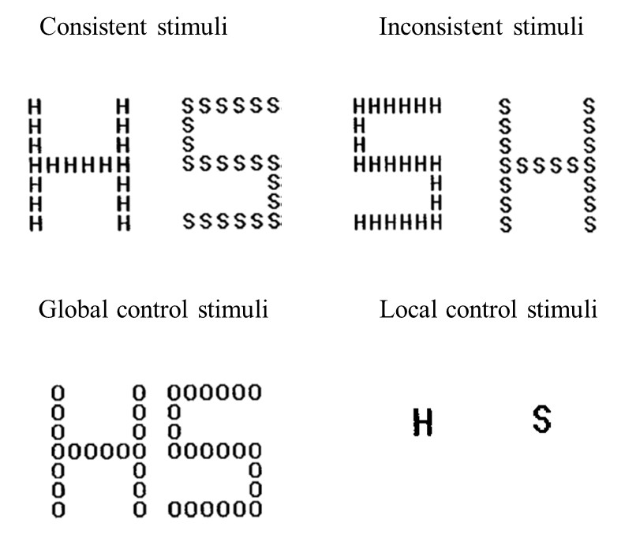

Figure 2. Examples of Navon stimuli as adapted from Roux and Ceccaldi (2001) for stimuli for which the local letters are the same as the global letter (consistent, upper left), the local letters are different from the global letter (inconsistent, upper right), and control stimuli for which the local information is irrelevant to the task (control, lower left) or the global information is absent (control, lower right).

The original Navon task requires the identification of letters. Navon letters consist of many small letters (local stimuli) that are arranged to form a larger letter (global stimulus; Figure 2). The global and local letters can be the same (consistent) or different (inconsistent). Participants are required to identify either the global or local letters. By relating performance in the Navon task and point-light action discrimination, Insch et al. (2012) found that, across all ages, the ability to decode emotions and actions from point-light displays was positively related to a global-processing bias, i.e., a preference for processing the global letters. More interestingly however, older adults exhibited a local processing bias in the Navon task, i.e., a preference for processing the local letters, which is in accordance with previous studies (Oken, Kishiyama, Kaye & Jones, 1999; Slavin, Mattingley, Bradshaw & Storey, 2002; Lux, Marshall, Thimm & Fink, 2008; Staudinger, Fink, Mackay & Lux, 2011). Overall, older adults performed worse on the biological motion task than younger adults. However, as shown by mediation analyses, age-differences in global to local processing did not entirely account for age-related changes in biological motion discrimination.

An age-related local processing bias as found by Insch et al. (2011) seems to be in contrast to the global form advantage for biological motion stimuli that was found by Pilz et al. (2010). Therefore, to assess the exact relationship between the age-related form-based local processing bias (Insch et al., 2012) and a potential form-based global processing advantage for point-light walkers in ageing (Pilz et al., 2010), this study combined the recent findings and stimuli by Insch et al. (2012) and those of Pilz et al. (2010). Rather than using a single computer-generated so called Cutting point-light walker as was used in Pilz et al. (2010), this study used complex motion captured actions (Vanrie and Verfaille, 2002). It has been suggested that motion-captured walkers provide stronger local motion signals than Cutting walkers (Saunders, Suchan and Troje, 2009), allowing us to better differentiate between the contributions of local motion and global form information for point-light walker processing. To assess the importance of form and motion information in biological motion perception, a matching task was employed, in which the first stimulus contained either local motion information, global form information, or both, and the second stimulus always contained local motion and global form information. Participants simply had to indicate whether the first and second stimulus showed the same action or not. Using this task, we were able to assess which kind of information older and younger adults preferentially utilise for biological motion processing. Based on the findings from Pilz et al. (2010), we anticipated that older adults would be worse at matching scrambled actions that primarily contain local motion compared to random-position actions that primarily contain global form information. In addition, we used the Navon task to investigate perceptual processing styles for both age groups. We expected that, similar to previous studies, both age groups would be faster at responding to the global than the local Navon letters, therefore exhibiting global precedence. In addition, we wanted to assess how the increased accuracy for local compared to global letters in older adults found by Insch et al. (2012) relates to the form-based processing advantage suggested by Pilz et al. (2010). We therefore correlated performance in the biological motion task with performance in the Navon task to investigate whether age-related differences in perceptual processing styles in the form-based Navon task accounted for the advantage of form over local motion information in biological motion processing.

Methods

Participants

18 younger participants (M = 19.9 years; SD = 1.2; Range = 19 - 23; 3 males) and 20 older participants (M = 65.4 years; SD = 3.9; Range = 61 -78; 4 males) took part in the experiment. 1 younger and 5 older participants were excluded from the participant sample due to poor visual acuity so that the analysis was based on 17 younger and 15 older adults. The exclusion of these participants did not change the age ranges of the remainder younger and older participants. Participants were recruited from the student population and the Psychology Participant Panel of the University of Aberdeen. All participants were naive as to the purpose of the experiment and had normal or corrected to normal visual acuity of at least 20/16 as measured by the Snellen chart. Furthermore, all older participants were free from ocular diseases such as cataracts, glaucoma and macular degeneration as confirmed by their last eye examination. Older participants completed the Montreal Cognitive Assessment (MoCA; Nasreddine, Phillips, Bedirian, Charbonneau, Whitehead, Colin et al., 2005), a screening measure for mild cognitive impairment. All participants’ scores were within the normal range (range 26-30/30). Participants were reimbursed for their time with £5 or course credit. Informed consent was received from each participant. Ethical approval was applied for and granted by the School of Psychology at the University of Aberdeen.

Apparatus

The experiment was conducted on an Apple Mac Mini with MATLAB under the Psychtoolbox extension (Brainard, 1997; Pelli, 1997; Kleiner, Brainard, Pelli, Ingling, Murray & Broussard, 2007). Stimuli was presented on a 19 in CRT Dell monitor (model M993S), with a resolution of 1024 x 768 pixels and a refresh rate of 100Hz. Participants were seated in a darkened room at a distance of approximately 52cm and viewed the stimuli binocularly.

Stimuli, task and procedure

Sequential action matching task
Stimuli for the action matching consisted of point-light actions recorded by Vanrie and Verfaille (2004; Figure 1). Point-light actions consisted of thirteen dots that simulated points on the head, near the shoulders, both elbows, both wrists, the hip, both knees and both ankles. For a full description of the stimulus set see Vanrie and Verfaille (2004).

Actions were presented as normal, scrambled and random-position actions similar to Pilz et al. (2010). Normal actions contained both local motion and global form information. Scrambled actions contained primarily local motion information - the vertical starting positions of the point-light dots were randomly selected along the y-axis, leaving the local motion of the single dots intact but distorting the global form (e.g., Bertenthal & Pinto, 1994; Thornton et al., 1998; Troje & Westhoff, 2006; Pilz et al., 2010). Random-position actions contained primarily global form information - each point-light was presented at a random position on the underlying skeleton within each presentation frame, leaving the global form intact but distorting the local motion of the single dots (Beintema & Lappe, 2004). Stimuli were presented both upright and inverted as it has been suggested that inversion disrupts the processing of the global form of point-light stimuli (Sumi, 1984; Pavlova & Sokolov, 2000; Troje & Westhoff, 2006). Therefore, inverted walkers serve as an additional condition to assess the ability to process the global form of the stimuli.

Point-light actions depicted one of nine actions: jumping, cycling, driving, playing pool, rowing, walking, playing tennis, waving and stirring (Vanrie & Verfaille, 2004). Each action subtended a visual angle of 3.0 x 6.0 degrees and each stimulus was presented for 660 ms at a frame rate of 30 frames per second (fps). It should be noted that in the original Vanrie and Verfaille (2004) paper the point-light actions were presented at a frame rate of 33 fps, which we adjusted to 30fps based on the monitor refresh rate. Point-light actions faced 90 degrees to the left or right so that only one side of the body was visible. Inverted point-light actions were rotated by 180 degrees so that they appeared to be standing on the ceiling. Point-light actions did not translate across the screen and were presented in the centre of the screen with a ± 5 pixel jitter along horizontal and vertical that was randomly chosen for each action presentation. Each action started at a random time-point within the action sequence. The jitter and the randomisation of the animation start decreased the positional and temporal predictability of the action sequence. Prior to the experiment, participants were familiarised with the stimuli. For each action, participants watched the three action conditions (normal, random-position and scrambled) together on the screen. During the experiment, two action figures were sequentially presented on the screen with an inter-stimulus interval of 500 ms. Participants had to indicate whether the two figures performed the same or different actions by pressing a key on a standard QWERTY computer keyboard (s for same and l for different). Participants were asked to respond as fast and accurately as possible beginning from the start of the second action. Both accuracy and median reaction times (RT) for same and different trials were recorded for further analysis. The duration of the inter-trial interval was randomly chosen between 1.4 and 2 s on each trial. All participants performed one block of 12 practice trials for each of the three conditions to become familiar with the stimuli and task. Six trials of upright and six trials of inverted trials were randomly intermixed per block. Feedback was provided during the practice trials but not during the main experiment. For the main experiment, participants performed three blocks of trials, one for each action condition. Upright and inverted point-light actions were presented randomly intermixed within each block. Each participant performed 80 trials per orientation, resulting in 160 trials per block and a total of 480 trials. The order of blocks was randomised for each participant. Figure 3 shows a diagram of a trial sequence.

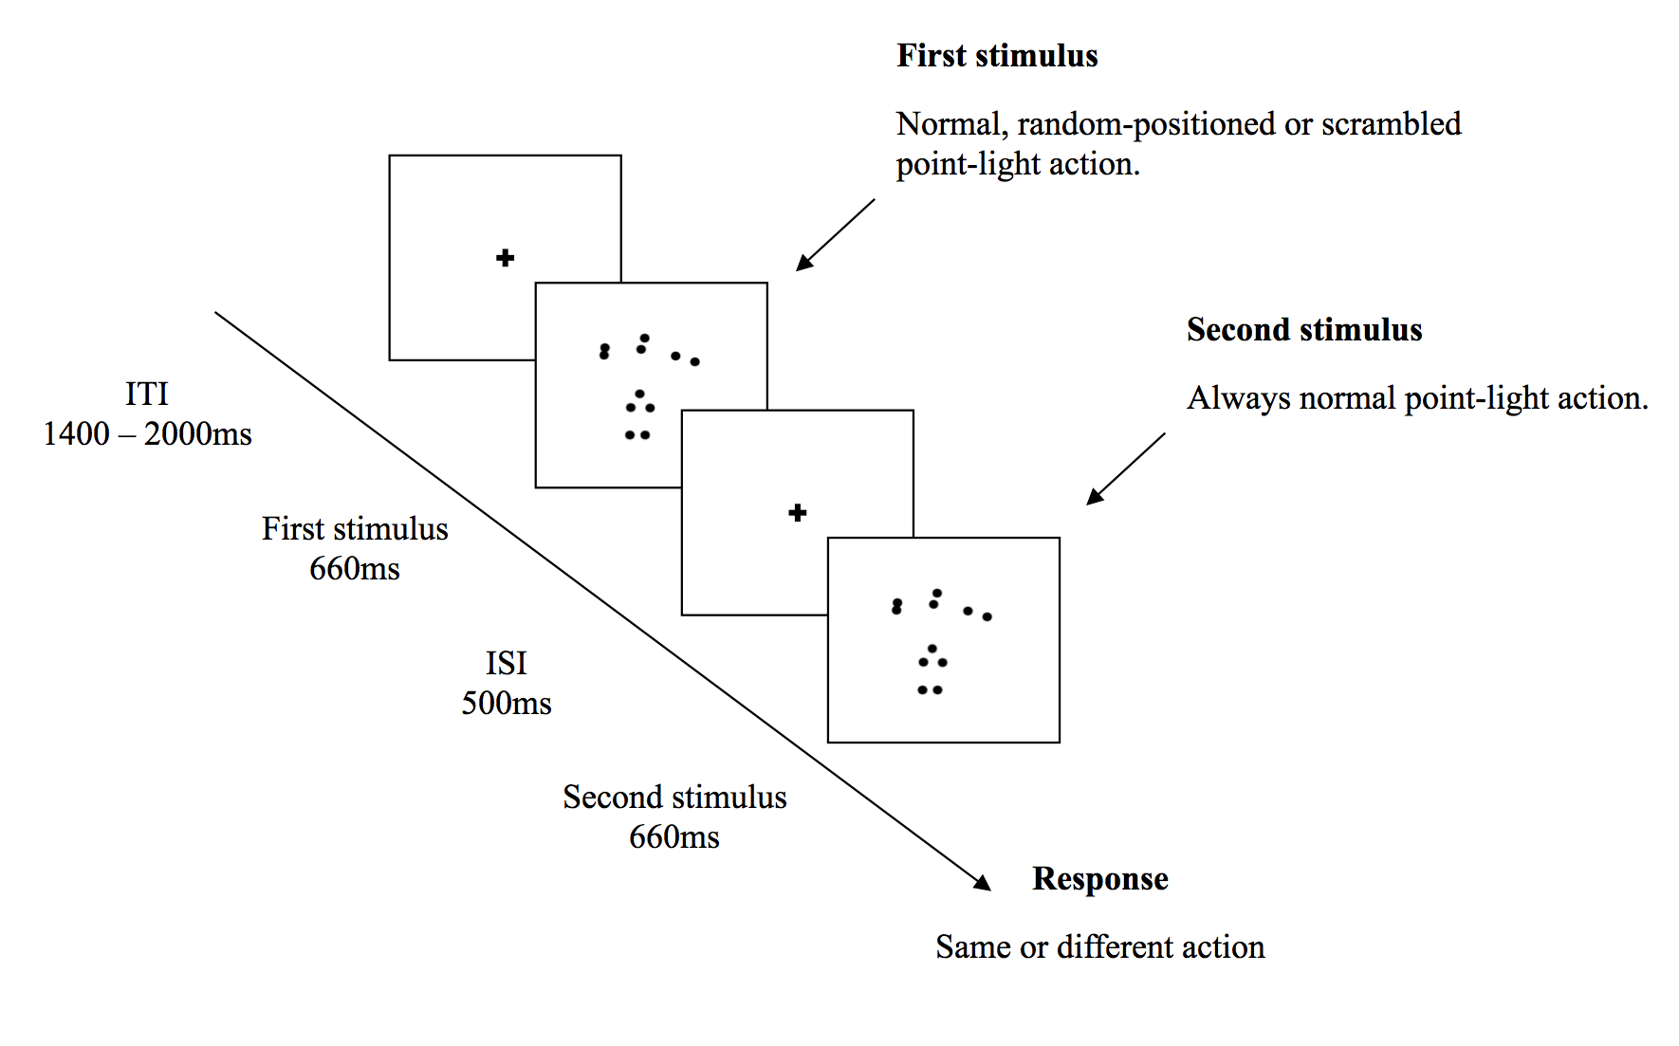

Figure 3. A schematic representation of one trial of the sequential action matching. The image depicts a same trial, in which a normal action is shown for both the first and the second stimulus. In this case, both actions depict a tennis player. Participants had to decide whether the two point light actions were depicting the same or different actions. Percentage accuracy and reaction time measures were recorded as the dependent variables. ITI = inter-trial interval, ISI = inter-stimulus interval.

Navon Task

The stimuli for the Navon task were adapted from Roux and Ceccaldi (2001). Stimuli were displayed in white on a grey background and consisted of the letters S and H (Figure 2). Global letters were created by placing local letters in a 6 (horizontal) x 7 (vertical) matrix. The global letters subtended a visual angle of 4° x 3°, and the smaller local letters, a visual angle of 0.5° x 0.3°. There were three conditions: consistent, inconsistent and control. In the consistent condition, both the local and global letters were the same (global H and local H, or global S and local S). In the inconsistent condition, the global and local letters differed (global H and local S, or global S and local H). In the global control condition, the stimulus was a global H or S composed of local zeros and in the local control condition, the stimulus was a single uppercase H or S (Figure 2). All stimuli were presented in the centre of the screen.

Each participant was tested in two back-to-back sessions. In one session, participants responded to the local aspect of the letters, and in the other session, they responded to the global aspect of the letters. Participants were asked to indicate whether the global or local letter, depending on session, was an “H” or “S” by pressing the respective keys on a QWERTY keyboard. Stimuli remained on the screen until response but participants were asked to respond as quickly and accurately as possible. In order to familiarise participants with the stimuli and task, 12 practice trials preceded each sessions. Feedback was not provided.

In the experimental trials, participants performed two blocks of trials, one for the local session and one for the global session. Target letter and consistency (inconsistent or consistent) were counterbalanced but randomised within each block. There were 48 trials per condition, resulting in 144 trials per session and a total of 288 trials. Both accuracy and median RT were recorded for further analysis. Due to a programming error, some participants performed three blocks of trials per session. However, for all participants, we only analysed the first block of trials per session, in accordance with Roux and Ceccaldi (2001).

Results

Visual acuity

An independent samples t-test showed that there was no significant difference in visual acuity between older (M= 19.5, SD= 2.2) and younger (M= 19.1, SD= 1.75) adults (t₍₃₀₎= -.673, p = . 506).

Sequential action matching task
In the sequential action-matching task, observers had to match two actions. The first action contained primarily form information (random-position), primarily local motion information (scrambled) or both (normal). The second action was always normal. To summarise the results of the matching task (details below), overall, older adults were less accurate and slower at matching the point-light actions compared to younger adults. Accuracy results revealed a significant interaction between age group and action condition, with older adults performing worse for random-positioned actions than younger adults. Reaction time results showed older adults to be significantly slower at matching upright scrambled actions and upright and inverted normal and random positioned actions, compared to younger adults.
Accuracy
Figure 4 shows mean accuracy for younger and older participants on the sequential matching task. Descriptive data is shown in Tables 1 and 2. A 2 (age) x 3 (action condition) x 2 (inversion) x 2 (trial condition - same or different) ANOVA on arcsin transformed data was carried out. To assess response biases, same and different trials were included in the ANOVA. The ANOVA revealed significant main effects of action condition (F _{(2,60)} = 200.9, p<.001), inversion (F _{(1, 30)} = 21.9, p <.001) and trial condition (F_{(1,30)} = 7.54, p =.010), which were further qualified by significant interactions for both action condition x inversion (F _{(2, 60) =} 20.7, p <.001) and action condition x trial condition (F _{(2,30)} = 9.72, p <.001).

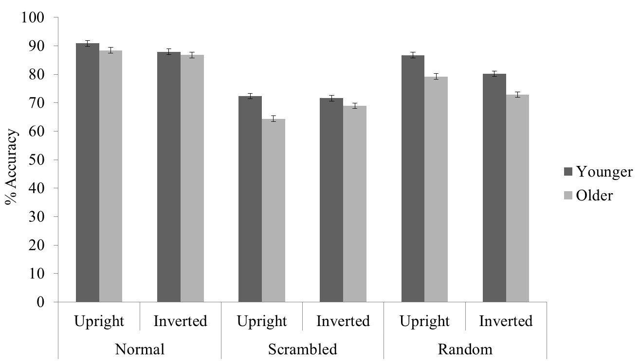

Figure 4. Overall mean accuracy scores for all (same and different) trials for younger and older participants for each condition on the matching task. Error bars represent ± 1 standard error.
In addition, the ANOVA revealed a significant age x action condition interaction (F _{(2, 60)} = 5.29, p = .008). Post-hoc independent samples t-tests revealed that older adults performed significantly worse than younger adults for random-position actions (t ₍₃₁₎ = 2.58, p = 0.15; older: M = 0.76; younger: M = 0.83) but there was no significant age difference for normal actions (t ₍₃₁₎ = .13, p = .90; older: M = 0.88; younger: M = 0.89) or scrambled actions (t ₍₃₁₎ = 1.55, p = .13; older: M = 0.67; younger: M = 0.72).
Finally, the ANOVA revealed an action condition x inversion x trial condition interaction (F_{(2,60)} = 3.28, p =.004). Post-hoc paired sample t-test revealed that participants performed better in the same trials compared to different trials for both upright normal actions(t ₍₃₁₎ = 7.87, p <.001) and normal inverted actions (t ₍₃₁₎ = 5.62, p <.001), and, for both upright random-position actions (t ₍₃₁₎ = 4.64, p <.001) and inverted random-position actions (t ₍₃₁₎ = 4.54, p <.001). For scrambled actions however, participants performed as accurately in the same trials as the different trials for both upright scrambled actions (t ₍₃₁₎ = -.992, p =.329) and inverted scrambled actions (t ₍₃₁₎ = .108, p = .914).

Table 1. Mean percentage accuracy scores and standard deviations for same trials, for both age groups on the action matching task.
Younger Participants Older Participants
Upright Inverted Upright Inverted
M SD M SD M SD M SD
Condition
Normal 96.0 0.03 93.0 0.06 97.0 0.03 96.0 0.04
Scrambled 69.0 0.19 73.0 0.18 61.0 0.16 65.0 0.17
Random 89.0 0.09 85.0 0.09 87.0 0.08 83.0 0.14

Table 2. Mean percentage accuracy scores and standard deviations for different trials, for both age groups on the action matching task.
Younger Participants Older Participants
Upright Inverted Upright Inverted
M SD M SD M SD M SD
Condition
Normal 85.0 0.08 83.0 0.09 79.0 0.16 78.0 0.20
Scrambled 76.0 0.11 71.0 0.13 68.0 0.19 73.0 0.17
Random 84.0 0.09 75.0 0.11 72.0 0.15 63.0 0.14

Reaction Times
We analysed median reaction times. Figure 5 displays the means of the median correct reaction times for younger and older participants on the action matching task. Descriptive data can be seen in Tables 3 and 4. A 2 (age) x 3 (action condition) x 2 (inversion) x (trial condition) ANOVA revealed significant main effects of age (F _{(1, 30)} = 7.16, p =.012), action condition (F _{(2, 60)} = 26.7, p <.001) and inversion (F _{(1,30)} = 12.9, p =.001) which were further qualified by significant interactions for both inversion x age (F_{(1,30)} = 5.06, p =.032) and action condition x inversion (F_{(2,60)} = 7.76, p =.001).

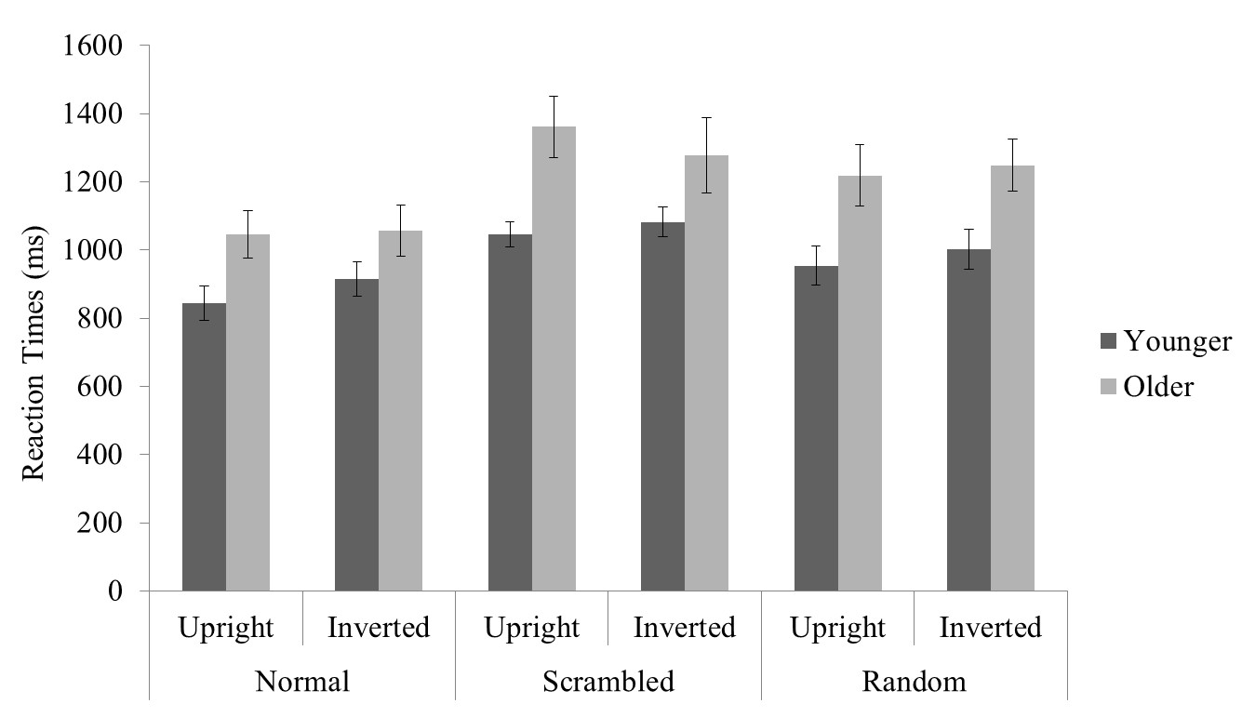

Figure 5. Means of the median reaction times for the action matching task for younger and older participants. Error bars represent ± 1 standard error.
Finally, a significant action condition x inversion x age interaction was found (F_{(2,60)} = 5.36, p =.007). To further assess this three-way interaction, we carried out 3 separate repeated measures age x inversion ANOVAs for each action condition. For normal actions, a main effect of age was found (F_{(1,30)} = 4.12, p =.05), older adults were significantly slower than younger adults, and there was a main effect of inversion (F_{(1,30)} = 5.46, p =.026). Similarly, for random-position actions, a main effect of age (F_{(1,30)} = 6.67, p =.015) and inversion was found (F_{(1,30)} = 7.89, p =.009). For scrambled actions, only a main effect of age was found (F_{(1,30)} = 7.56, p =.010), but no main effect of inversion. The ANOVAs revealed no other significant main effects or interactions.

Table 3. Means and standard deviations of the median reaction times for same trials, for both age groups on the action matching task.

Younger Participants Older Participants
Upright Inverted Upright Inverted
M SD M SD M SD M SD
Condition
Normal 810 0.20 880 0.22 900 0.23 860 0.21
Scrambled 1040 0.16 1070 0.17 1350 0.40 1370 0.34
Random 960 0.24 980 0.25 1120 0.31 1150 0.30

Table 4. Means and standard deviations of the median reaction times for different trials, for both age groups on the action matching task.
Younger Participants Older Participants
Upright Inverted Upright Inverted
M SD M SD M SD M SD
Condition
Normal 880 0.22 950 0.21 1190 0.33 1260 0.43
Scrambled 1050 0.18 1090 0.19 1370 0.36 1180 0.80
Random 950 0.24 1030 0.25 1320 0.40 1340 0.31

Navon Task

Examples of the Navon stimuli can be seen in Figure 2. As predicted, both age groups exhibited global precedence, with reaction times faster when responding to the global than local letters. Overall, older adults were slower but more accurate at responding to the Navon letters than younger adults. The only significant age difference in reaction times was for consistent letters, in that the age difference was larger for local compared to global letters. In general, both age groups were faster and more accurate in responding to consistent stimuli (e.g., global H and local H) for both global and local levels, compared to inconsistent stimuli (e.g., global S and local H). Additionally, all participants were more accurate at responding to the local than global letters.

Accuracy

Figure 6 displays mean accuracy for younger and older participants for the Navon task. Descriptive data can be seen in Table 5. A 2 (age) x 3 (consistency) x 2 (levels) ANOVA on arcsin transformed data revealed significant main effects of age (F_{(1,30)} = 22.0, p <.001), consistency (F_{(2,60)} = 18.8, p <.001), and level (F_{(1,30)} = 9.6, p = .004).
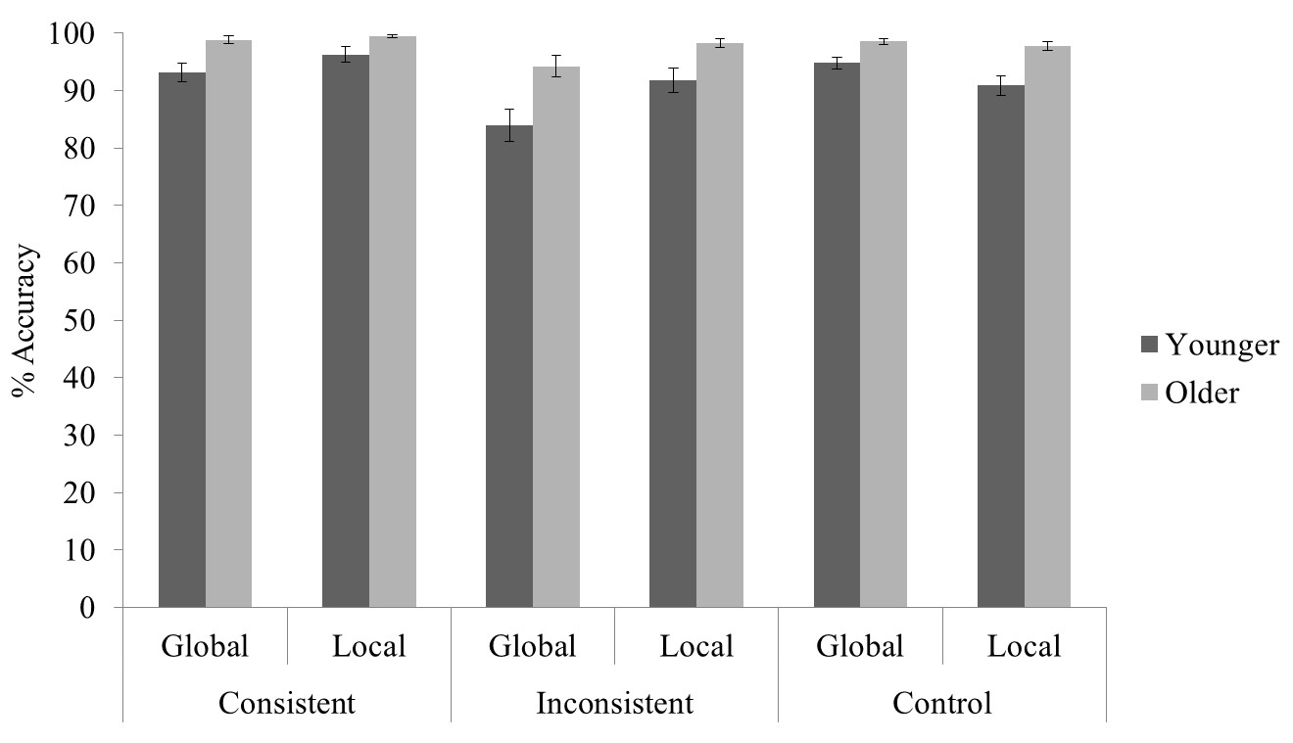
Figure 6. Mean accuracy for younger and older participants on the Navon task. Error bars represent ± 1 standard error.
In addition, the ANOVA revealed a significant level x consistency interaction (F_{(2,30)} = 10.8, p <.001). A paired sample t-test revealed that participants were more accurate for local consistent letters than global consistent letters (t₍₃₁₎ = -2.36, p =.025), and, more accurate for local inconsistent letters than for global inconsistent letters (t₍₃₁₎ = -4.35, p <.001). However, participants were more accurate for global control letters than for local control letters (t₍₃₁₎ = 2.29, p =.030). The ANOVA revealed no other significant main effects or interactions.
Table 5. Mean percentage accuracy and standard deviations for both age groups on the Navon task.
Younger Participants Older Participants
Global Local Global Local
M SD M SD M SD M SD
Condition
Consistent 93.0 0.06 96.0 0.06 99.0 0.03 99.0 0.01
Control 95.0 0.04 91.0 0.07 99.0 0.02 98.0 0.03
Inconsistent 84.0 0.12 92.0 0.09 94.0 0.07 98.0 0.03

Reaction Times

We analysed median reaction times. Figure 7 displays the means of the median correct reaction times for younger and older participants on the Navon task. Descriptive data can be seen in Table 6. A 2 (age) x 3 (consistency) x 2 (levels) ANOVA revealed significant main effects of age (F_{(1,30)} = 19.3, p <.001), level (F_{(1,30)} = 20.9, p <.001), and consistency (F_{(2,60)} = 14.2, p <.001) which were further qualified by a significant level x consistency interaction (F_{(2,60)} = 3.64, p =.032).

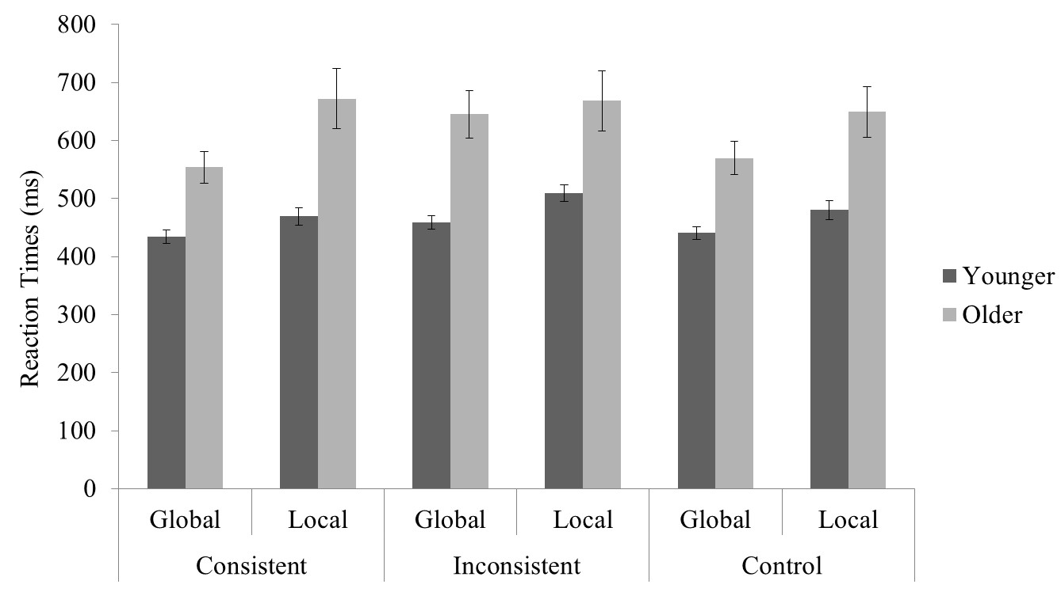

Figure 7. Means of the median reaction times for younger and older participants on each condition of the Navon Task. Error bars represent ± 1 standard error.
Finally, the ANOVA revealed an age x level x consistency interaction (F_{(2,60)} = 7.05, p= .002). To further assess this three-way interaction, we carried out 3 separate repeated measures ANOVAs, one for each level of consistency (consistent, inconsistent, control). In the consistent condition, we found a significant main effect of age (F_{(1,30)} = 19.3, p <.001), older adults were slower than younger adults, and a main effect of level (F_{(1,30)} = 15.6, p <.001), all participants were slower at responding to the local compared to the global letters. In addition, we found a level x age interaction in the consistent condition (F_{(1,30)} = 4.54, p =.041) in that only older adults were significantly slower at responding to the local compared to the global letters. In the inconsistent condition, we found a significant main effect of age (F_{(1,30)} = 17.2, p <.001), older adults were generally slower than younger adults, and a main effect of level (F_{(1,30)} = 16.7, p <.001), participants’ reaction times were slower for the local compared to the global letters, showing a global interference effect in the local condition. Finally, in the control condition, we found a significant main effect of age (F_{(1,30)} = 18.4, p <.001), older adults were generally slower than younger adults, and a main effect of level (F_{(1,30)} = 15.0, p =.001), participants were slower at responding to the local compared to the global letters. The ANOVA revealed no other significant main effects or interactions.

Table 6. Means and standard deviations of the median reaction times for both age groups on the Navon task.
Younger Participants Older Participants
Global Local Global Local
M SD M SD M SD M SD
Condition
Consistent 430 0.05 470 0.06 550 0.10 670 0.20
Control 440 0.04 480 0.07 570 0.11 650 0.17
Inconsistent 460 0.05 510 0.06 650 0.16 670 0.20

Global-local processing and biological motion processing

To determine whether there was a relationship between age, global-local processing styles and biological motion processing, Pearson’s Correlation coefficients on accuracy measures were determined separately for both younger and older participants for performance on action task (same trials only) and Navon global and local inconsistent trials (Table 7 & Table 8). Correlations were solely determined for the inconsistent trials of the Navon task because they most strongly related to global precedence. Further, correlations were carried out on both upright and inverted actions because the global form disruption in the inverted actions tested against the global processing bias in the Navon task. With a false discovery rate of 0.1, none of the raw p-values reached the critical value as computed with the Benjamin-Hochberg procedure (Benjamini & Hochberg, 1995), i.e., there were no significant correlations between performance on the action matching task and the Navon task for older or younger participants.
We also analysed reaction time data. To facilitate the readability of the manuscript, we decided to present the accuracy data only, because those are more comparable to Insch et al. (2010). A full report on reaction time data is provided in the supplementary material (Supplementary Table S1 & Supplementary Table S2). For younger adults there were no correlations, for older adults all correlations were significant apart from scrambled upright and inverted, which were the most difficult conditions. These results are not surprising and most likely indicate an overall variability in motor abilities within the older age group that is especially pronounced in the less challenging conditions, i.e., some participants are overall fast whereas others are overall slow.

Table 7. Correlations between performance on the action matching task and Navon task for younger participants. None of the correlations were significant, when using the Benjamini-Hochberg false discovery procedure (Benjamini & Hochberg, 1995).
 | Global inconsistent |  | Local inconsistent
 | r | p-value | r | p-value
Normal upright | .513 | .035 | .417 | .096
Normal inverted | .252 | .329 | .407 | .105
Scrambled upright | .435 | .081 | .458 | .064
Scrambled inverted | .416 | .097 | .554 | .021
Random upright | .374 | .139 | .409 | .103
Random inverted | .325 | .203 | .452 | .069

Table 8. Correlations between performance on the action matching task and Navon task for older participants. None of the correlations were significant.
 | Global inconsistent |  | Local inconsistent
 | r | p-value | r | p-value
Normal upright | -.043 | .880 | -.006 | .982
Normal inverted | -.221 | .430 | .107 | .703
Scrambled upright | -.221 | .430 | -.120 | .669
Scrambled inverted | -.223 | .425 | -.069 | .808
Random upright | -.035 | .901 | -.019 | .947
Random inverted | .425 | .115 | -.118 | .675

Discussion

The current study investigated age-related changes in the ability to process local motion and global form information in more complex biological motion stimuli using a sequential action matching task. In addition, we assessed age-differences in perceptual processing styles, i.e., local and global form-based processing, and whether differences in perceptual processing styles account for an advantage of form over local motion information in biological motion perception.

In the sequential action-matching task, observers had to match two actions. The first action contained primarily form information (random-position), primarily local motion information (scrambled) or both (normal). The second action was always normal. All observers performed above chance in all conditions. Overall, performance was best for normal actions, closely followed by random-position actions. Performance in both older and younger adults was worse for scrambled actions. These results are in accordance with previous results suggesting that global form is more important for processing point-light actions than local motion information for tasks in which participants have to discriminate the walking direction or recognize actions from point-light stimuli (e.g., Beinteman and Lappe, 2002; Pilz et al., 2010; Insch et al., 2012). Slightly better performance for same compared to different trials in the normal and random-position conditions suggests a potential response bias for conditions containing form information.

Above-chance performance for scrambled actions is surprising given previous finding by Pilz et al. (2010) who found that younger and older participants performed at chance for scrambled stimuli in a direction discrimination task. This difference between our results and Pilz et al. (2010) may be based on two major differences between the two studies. The first difference between the two studies is stimulus-related. Pilz et al. (2010) used point-light walkers that were generated by an algorithm, so called Cutting walkers (Cutting, 1978). In contrast, this study used a variety of motion-captured actions ranging from cycling to drinking (Vanrie and Verfaille, 2004). Saunders, Suchan and Troje (2009) previously showed that participants are able to identify walking directions from scrambled motion-captured walkers but not from so called Cutting walkers, which suggests that local motion signals from motion-captured walkers are more informative than those of a Cutting walker. In addition, Spencer et al. (2016), recently showed that older and younger adults are able to recognise emotions from scrambled motion-captured point-light walkers and similar to Saunders et al. (2009), are able to discriminate the walking direction from those emotional walkers even on the basis of the local motion information alone. The second difference between the two studies is task-related. Pilz et al. (2010) employed a walking direction discrimination task, in this study we employed a matching task. The second stimulus was always normal and the local motion information was identical for the two sequentially presented stimuli in the scrambled condition, which might have made the task easier than the direction discrimination task in Pilz et al. (2010).
It has been suggested that speed and spatial frequency of local motion affects older adults’ performance. However, in our study, we did not find age differences for stimuli containing local motion information, which indicates that speed and spatial frequency information affect older and younger adults equally.

Contrary to our predictions of finding biggest age-differences for scrambled walkers, the only overall significant age-difference was found for random-position actions in that older adults were less accurate than younger adults. This age difference is surprising given that Pilz et al. (2010) found similar performance for both age groups for random-position walkers. Yet, stimulus duration in Pilz et al. (2010) varied from 80ms to 4.8s, whereas the stimulus duration in the matching task used here was always 660ms, a duration at which older adults’ performance in Pilz et al. (2010) was also below younger adults’ performance. Therefore, we would expect that extending the duration of the actions in the matching paradigm might enhance older adults’ performance for random-position actions. However, it has to be noted that in the normal condition, participants had to match two identical point-light actions with identical information content, which is easier than matching a random-position to a normal action. The global form information is derived differently for random-position and normal stimuli. In addition, also the global motion information can be derived differently in both kinds of trial, from integrating the global form over time (normal and random-position) or from integrating the local motion trajectories (normal). These differences might have made the matching task more difficult for older adults.

Performance did not differ between age-groups in the normal condition. However, this is not surprising given that first and second stimulus are almost identical apart from a different start-point in the action cycle. Therefore, the task is much easier than the one used in Pilz et al. (2010). In the current experiment, the normal condition was merely employed as a control and the main conditions of interest were scrambled and random-position actions, for which we yielded overall similar results as Pilz et al. (2010) – better performance for random-position than scrambled.

Both age groups showed inversion effects in that performance was better for upright than for inverted point-light actions. The inversion effect was larger for random-position than normal actions and absent for scrambled actions. A number of previous studies have reported inversion effects for point light actions and it has been suggested that inversion disrupts the processing of the global form of point-light stimuli (Sumi, 1984; Pavlova & Sokolov, 2000; Troje & Westhoff, 2006). Therefore, larger inversion effect for random-position compared to scrambled actions that contain primarily local motion information, is in accordance with previous findings.

In the second task of this paper, we investigated perceptual processing styles using the Navon task (Navon, 1977). During this task, participants had to discriminate letters. Navon letters consist of many small letters (local stimuli) that are arranged to form a larger letter (global stimulus; Figure 2). The global and local letters can be the same (consistent) or different (inconsistent). In one part of the task, participants had to identify the local letters and in the other part of the task, participants had to identify the global letters. Commonly, participants are faster in the global task (global precedence) and have faster reaction times for consistent letters both when they have to identify the local or the global letters. As expected, participants were faster at responding to the global than the local letters, thus exhibiting global precedence, and they were faster in responding to consistent than inconsistent stimuli for both global and local levels (Roux and Ceccaldi, 2001; Georgiou-Karistianis et al. 2006). In addition, older adults were overall slower than younger adults on the Navon task, which is also in accordance with previous studies (Roux and Ceccaldi, 2001; Georgiou-Karistianis et al. 2006). Typically, when participants exhibit global precedence it is also found that they display global interference, i.e., slower reaction times for local inconsistent than global inconsistent letters (Roux and Ceccaldi, 2001; Georgiou-Karistianis et al., 2006), which is confirmed by our results.

Also accuracy results confirmed previous findings in that participants were more accurate in responding to consistent than inconsistent stimuli for both global and local levels (Insch et al., 2012; Roux and Ceccaldi, 2001). More importantly, both age groups were overall better for local than global letters. However, this accuracy advantage for local letter could be related to a speed-accuracy trade off given that participants were overall slower for local than global letters. We also found that older adults were more accurate for the local compared to the global inconsistent trials, which can be taken as an example of local interference on the global letters or a local processing bias as termed by Insch et al. (2012).

Most interestingly however, older adults were more accurate than younger adults in their performance on the Navon task. This advantage for older adults is surprising and contradicts previous studies, which either found no accuracy differences between age groups (Oken et al., 1999; Georgiou-Karistianis et al., 2006; Lux et al., 2008), or found younger adults to be more accurate (Roux & Ceccaldi, 2001; Bruyer, Scailquin & Samson, 2003). Again, a speed-accuracy trade-off might explain the advantage for older adults as they took longer to respond than younger adults. Another explanation might be motivational factors. Ageing is typically associated with declining cognitive abilities, and it has been suggested that such negative association motivates older adults under certain conditions. For example, Ennis, Hess and Smith (2013) found older adults to be highly motivated and more effortful than younger adults on a range of cognitive tasks, and suggested this was due to older adults wanting to perform as well as younger adults. In addition to an increased motivation of older adults, also a decreased motivation of younger adults might have led to the performance difference. The Navon task was relatively long, and most younger adults performed for course credits, which might have made them less motivated.

Taken together, we found an overall global form advantage in the biological motion task and better performance for local letters in the Navon task, which suggests that there is no straightforward relationship between global form-based processing for biological motion processing and global processing in the Navon task. The non-significant correlations between the two tasks supported this. It is interesting to note that effect sizes for older and younger adults differ considerably. The corrections for false discovery showed that the potential correlations between the Navon and the biological motion task were false discoveries. In addition, performance measures for normal upright walkers were all above 94% correct, and given that performance correlated both with local and global performance in the Navon task, a potential relationship would be difficult to assess. We suggest that a potential relationship could emerge due to similarities in task difficulty rather than similarities in the processing of the stimuli given that performance in the Navon task was overall relatively high, such as performance in the normal condition for the biological motion task. Given the lack of significant correlations between the Navon and the biological motion task, our results indicate that local motion and global form information in biological motion stimuli, and form-based local/global processing biases, are unrelated.

Our results are surprising in that local and global processing biases are not related for different tasks, however, previous studies on younger and older adults have shown visual tasks are not necessarily related. Instead, these studies suggest that there are global and local processing differences in different tasks, but such differences are not related across tasks. For example, Wagemans, Van der Hallen, Chamberlain, Van de Cruys and de-Wit (2014) tested over 250 younger participants on three measures that are often taken as measures for local and global processing biases: coherent motion processing, the embedded figures test and the Navon task. They did not find significant correlations in samples of above 250 participants. Similarly, Shaqiri, Clarke, Kunchulia, Herzig, Pilz & Herzog (2015) compared younger (108) and older (131) adults’ performance on fourteen different perceptual tasks (e.g. motion perception, orientation sensitivity and biological motion perception) and four cognitive tasks (e.g. MoCA and digit span). Similar to Wagemans et al. (2014), they also did not find many relevant significant correlations between the different measures. Cappe, Clarke, Mohr and Herzog (2014) also found no relationship between different perceptual tasks in a sample of younger adults. Dale and Arnell (2013) compared younger participants’ performance on three distinct global/local measures (Navon letters, hierarchical shapes, spatial frequency faces). They not only found the Navon letter task to be the least reliable measure with poor test-reliability, but also found no relationship between the three measures.
It is unlikely that our results were driven by optical factors such as visual acuity. It could be argued that participants, particularly older adults, were not able to see the local dots or letters as well as younger adults, contributing to their global bias. Yet, as stated previously all participants had normal or corrected to normal visual acuity and visual acuity did not differ between age groups.
In conclusion, the results of the present study add to the growing body of evidence suggesting age-related changes in biological motion perception. Age-differences in biological motion perception, however, seem to vary based on task and stimulus parameters, which makes it difficult to generalise them to an overall deficit. Our results further showed that older and younger adults are able to match point-light actions that primarily contain local motion information, but this ability seems to depend on the type of task and stimulus used. Overall, both older and younger adults seem to rely more on global form than local motion when matching point-light actions, which supports previous studies. Our results also confirmed previous studies using Navon stimuli that found precedence for global over local form information. However, global precedence did not account for the advantage of form over local motion information in biological motion stimuli.

References

Andres, A. J., & Fernandes, M. A. (2006). Effect of short and long exposure duration and dual-tasking on a global–local task. Acta Psychologica, 122, 247-266.
Bardi, L., Regolin, L., & Simion, F. (2011). Biological motion preference in humans at birth: role of dynamic and configural properties. Developmental Science, 14, 353-359.
Beintema, J., & Lappe, M. (2002). Perception of biological motion without local image motion. Proceedings of the National Academy of Science USA, 99, 5661-5663.
Benjamini, Y., & Hochberg, Y. (1995). Controlling the false discovery rate: a practical and powerful approach to multiple testing. Journal of the Royal Statistical Society. Series B (Methodological), 289-300.
Bennett, P. J., Sekuler, R., & Sekuler, A. B. (2007). The effects of aging on motion detection and direction identification. Vision Research, 47, 799-809.
Bertenthal, B. I., Proffitt, D. R., & Cutting, J. E. (1984). Infant sensitivity to figural coherence in biomechanical motions. Journal of Experimental Child Psychology, 37, 213-230.
Bertenthal, B. I., Proffitt, D. R., & Kramer, S. J. (1987). Perception of biomechanical motions by infants: implementation of various processing constraints. Journal of Experimental Psychology: Human Perception and Performance, 13, 577.
Bertenthal, B. I., & Pinto, J. (1994). Global processing of biological motions. Psychological Science, 5, 221–225.
Billino J., Bremmer, F., & Gegenfurtner, K. R. (2008) Motion processing at low light levels: Differential effects on the perception of specific motion types. Visual Research, 48, 1254-1261.
Bonda, E., Petrides, M., Ostry, D., & Evans, A. (1996). Specific involvement of human parietal systems and the amygdala in the perception of biological motion. Journal of Neuroscience, 16, 3737-3744.
Boutet, I., & Faubert, J. (2006). Recognition of faces and complex objects in younger and older adults. Memory & Cognition, 34, 854-864.
Brainard, D. H. (1997). The psychophysics toolbox. Spatial Vision, 10, 433-436.
Bruyer, R., Scailquin, J. C., & Samson, D. (2003). Aging and the locus of the global precedence effect: A short review and new empirical data. Experimental Aging Research, 29, 237-268.
Cappe, C., Clarke, A., Mohr, C., & Herzog, M. H. (2014). Is there a common factor for vision? Journal of Vision, 14, 4.
Cutting, J. E. (1978). A program to generate synthetic walkers as dynamic point-light displays. Behavior Research Methods and Instrumentation, 10, 91–94.
Dale, G., & Arnell, K. M. (2013). Investigating the stability of and relationships among global/local processing measures. Attention, Perception, & Psychophysics, 75, 394-406.
Dekeyser, M., Verfaillie, K., & Vanrie, J. (2002). Creating stimuli for the study of biological-motion perception. Behavior Research Methods, Instruments, & Computers, 34, 375-382.
Dittrich, W. H., Troscianko, T., Lea, S. E., & Morgan, D. (1996).Perception of emotion from dynamic point-light display represented in dance. Perception, 25, 727–738.
Duchaine, B., Yovel, G., & Nakayama, K. (2007). No global processing deficit in the Navon task in 14 developmental prosopagnosics. Social Cognitive and Affective Neuroscience, 2, 104-113.
Ennis, G. E., Hess, T. M., & Smith, B. T. (2013). The impact of age and motivation on cognitive effort: Implications for cognitive engagement in older adulthood. Psychology and Aging, 28, 495.
Fox, R., & McDaniel, C. (1982). The perception of biological motion by human infants. Science, 218, 486-487.
Gaspar, C. M., Bennett, P. J., & Sekuler, A. B. (2008). The effects of face inversion and contrast-reversal on efficiency and internal noise. Vision Research, 48, 1084-1095.
Gaspar, C., Sekuler, A. B., & Bennett, P. J. (2008). Spatial frequency tuning of upright and inverted face identification. Vision Research, 48, 2817-2826.
Georgiou-Karistianis, N., Tang, J., Mehmedbegovic, F., Farrow, M., Bradshaw, J., & Sheppard, D. (2006). Age-related differences in cognitive function using a global local hierarchical paradigm. Brain Research, 1124, 86-95.
Harrison, T. B., & Stiles, J. (2009). Hierarchical forms processing in adults and children. Journal of Experimental Child Psychology, 103, 222-240.
Heberlein, A. S., & Saxe, R. R. (2005). Dissociation between emotion and personality judgements: Convergent evidence from functional neuroimageing. NeuroImage, 28, 770-777.
Insch, P. M., Bull, R., Phillips, L. H., Allen, R., & Slessor, G. (2012). 'Adult ageing, processing style, and the perception of biological motion'. Experimental Ageing Research, 38, 169-185.
Johansson, G. (1973). Visual perception of biological motion and a model for its analysis. Perceptual Psychophysics, 14, 201-211.
Kleiner, M., Brainard, D., Pelli, D., Ingling, A., Murray, R., & Broussard, C. (2007). What’s new in Psychtoolbox-3, Perception, 36, 1-1.
Kosslyn, S. M., Brown, H. D., & Dror, I. E. (1999). Aging and the scope of visual attention. Gerontology, 45, 102-109.
Kozlowski, L. T., & Cutting, J. E. (1977). Recognizing the sex of a walker from a dynamic point-light display. Perception & Psychophysics, 21, 575–580.
Loula, F., Prasad, S., Harber, K., & Shiffrar, M. (2005). Recognizing people from their movement. Journal of Experimental Psychology: Human Perception and Performance, 31, 210.
Lu, H. (2010). Structural processing in biological motion perception. Journal of Vision, 10, 1-13.
Lux, S., Marshall, J. C., Thimm, M., & Fink, G. R. (2008). Differential processing of hierarchical visual stimuli in young and older healthy adults: Implications for pathology. Cortex, 44, 21-28.
Ma, Y., Paterson, H. M., & Pollick, F. E. (2006). A motion capture library for the study of identity, gender, and emotion perception from biological motion. Behaviour Research Methods, 38, 134-141.
Mather, G., Radford, K., & West, S. (1992). Low-level visual processing of biological motion. Proceedings of the Royal Society of London B: Biological Sciences, 249, 149–155.
Moore, D. G., Goodwin, J. E., George, R., Axelsson, E. L., & Braddick, F. (2007). Infants perceive human point-light displays as solid forms. Cognition, 104, 377-396.
Nasreddine, Z. S., Phillips, N. A., Bédirian, V., Charbonneau, S., Whitehead, V., Collin, I., ... & Chertkow, H. (2005). The Montreal Cognitive Assessment, MoCA: a brief screening tool for mild cognitive impairment. Journal of the American Geriatrics Society, 53, 695-699.
Navon, D. (1977). Forest before trees: The precedence of global features in visual perception. Cognitive Psychology, 9, 353-383.
Navon, D., & Norman, J. (1983). Does global precedence reality depend on visual angle? Journal of Experimental Psychology: Human Perception and Performance, 9, 955.
Norman, J. F., Clayton, A. M., Shular, C. F., & Thompson, S. R. (2004). Aging and the perception of depth and 3-D shape from motion parallax. Psychology and Aging, 19, 506.
Oken, B. S., Kishiyama, S. S., Kaye, J. A., & Jones, D. E. (1999). Age-related differences in global-local processing: stability of laterality differences but disproportionate impairment in global processing. Journal of Geriatric Psychiatry and Neurology, 12, 76-81.
Pavlova, M., Krägeloh-Mann, I., Birbaumer, N., & Sokolov, A. (2001). Biological motion shown backwards: the apparent-facing effect. Perception, 31, 435-443.
Pavlova, M. A. (2012). Biological motion processing as a hallmark of social cognition. Cerebral Cortex, 22, 981-995.
Pelli, D. G. (1997). The VideoToolbox software for visual psychophysics: Transforming numbers into movies. Spatial Vision, 10, 437-442.
Pilz, K.S., Bennett, P.J. & Sekuler, A.B. (2010). Effects of ageing on biological motion discrimination. Vision Research, 50, 211-219.
Pollick, F. E., Kay, J. W., Heim, H., & Stringer, R. (2005). Gender recognition from point-light walkers. Journal of Experimental Psychology: Human Perception and Performance, 31, 1247.
Poirel, N., Pineau, A., & Mellet, E. (2008). What does the nature of the stimuli tell us about the Global Precedence Effect? Acta Psychologica, 127,1-11.
Roether, C. L., Omlor, L., & Giese, M. A. (2008). Lateral asymmetry of bodily emotion expression. Current Biology, 18, 329-330.
Roudaia, E., Bennett, P. J., Sekuler, A. B., & Pilz, K. S. (2010). Spatiotemporal properties of apparent motion perception and aging. Journal of Vision, 10, 5.
Roux, F., & Ceccaldi, M. (2001). Does aging affect the allocation of visual attention in global and local information processing? Brain and Cognition, 46, 383-396.
Saunders, D. R., Suchan, J. & Troje, N. F. (2009). Off the wrong foot: local features in biological motion. Perception, 38, 522-532.
Sekuler, A. B., Gaspar, C. M., Gold, J. M., & Bennett, P. J. (2004). Inversion leads to quantitative, not qualitative, changes in face processing. Current Biology, 14, 391-396.
Shaqiri, A., Clarke, A., Kunchulia, M., Herzig, D., Pilz, K., & Herzog, M. (2015). The effects of aging on perception and cognition. Journal of Vision, 15, 802-802.
Slavin, M. J., Mattingley, J. B., Bradshaw, J. L., & Storey, E. (2002). Local–global processing in Alzheimer’s disease: an examination of interference, inhibition and priming. Neuropsychologia, 40, 1173-1186.
Spencer M. Y., Sekuler, A. B., Bennett, J. B., Giese, M. A., & Pilz, K. S. (2016). Effects of aging on discriminating emotions from point-light walkers. Psychology and Aging, Epub ahead of print.
Staudinger, M. R., Fink, G. R., Mackay, C. E., & Lux, S. (2011). Gestalt perception and the decline of global precedence in older subjects. Cortex, 47, 854-862.
Sumi, S. (1984). Upside-down presentation of the Johansson moving light-spot pattern. Perception, 13, 283-286.
Thornton, I. M., Pinto, J. & Shiffrar, M. (1998). The visual perception of human locomotion. Cognitive Neuropsychology, 15, 535-552.
Thurman, S. M., & Grossman, E. D. (2008). Temporal “Bubbles” reveal key features for point-light biological motion perception. Journal of Vision, 8, 28.
Troje, N. F. (2003). Reference frames for orientation anisotropies in face recognition and biological-motion perception. Perception, 32, 201-210.
Troje, N. F., Westhoff, C., & Lavrov, M. (2005). Person identification from biological motion: Effects of structural and kinematics cues. Perception & Psychophysics, 67, 667-675.
Troje, N. F., & Westhoff, C. (2006). The inversion effect in biological motion perception: Evidence for a “life detector.” Current Biology, 16, 821–824.
Vanrie, J., & Verfaillie, K. (2004) Perception of biological motion: A stimulus set of human point-light actions. Behaviour Research Methods Instruments and Computers, 36, 625-629.
Wagemans J, Van der Hallen R, Chamberlain R, Van de Cruys S, de-Wit L, 2014, " (in)Validating measures of local and global processing " Perception 43 ECVP Abstract Supplement, page 175.
Wittinghofer, K., de Lussanet, M. H., & Lappe, M. (2012). Local-to-global form interference in biological motion perception. Attention, Perception, & Psychophysics, 74, 730-738.

